| Policy: |
| --- |

Hospital profiles provide key information required by Ontario Health (Trillium Gift of Life Network [TGLN]) coordinators to effectively manage a case at and provide follow-up to referring facilities. For the purposes of this process instruction, the most responsible coordinator is defined as the Specialist(s), Organ and Tissue Donation (OTDC) or Specialist, Hospital Development (HDC) who provides hospital development support for the healthcare facility.

| **Procedure:** |
| --- |

**Creating Hospital Profiles:**

A new hospital profile will be created for any new facility/agency who formally reports potential organ and/or tissue donors to Ontario Health (TGLN)

1. HDCs develop and maintain the Hospital Profile Template and will provide a blank template for completion upon request.
2. The Hospital Program department is responsible for the primary work of creating profiles for hospital/hospices who formally notify Ontario Health (TGLN) of potential organ or tissue donors. The Tissue Program is responsible for the primary work of creating profiles for paramedic and coroners who formally notify Ontario Health (TGLN) of potential organ or tissue donors.
3. The HDC will upload the initial completed profile to the Hospital Profile SharePoint site (https://qmsqa.giftoflife.on.ca/sites/hospitalprofiles/_layouts/15/start.aspx#/SitePages/Home.aspx) upon request from the Tissue Program or Hospital Programs.
4. The HDC will ensure the profile naming convention is as follows:
   1. Corporate Name – Site Name
   2. The HDC will enter the SharePoint Meta Tags as follows:
      1. OTDC Name (for OTDC supported facilities)
      2. HDC Name (for HDC and OTDC supported facilities)
      3. Last date revised by Hospital (as specified on hospital profile)

**Accessing Hospital Profile:**

1. Hospital Profiles are stored and accessible in a read only form on the Hospital Profile SharePoint for all Ontario Health (TGLN) staff using their windows ID <https://qmsqa.giftoflife.on.ca/sites/hospitalprofiles/_layouts/15/start.aspx#/SitePages/Home.aspx>
2. The Hospital Profiles can be edited on the Hospital Profile SharePoint site by the most responsible coordinator(s), HDCs, Tissue Specialists, and any other Ontario Health (TGLN) staff member as deemed appropriate by the Directors of Hospital Programs and/or Director of Tissue.
3. Upon request, the HDC will grant or remove edit privileges to the hospital profiles.

**Updating and maintaining Hospital Profiles:**

1. Change requests related to hospital processes or internal Ontario Health (TGLN) processes should be:
   1. forwarded to the most responsible coordinator or designate
   2. reviewed and incorporated into the hospital profile by the most responsible coordinator or designate
2. Change requests related to internal Ontario Health (TGLN) tissue donation processes (e.g., dispatch, tissue offers, tissue transport) or tissue bank practices:
   1. Should be forwarded to the Tissue Managers or designate(s).
   2. reviewed and incorporated into the hospital profile by the most responsible Tissue Clinical Specialist
3. Hospital Profiles should be reviewed/updated on a yearly basis by the most responsible coordinator in conjunction with the referring facility and the SharePoint Meta Tags should be updated to indicate the last date revised by hospital.

**Exhibit 1: Hospital Profile Template**

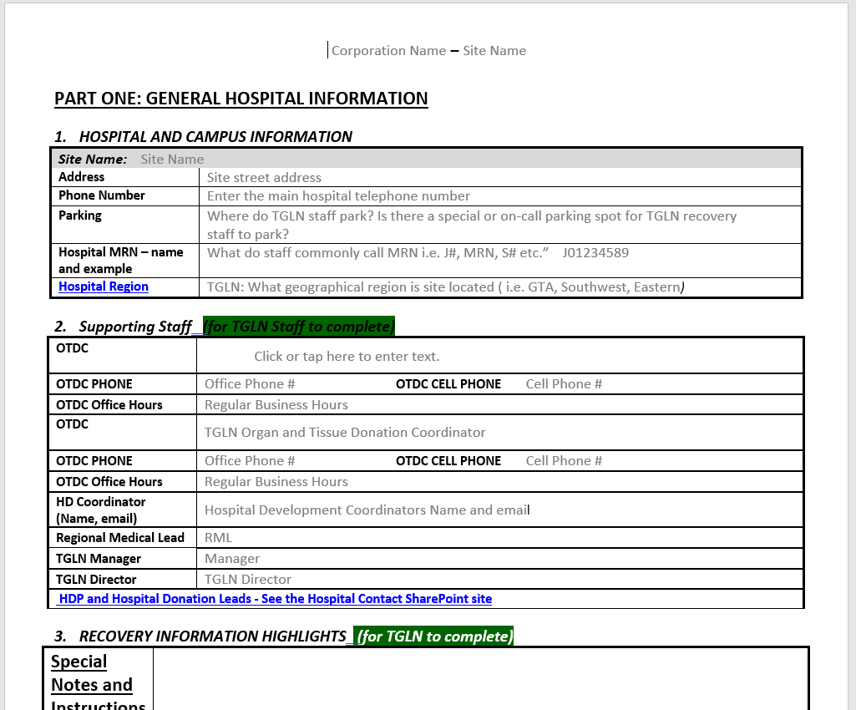**Page 1**