**Provincial Organ and Tissue Donation Policy Template**

Approved by Ontario Health (TGLN) Clinical Operations Committee June 2023

Approved by Provincial Donation Steering Committee September 2023

**Policy:**

<Insert Hospital Name> is committed to providing comprehensive end-of-life care that is compassionate in nature. This includes honouring a patient’s consent decision to donate organs and/or tissues after death or by ensuring that the opportunity for donation has been provided to the patient (if applicable) or the family/substitute(s) when a patient’s consent has not previously been registered. Our donation practices are guided by the following goals:

* Maximize opportunities to save and transform lives through organ and/or tissue donation;
* Honour the registered consent decision and values of donor patients and their family/substitute(s); and
* Integrate organ and tissue donation into the delivery of quality end-of-life care for donor patients and their family/substitute(s).

Our primary duty is to serve the best interests of the potential donor patient, and to act on their consent decision and values related to donation. This duty is best fulfilled by aligning decisions and actions with the following values:

* Respect the patient’s dignity by providing end-of-life care that balances the desire to fulfill the patient’s consent decision and values related to donation, while not intentionally hastening or interfering with the patient’s dying process;
* Compassionately support the patient and/or family/substitute(s);
* Align with emerging leading practices to appropriately maximize all donation opportunities; and
* Every eligible patient or their family/substitute(s) has the opportunity to discuss donation with an expert, including being informed of the patient’s registered consent decision, when applicable for substitutes.

In keeping with the *Gift of Life Act* notification provisions Part II.I – Designated Facilities – Routine Notification and Required Consent, in identified patient care areas, mandatory notification triggers are outlined in section 1. of this policy.

<Insert Hospital Name> is steadfast in its commitment to the patients they serve, and recognizes that notifying Ontario Health (TGLN) of all patients who are at high risk of imminent death and death to optimize each and every donation opportunity not only for their patients and their family/substitute(s), but also for the lives of others.

Consistent with the requirements of the *Gift of Life Act*, <Insert Hospital Name> will make every effort to ensure that the mandatory donation discussion involving Ontario Health (TGLN) will occur for all patients deemed medically suitable by Ontario Health (TGLN). If the patient has a registered consent decision, this information will be provided to the patient’s family/substitute(s) by Ontario Health (TGLN).

Consistent with the standards of excellence identified by Accreditation Canada, <Insert Hospital Name> will identify and mobilize the necessary resources to facilitate successful organ and tissue donation. To ensure that every patient who is medically suitable to donate organs and/or tissues is given the opportunity to save and transform the lives of others, hospital staff will notify Ontario Health (TGLN) in as timely a manner as possible, to allow sufficient time to determine medical suitability.

**Definitions:**

**Ancillary Testing:** Tests completed to determine the absence or presence of cerebral blood flow used to corroborate the clinical assessment for death determination by neurologic criteria.

**Death Determination by Circulatory Criteria (DCC):** The process for determining death of an individual based on circulatory criteria.

**Death Determination by Neurologic Criteria (DNC):** The process for determining death of an individual based on neurologic criteria.

***Gift of Life Act*:** Ontario legislation that governs the donation of organs and tissues for the purposes of transplantation, medical education or scientific research.

**Invasive Physiologic Support:** Interventions used to maintain the function of the body and organs, excluding the brain, after death determination by neurologic criteria.

**Life-Sustaining Measures:** For the purpose of this document, this term refers to supplemental inhaled oxygen, positive airway pressure, endotracheal intubation, mechanical ventilation, cardiac pacing or other cardio-circulatory assist device, hemodynamic medical therapy, inotrope/vasopressor therapy or other cardiac medical support, and/or dialysis.

**Medical Assistance in Dying (MAID):**

* 1. The administration by a physician or nurse practitioner (NP) of a substance to a person, at their request, that causes their death; or
  2. The prescribing or providing by a physician/NP of a substance to a person at their request, so that they may self-administer the substance and in doing so cause their own death.

**Non-Perfused Organ Donation (NPOD):** Refers to the process of organ recovery following asystole.

**Organ Donation:** Removal of organs that are critically dependent upon continuous blood flow for maintenance of viability at normal body temperature. For the purpose of post-mortem organ donation for transplantation, two physicians must confirm death prior to the removal of organs. There are two types of deceased organ donation:

1. Donation after DNC
2. Donation after DCC

**Substitute(s):** When used in relation to deceased donation the substitute(s) is the person or persons who may provide consent for donation as identified in the *Gift of Life Act.*

**Tissue Donation:** Removal of tissues that are not critically dependent upon continuous blood flow for maintenance of viability at normal body temperature, for the purpose of transplantation. Tissues that may be donated after death include eyes/ocular tissue, skin, bone and connective tissue, veins, and heart valves.

**Ontario Health (Trillium Gift of Life Network [TGLN]):** is responsible for organ and tissue donation and transplantation in Ontario.

**Ontario Health (TGLN) Coordinators:** Specialists in donation employed by Ontario Health (TGLN), who are available to assess eligibility to donate organs and/or tissues, provide support to patients and/or families/substitutes and health care professionals, and facilitate organ and tissue recovery.

**Withdrawal of Life-Sustaining Measures (WLSM):** Refers to the removal of life-sustaining interventions when these interventions are not expected to provide further benefit to the patient, or when the patient and/or their substitute decision-maker(s) withdraws consent to treatment. After WLSM, these interventions are not reinstituted, even if the patient deteriorates. This is distinct from decreasing the patient’s level of support as the patient’s status improves (weaning) and from continuing medical support to maintain the opportunity for the potential of organ donation.

**Process**:

1. **Notification**

A timely notification to Ontario Health (TGLN) ensures the opportunity for organ and/or tissue donation can be assessed and allows patients and/or families/substitutes to honour end-of-life decisions about organ and tissue donation.

***Notification Indicators for Mandatory Patient Notification to Ontario Health (TGLN)***

* 1. Notify Ontario Health (TGLN) with all ventilated patients, including patients receiving life-sustaining non-invasive ventilation (e.g., BiPAP®/CPAP) and with patients who have requested Medical Assistance in Dying (MAID) as indicated below, who meet any of the following criteria:

**G** Grave prognosis or GCS = 3

**I** Injured brain or non-recoverable injury/illness

**F** Family/patient-initiated discussion of donation or withdrawal of life-sustaining measures

**T** Therapy limited, de-escalation of treatment, or withdrawal of life-sustaining measures discussion planned

**+** For patients who have requested MAID:

* after the first confirmation of eligibility assessment with a reasonably foreseeable natural death,
* after the second confirmation of eligibility assessment when natural death is not reasonably foreseeable

The health care team must notify/update Ontario Health (TGLN) when a patient’s condition changes, a DNC assessment is planned, a WLSM discussion is being considered, and/or following a decision for WLSM.

* 1. For all non-ventilated patients located **within critical care units (e.g., ED/ICU)** notify Ontario Health (TGLN):
* Within one (1) hour of death
* When the topic of donation is raised by the family/patient
* For patients who have requested MAID:
  + after the first confirmation of eligibility assessment with a reasonably foreseeable natural death,
  + after the second confirmation of eligibility assessment when natural death is not reasonably foreseeable
  1. For all non-ventilated patients located **outside critical care units (e.g., Floors),** aged 79 and younger, notify Ontario Health (TGLN):
* Within one (1) hour of death
* When the topic of donation is raised by the family/patient
* For patients who have requested MAID:
  + after the first confirmation of eligibility assessment with a reasonably foreseeable natural death,
  + after the second confirmation of eligibility assessment when natural death is not reasonably foreseeable
  1. For infants and neonates, only those who are greater than or equal to 36 weeks corrected gestational age meet the requirements for notification to Ontario Health (TGLN) (see 1.6-1.8). Stillbirths, regardless of gestational age, are not required to be notified to Ontario Health (TGLN).
  2. For all patient notifications a call back to Ontario Health (TGLN) must occur at time of death, unless otherwise directed by the Ontario Health (TGLN) Coordinator.
  3. To ensure that the opportunity for organ donation is preserved, notification must occur prior to the removal of invasive physiologic support, initiation of WLSM, or prior to a MAID provision (as per notification indicators 1.1-1.3). Timely notification or update after asystole ensures that the opportunity for tissue donation can be preserved.
  4. Notification of a potential organ and/or tissue donation patient to Ontario Health (TGLN) does not require or imply a change in therapeutic approach, or mandate a discussion regarding donation at that time. The intent of such a notification is to allow Ontario Health (TGLN) to:
     + Assess organ and/or tissue donation potential
     + Identify whether the patient has a registered consent decision regarding donation
     + Plan an approach in collaboration with the healthcare team to discuss organ and tissue donation with patient/substitute(s)
  5. Medical management required to preserve the opportunity for donation is not considered to be escalation of therapy when a period of time exists in which the patient must be maintained prior to speaking with the family/substitute about the opportunity for organ and tissue donation.
  6. The notification date and time, and the identification number (“TGLN Number”) assigned by Ontario Health (TGLN) shall be recorded in the patient’s chart. <insert hospital-specific documentation requirements if necessary>.

1. **Medical Suitability Determination**
   1. Hospital staff will provide Ontario Health (TGLN) with the information required to determine preliminary medical suitability for organ and tissue donation. Hospital staff will use Ontario Health (TGLN)’s Routine Notification Worksheet (Appendix A) or MAID Pre-Provision Intake Form (Appendix B) [if a hospital-specific alternative has been developed, insert form name and sample to appendix] to provide information such as the patient’s general health, admission history, known co-morbid conditions, and infectious and transmissible diseases.
   2. The Ontario Health (TGLN) Coordinator will assess and make a preliminary determination of medical suitability for organ and/or tissue donation. Ontario Health (TGLN) will then establish a plan for follow-up or support in conjunction with the health care team.
2. **Donation Discussion**

The *Gift of Life Act*mandates that consent for organ and tissue donation will occur in a manner that is identified by Ontario Health (TGLN). As such, the process for consent must be consistent with the requirements set forth by Ontario Health (TGLN).

***Guiding Principles for All Patients***

* 1. The Ontario Health (TGLN) Coordinator and the inter-professional team members will jointly develop a plan for the approach and discussion with the patient (if applicable) and/or the family/substitute(s) regarding donation options.
  2. It is the responsibility of medical staff to discuss all prognostic and treatment-related issues with the patient or the patient’s substitute decision-maker as per the *Health Care Consent Act (HCCA)*. Ontario Health (TGLN) will not be involved in this discussion, or in any discussion or decision related to withdrawal of life-sustaining measures.
  3. <Insert Hospital Name> staff will make every effort to involve an Ontario Health (TGLN) Coordinator in all conversations regarding organ and tissue donation with the patient and/or the patient’s family/substitute(s) members.
  4. It is the responsibility of Ontario Health (TGLN) to discuss the opportunity for organ and tissue donation with the patient and/or the patient’s family/substitute(s).
  5. No discussion about organ and/or tissue donation is to be initiated with patients and/or the family/substitute(s) if there is any prognosis for significant functional recovery, if significant prognostic uncertainty exists, and/or if any escalation/continuation in current therapy is under consideration, except in the following circumstances:
* Patient or the patient’s family/substitute(s) has requested to discuss this topic.
* Patient’s attending intensivist/physician believes that a discussion regarding donation is necessary in order to determine direction of therapy (in relation to organ donation after DNC)
* There is a consensual decision for WLSM (in relation to organ donation after DCC)
* For patients who have requested MAID and have not asked about donation:
  + after the first confirmation of eligibility assessment with a reasonably foreseeable natural death,
  + after the second confirmation of eligibility assessment when natural death is not reasonably foreseeable
  1. In situations where the family/substitute(s) decline the opportunity to speak with Ontario Health (TGLN) about organ and tissue donation, Ontario Health (TGLN) may approach the family/substitute(s) with information about the patient’s registered consent decision or the <Insert Hospital Name> physician or health care team member may be requested to share the fact the patient has a registered consent decision on record and the fact that this constitutes legal consent for donation.

***Organ and Tissue Donation Discussion: Patient’s Life-Sustained with Mechanical Ventilation and/or Invasive Physiologic Support***

* 1. The health care team should make every effort to notify/update Ontario Health (TGLN) prior to DNC assessment and/or any discussion with the patient/substitute(s) regarding WLSM. This proactive step ensures that Ontario Health (TGLN) can promptly assign a Coordinator to establish a plan of support.
  2. In all circumstances where a patient has an established cause of devastating brain injury severe enough to cause death, DNC should be assessed according to <insert DNC policy reference here>. Assessing and confirming DNC gives the family/substitute(s) relevant information to assist in making end-of-life decisions.
  3. If Ontario Health (TGLN) identifies potential for organ donation, an Ontario Health (TGLN) Coordinator will develop a plan with the patient’s most responsible physician (MRP) and health care team for the next steps in the donation process. The next steps include planning for the Ontario Health (TGLN) Coordinator to lead the donation discussion with the patient (if applicable) or family/substitute(s).
  4. In situations where the family/substitute(s) have requested a rapid enactment of WLSM, the MRP and health care team will make every effort to ensure that Ontario Health (TGLN) is notified/updated and has the opportunity to speak with the patient and/or family/substitute(s) about organ donation (if deemed medically eligible by Ontario Health [TGLN]). If necessary, the MRP or health care team will inform the family/substitute(s) that as part of end-of-life practices in Ontario, Ontario Health (TGLN) will be consulted to check if there is a registered consent decision to donate and will speak with the family/substitute(s) if the patient has the ability to help others through organ and/or tissue donation.

***Organ and Tissue Donation Discussion: Patients Requesting Medical Assistance in Dying (MAID)***

A patient’s decision to seek MAID should be made prior to the initiation of any discussion of organ and tissue donation. The organ donation, procurement, and transplant teams must not influence, or be perceived to be influencing, the patient’s decisions or approval to receive MAID.

Each patient should be extended dignity and autonomy to provide first-person consent in accordance with their own preference regarding organ and tissue donation. Every medically eligible patient should be offered an opportunity to speak with an expert in donation from Ontario Health (TGLN).

Patients requesting MAID should be offered the opportunity to be organ and tissue donors with sufficient time to enable them to incorporate donation into their plan for end-of-life should they so wish.

* 1. Following notification for patients requesting MAID (as per 1.1-1.3) and the determination of medical suitability for organ and/or tissue donation, an Ontario health (TGLN) Coordinator will collaborate with the health care team <or insert additional hospital-specific departments /roles involved in the MAID process> to develop a plan of support for the next steps in the donation process. The next steps include planning for the Ontario Health (TGLN) Coordinator to lead the donation discussion.
  2. Whenever possible, the Ontario Health (TGLN) Coordinator will discuss donation opportunities directly with the patient in advance of the day of provision. Patients may defer this conversation to their substitute(s) as appropriate. In some circumstances, the patient may want to defer the consent process to their family/substitute(s), to take place after death has occurred (see 4.1 – 4.3).
  3. <if required, insert any other hospital specific processes needed in the policy for organ donation following MAID or refer to hospital MAID policy if it includes organ donation specific processes>

***Tissue Donation Discussion: All Patients Following Death***

* 1. The health care team must notify/update Ontario Health (TGLN) following a patient's death (as per Routine Notification indicators 1.1 - 1.3) unless otherwise directed by the Ontario Health (TGLN) Coordinator.
  2. When the patient is deemed suitable to donate tissues, either the physician or nurse will connect the Ontario Health (TGLN) Coordinator by phone with the patient or the patient’s family/substitute(s), whenever possible, while the family/substitute is at the hospital.
  3. If the patient’s family/substitute(s) is not available at the hospital, the physician or nurse will provide the family/substitute(s) contact information to the Ontario Health (TGLN) Coordinator.
  4. Ontario Health (TGLN) will fax a Hold Body form to <insert location where form is sent> if tissue donation potential exists. The Hold Body Form will be placed <insert hospital-specific processes such as photocopying and placing in chart and/or shroud>. This form ensures that the body is not released before consent for tissue donation is requested and before tissue recovery occurs.
  5. If the family/substitute(s) declines donation or Ontario Health (TGLN) is unable to connect with them in the allotted time for tissue donation, the Ontario Health (TGLN) coordinator will inform the hospital to release the body <insert hospital-specific processes if necessary>.

1. **Donation Consent & Coroner Considerations**

***Donation Consent***

The *Gift of Life Act* is the only legislation applicable to deceased donation consent decisions. The *Health Care Consent Act (HCCA*) and *Substitute Decisions Act* *(SDA)* are no longer in effect after death. The *Gift of Life Act* states that obtaining consent for donation under the *Gift of Life Act* is full authority to proceed with donation.

* 1. In cases of donation after DCC, a second consent is required to proceed with pre-mortem assessment and interventions for the purpose of organ donation and must be completed by the substitute decision-maker (SDM) under the *HCCA*. The following consents to proceed with donation after DCC include:
* *Consent to Donate Organs and/or Tissues*
* *Consent to Interventions for the Purpose of Organ Donation after Death Determination by Circulatory Criteria*
  1. There are two situations that exist where two consent forms are not required in donation after DCC:
* Consent by a conscious, competent person (e.g., MAID) requires only *First-Person Consent to Donate Organs and/or Tissues* form to be completed. *First-Person Consent* documentation is sufficient to proceed with deceased donation even if the individual later becomes incapable, provided that the patient has completed a waiver of final consent for MAID and the MAID provision occurs on or before the date indicated on the waiver of final consent for MAID.
* A deceased donation circumstance that meets **all** of the following criteria:
* The patient has a registered consent decision; AND
* There are no available substitute decision-makers under the *Health Care Consent Act;* AND
* The MRP has proposed a plan for withdrawal of life-sustaining measures to the Public Guardian and Trustee (PGT); AND
* The PGT has provided consent for the withdrawal of life-sustaining measures (WLSM) plan; AND
* The WLSM plan enables donation to proceed; AND
* There are no available substitutes under the *Gift of Life Act;* AND
* The MRP’s medical opinion indicates organ testing or administration of heparin is not “treatment” under the *Health Care Consent Act* AND the interventions will not hasten death.
  1. If consent for organ and/or tissue donation is obtained, the consent form(s) should be placed in the patient’s chart. The Ontario Health (TGLN) Coordinator may provide the form(s) in person or may fax the form(s) to <insert hospital location and any other hospital processes for consent form>.

***Coroner Considerations***

* 1. If criteria are met according to the *Coroners Act* (1990), the health care team can notify Ontario Health (TGLN) prior to consulting with the coroner. Ontario Health (TGLN) will obtain permission for organ and/or tissue donation from the coroner when the patient meets the requirements to be a coroner’s case under the *Coroners Act* except for circumstances outlined in 4.5.

**Note:** there is no requirement to obtain permission from the Office of the Chief Coroner (OCC) to proceed with organ and/or tissue donation following MAID however, standard reporting procedures must occur after death following MAID as outlined in the OCC’s Medical Assistance in Dying electronic death reporting system found here: https://forms.mgcs.gov.on.ca (search term “MAID”). All healthcare providers should be aware of their obligations under the *Coroners Act*. <Insert Hospital name> will make every effort to support the coroner’s investigative requests to enable the successful recovery of organs and/or tissue.

1. **Organ Donation** - **Medical Management and Testing**
   1. The medical management for organ and/or tissue donation should be in accordance with <Insert Hospital Name> physician order set for donation.
   2. Organ-specific testing necessary to determine medical suitability for donation will be expedited.
   3. In the event that an individual outside the hospital has been deemed eligible and consents for organ donation following MAID, <Insert Hospital Name> will work in collaboration with Ontario Health (TGLN) to accommodate suitability testing, plan admission, and organ recovery. For patients eligible for NPOD after MAID provision at home, a discussion with hospital leadership and Ontario Health (TGLN) will occur to determine if the hospital will accept the transfer of the deceased patient directly to the operating room for organ recovery following the MAID provision at home.
2. **Organ Donation - Operating Room Booking and Setup**
   1. In collaboration with the patient (if applicable), family/substitute(s), the hospital staff, Ontario Health (TGLN), and transplant hospitals, the time of organ recovery will be determined and logistics for the recovery process will be arranged. In situations of organ donation following DCC, the time and place of WLSM or the MAID provision will also be arranged.
   2. Organ donors must be given priority OR booking considerations. If a conflict regarding timing of a donor OR occurs, the escalation process is as follows: <insert process here>
   3. Anesthetists (or a Registered Respiratory Therapist or Anesthesia Assistant delegate as per hospital policy) may be required for the following:

* Re-intubation for the purposes of lung donation (in situations of DCC donation)
* Management of the donor throughout the organ recovery procedure, including the ventilator
* Assistance with bronchoscopy in the Operating Room
  1. All visiting recovery teams will be granted temporary operating room privileges for organ and/or tissue recovery (insert hospital procedures for granting privileges).
  2. Scrubs and lockers for the recovery team(s) will be provided by <Insert Hospital Name>.
  3. Prior to the withdrawal of life-sustaining measures, MAID provision, and/or the patient’s arrival to the OR, the <insert hospital name> OR nursing staff will prepare the surgical suite in advance of the recovery surgery. When the recovery team arrives, the surgical area (including back table and preservation solutions) will be prepared. The teams involved in the recovery surgery will include but are not limited to <insert hospital name> OR nursing staff, transplant team(s), and an Ontario Health (TGLN) Coordinator.

1. **Organ Donation – Physician Requirements for Death Determination**
2. Two physicians are required for the determination of death in circumstances of organ donation following DNC or DCC. It is the responsibility of the MRP to identify a second physician to complete death determination <or insert hospital-specific processes as required>.
3. If the potential for organ donation exists, the physicians determining death must not have any association or active involvement in transplant procedures, organ allocation, or care of the intended transplant recipient. The physicians must also be cognizant of factors that might influence their judgment when confirming death. <If the hospital participates in both transplant and donation, specific processes to mitigate the above should be detailed here>.
4. In circumstances of organ donation following DNC, physicians performing clinical assessments for DNC must hold full and current licensure for independent (non-educational) medical practice in Ontario. The physicians must have skills and knowledge in the management of patients with severe brain injury, as well as in DNC for all relevant age groups within their care. See <Insert name of DNC policy> for DNC policy and procedure.
5. In circumstances of organ donation following DCC, the first physician must have full and current licensure for independent medical practice by a college of physicians and surgeons or licensing authority in the relevant Canadian jurisdiction, and the requisite skill and knowledge in DCC including the ability to interpret the monitoring device(s) being used; a particular level of specialty certification is not required.  The second physician may hold an Ontario general or educational license to practice medicine (e.g., residents, fellows), provided that they have the requisite skill and knowledge in DCC, including the ability to interpret monitoring devices being used.  Both physicians must be available to attend to the patient until the organ flush has commenced. The Ontario Health (TGLN) Coordinator will inform the physicians once organ flush has begun and relieve them of their duty. <insert physician’s responsible for DCC and any accompanying hospital-specific processes>.
6. **Organ Donation – WLSM or MAID Provision and Confirmation of Death Determination by Circulatory Criteria (DCC)**

***Withdrawal of Life-Sustaining Measures or MAID Provision***

* 1. The WLSM or MAID provision will be in accordance with regular hospital policy, and the identified wishes, and the best interest of the patient (reference hospital end-of-life policy here).
  2. In accordance with (insert hospital policy reference) the family/substitute(s) will be able to be present if they so wish during WLSM or for the MAID provision if the patient so wishes. Family/substitute(s) support will continue as per hospital practice and policy.
  3. At <Insert Hospital Name>, the WLSM typically occurs <insert location> and remains the responsibility of the ICU team.
  4. The location of the MAID provision will be determined on a case-by-case basis and remains the responsibility of the MAID team. <insert hospital-specific processes for organ donation following MAID if needed>
  5. Any anticoagulant, vasodilators and/or osmotic diuretics that are required by the transplant program team, prior to WLSM or MAID provision and that have been reviewed by the MRP will be ordered and administered by the physician/NP and/or staff. Note: anticoagulant and vasodilators will not be administered if in the opinion of the patient’s physician, it would hasten their death.
  6. If the WLSM or MAID Provision will occur inside of the OR:
* The recovery team, including the OR staff, will leave the OR room during the WLSM or MAID provision process and will return following confirmation of death determination
* The health care team responsible for WLSM or MAID and the Ontario Health (TGLN) Coordinator will accompany the patient to the OR where the WLSM or MAID provision will occur.
* In situations where the patient’s family/substitute(s) are present at end-of-life, the family/substitute(s) are brought into the OR area and can stay with the patient during the WLSM or MAID provision.
* The WLSM maneuvers or interventions will be conducted by the ICU physician/NP and/or staff. The MAID provision will be conducted by the MAID provider.
* Following confirmation of DCC (see 8.11-8.17), the health care team involved in the WLSM or MAID Provision (and family/substitute(s) if applicable) leave the OR and the ICU/MAID team will continue to support the family/substitute(s) as required.
  1. The recovery team and OR staff will then return to the room.
  2. The <Insert Hospital Name> team will establish a plan for continued care if the patient survives longer than the time deemed suitable for organ recovery (generally less than or equal to 3 hours) after WLSM.
  3. There are rare circumstances where DCC does not occur timely for standard organ donation, yet remains medically eligible for NPOD lung donation. If the family/substitute(s) provides consent, the hospital will collaborate with Ontario Health (TGLN) to facilitate NPOD lung donation if the patient dies within 24 hours following WLSM. <Please consult with your Ontario Health (TGLN) Coordinator to determine the applicability of this statement to your specific hospital>.
  4. If solid organ donation after DCC is not possible, if consented and medically eligible, the patient will remain suitable for tissue donation (See Section 10 for Ocular and Multi-tissue donation).

***Confirmation of Death Determination by Circulatory Criteria (DCC)***

* 1. Continuous invasive arterial blood pressure monitoring is used to confirm DCC (see 8.15 for alternate monitoring if arterial line is unavailable).
  2. For the purposes of donation, two physicians are required to confirm DCC following a five (5) minute hands-off observation period.
  3. The observation period begins when there is an arterial pulse pressure of less than or equal to 5 mmHg and within the error of measurement for clinical monitoring equipment, apnea and pulselessness. If arterial pulse pressure resumes at any time during the five (5) minute period, the observation time is restarted.
  4. During the observation period, there must be continuous observation of the patient and monitoring devices by two physicians to confirm the following:
* Absence of blood pressure monitored by an arterial line showing a continuous arterial pulse pressure of less than or equal to 5 mmHg OR electrical asystole if an arterial line is unavailable; AND
* Absence of respiratory effort; AND
* Absence of palpable pulse
  1. In the event the healthcare team is unable to insert an arterial line or the patient who has requested MAID has declined consent for an arterial line, the Ontario Health (TGLN) Coordinator will place a mandatory call to Ontario Health (TGLN)’s Donation Support Physician to discuss the only alternative method: Continuous Electrocardiogram (ECG) monitoring; no other non-invasive monitoring devices are supported. An ECG showing asystole during the five (5) minute observational period can be used to confirm the permanent cessation of circulation in DCC.

**To note:** Where ECG alone is used to monitor circulation, and there is a return of any ECG activity, the five (5) minute observation period must be restarted.

* 1. Both physicians must examine the patient to confirm that the patient fulfills the criteria for DCC, and record the time of death as the time the observation period was complete. This will be documented on the Ontario Health (TGLN) ***Confirmation of Death Determination by Circulatory Criteria (DCC) for the Purposes of Organ Donation*** form and a copy of this form will be placed on the patient’s chart.
  2. Both physicians must be available to attend to the donor until the organ flush has commenced. The Ontario Health (TGLN) Coordinator will inform the physicians once organ flush has begun and relieve them of their duty. <insert physician’s responsible for DCC and any accompanying hospital-specific processes>.

1. **Organ Recovery (Both DNC and DCC)**
   1. Prior to the commencement of the organ recovery procedure, the <Insert Hospital Name> operating room staff member most responsible (usually the circulating nurse) will review the consent form for deceased donation and other forms which may include: *Consent to Donate Organs and/or Tissues or First-Person Consent to Donate Organs and/or Tissues* form. As well as the *Consent to Interventions for the Purpose of Organ Donation after Death Determination by Circulatory Criteria* form (if applicable), the *Coroner/Forensic Pathologist Permission* form (when applicable), and the Ontario Health (TGLN) ***Confirmation of Death Determination by Circulatory Criteria (DCC) for the Purposes of Organ Donation*** form (which will be completed at death prior to skin cut) or *Confirmation of Death Determination by Neurologic Criteria* form.
   2. A completed death certificate and/or Warrant to Bury are not required to proceed with organ recovery. Although these documents are not mandatory prerequisites for organ recovery, their completion remains the responsibility of the MRP/NP and/or Coroner <insert hospital policy reference if required>.
   3. To proceed with post-mortem organ recovery for donation and transplantation, there must be confirmation and documentation of death by two physicians.
   4. If any individual in the operating room raises a question or concern regarding DCC at any time, this individual should instruct the operating recovery teams to stop all recovery procedures. The physicians determining death will be called to attend to address the concern and perform a reassessment of the patient if required. The operation will only commence when the DCC concern is resolved to the satisfaction of the physicians determining death.
   5. In situations of lung donation following DCC, the airway may be re-intubated immediately after DCC, according to usual clinical practice and lungs can be inflated with a single recruitment maneuver using oxygen.
   6. However, prior to initiating tidal volume ventilation, the following conditions must be met:

* A minimum period of ten minutes elapsed from confirmation of death determination
* Sternotomy has occurred and the chest is open

The Ontario Health (TGLN) Coordinator will notify the surgical team when the time requirement has been met.

* 1. Documentation for the donor recovery will be consistent with <insert hospital policy reference: hospital policy which references documentation standards for the institution> and must include the names of all of the visiting recovery team members, the skin cut time and the cold flush time.
  2. Once all suitable donated organs have been recovered, the patient will be prepared and transferred to the morgue, according to <insert hospital policy reference>, including notification of the coroner by the health care team if applicable.
  3. If the patient is also donating tissues, refer to Section10 of this policy for details.
  4. If organs are deemed unsuitable for transplant once organ recovery has commenced, <insert hospital-specific process and location for removal of invasive physiologic support (if applicable) and/or after death care to proceed>.

1. **Ocular Tissue and Multi-Tissue Recovery**

***General***

* 1. Ocular (eye) recovery must occur in an area that meets the requirements set forth by the Eye Bank Association of America (see Appendix C).
  2. Multi-tissue [any or combination of: heart for valves, musculoskeletal (bone), or skin] recovery must occur in a sterile environment (e.g. the operating room). Multi-tissue donors will be given priority booking based on the estimated time required for the recovery procedure.
  3. Ocular tissue recovery should commence as soon as possible following death, up to a maximum of 12 to 15 hours after the patient’s death depending on the type of ocular tissue being recovered.
  4. Multi-tissue recovery should commence as soon as possible following death. The maximum time permitted from the time of death to the start of multi-tissue recovery is 24 hours for bodies that have been refrigerated/cooled within 12 hours after asystole. Where refrigeration/cooling the body is unavailable or body refrigeration/cooling is greater than 12 hours from time of death, multi-tissue recovery must begin within 15 hours. Ontario Health (TGLN) will provide guidance with required recovery timelines as it will depend on the type and combination of tissues being recovered.
  5. In keeping with the *Gift of Life Act*, <insert hospital name> will enable an Ontario Health (TGLN) Coordinator access to the potential donor’s chart to review medical suitability prior to tissue recovery. Following tissue donation, in some circumstances, an additional chart review may also be requested by Ontario Health (TGLN) for a further review of medical suitability from tissue banking programs, therefore <insert hospital name> will endeavour to promptly provide the patient’s chart to Ontario Health (TGLN).
  6. <include hospital-specific instructions when Ontario Health (TGLN) Coordinator arrives to the hospital>.

***Ocular Tissue Recovery***

* 1. If Ontario Health (TGLN) Coordinator deems the patient suitable for ocular tissue donation, activities to preserve tissue integrity may be requested and procedural guidance will be provided if needed. If consent is obtained, an Ontario Health (TGLN) Coordinator will be dispatched to the hospital to recover the ocular tissues.
  2. (insert department or role) will provide the Ontario Health (TGLN) Coordinator with access to the ocular tissue recovery area <insert ocular tissue recovery location>.
  3. If required, <insert person or department> will obtain the body from the refrigeration unit. The Ontario Health (TGLN) Coordinator is not trained or qualified to operate hospital equipment.
  4. If required, <insert person or department> will assist to turn the body while the Ontario Health (TGLN) Coordinator completes the physical assessment.

***Upon completion of the Ocular Tissue Recovery***

* 1. The body is returned to the storage location from where the donor body was removed or the <insert person or department> is notified that the procedure is complete and the body can be returned to cold storage. <modify for hospital specific processes>.
  2. If consent has also been obtained for multi-tissue donation, the body will be returned back to refrigeration, along with the *Hold Body* form. See Multi-Tissue Recovery section below.
  3. The Ontario Health (TGLN) Coordinator will place an Eye Recovery Note in the patient’s chart, if available. If the chart is unavailable, the Eye Recovery note will be faxed to Health Records <insert person or department if different.>
  4. After ocular tissue recovery is complete the Ontario Health (TGLN) Coordinator will sign out of the hospital <insert location> and organize transport of the ocular tissue back to the Eye Bank of Canada (Ontario Division). <Insert Hospital Name> has assigned <insert details of location where the ocular tissue cooler is stored> location for storage of the ocular cooler while it is pending pickup from Ontario Health (TGLN)’s courier.
  5. For multi-tissue, see process below in 10.16. For ocular exclusive recovery, upon completion, the Ontario Health (TGLN) Coordinator will inform the hospital to release the body <insert hospital-specific processes if necessary>. If applicable, the hospital is to notify the coroner.

***Multi-Tissue Recovery***

* 1. Whenever possible, the recovery of multi-tissue will occur at the Office of the Chief Coroner/Ontario Forensic Pathology Service (OCC/OFPS), however there may be situations where the multi-tissue must occur in <Insert Hospital Name>’s operating room.
  2. When the patient is to be transferred to another facility for multi-tissue recovery (e.g., the OCC/OFPS), the death certificate or Warrant to Bury must be completed within one hour of notification of suitability from Ontario Health (TGLN). If the MRP/Coroner is unavailable to complete the death documentation within this timeframe, <insert hospital escalation process>.
  3. Ontario Health (TGLN) will arrange for the transportation of the patient to another facility for multi-tissue recovery.

***Planning for Multi-Tissue Recovery at <Insert Hospital Name>***

* 1. In situations where the multi-tissue is recovered at <Insert Hospital Name>, the multi-tissue recovery will be given priority OR booking.
  2. The booking of a multi-tissue recovery procedure will follow the <Insert Hospital Name> OR booking procedure, if applicable.
  3. An OR staff member is required to be available at all times for any inquiries, however a scrub or circulating nurse is not required for multi-tissue recovery.
  4. To facilitate multi-tissue recovery, the hospital will provide the following equipment:
* 1 work table or desk for recovery documentation and paperwork
* 1 OR table
* 3 back tables (large preferred)
* 2 mayo stands
* 2 IV poles
* Garbage/Biohazard bags and bins (minimum 2 bins)
* Sharps container
  1. Scrubs and lockers for the recovery team(s) will be provided by <Insert Hospital Name>.
  2. <Include hospital specific information about who will transfer the body to and from the OR for multi-tissue recovery>

***Upon Completion of the Multi-Tissue Recovery Procedure***

* 1. The Ontario Health (TGLN) Coordinator will place a Multi-Tissue Recovery Note in the patient’s chart, if available. If the chart is unavailable, the Multi-Tissue Recovery Note will be faxed to Health Records <insert person or department if different.>.
  2. Ontario health (TGLN) will notify <OR staff member or transport contact> to transport the patient’s body back to the morgue.
  3. Upon completion of all tissue recovery, the Ontario Health (TGLN) Coordinator will inform the hospital to release the body <insert hospital specific processes if necessary>. If applicable, the hospital is to notify the coroner.

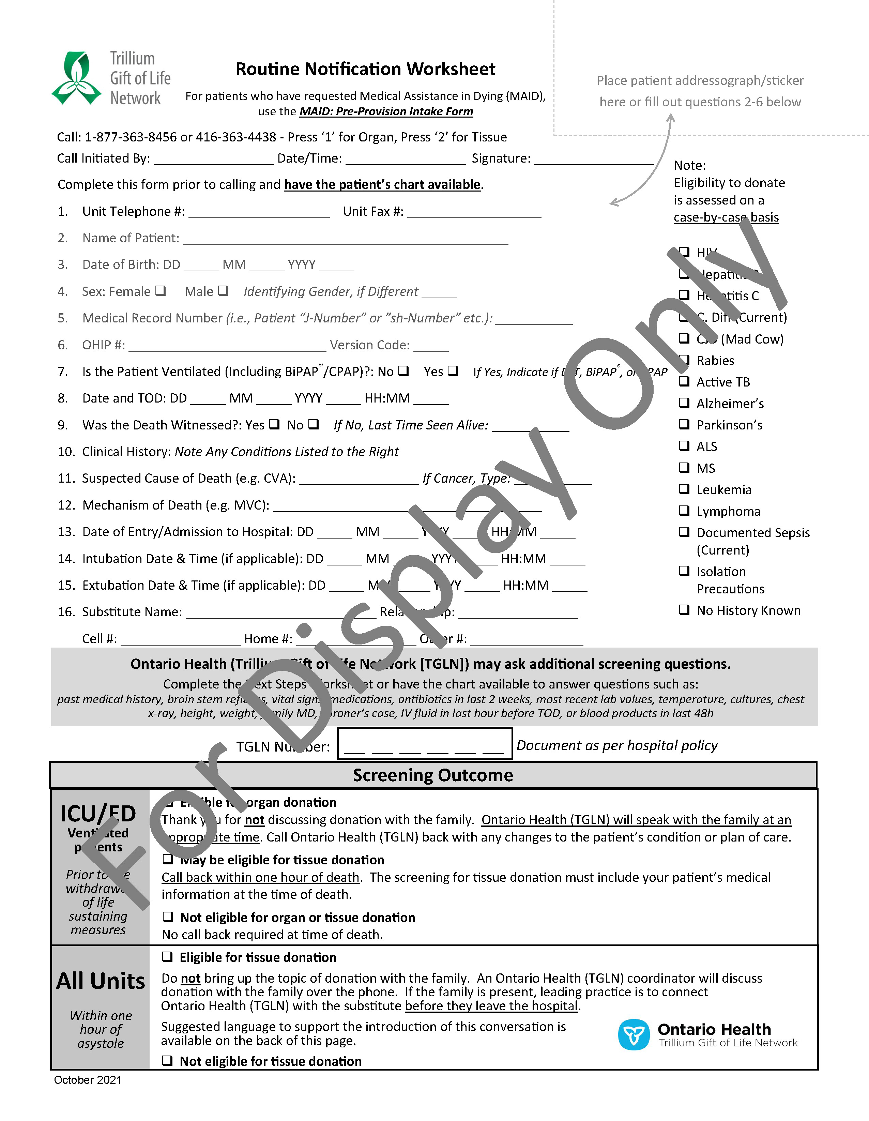**Appendix A: Routine Notification Worksheet**

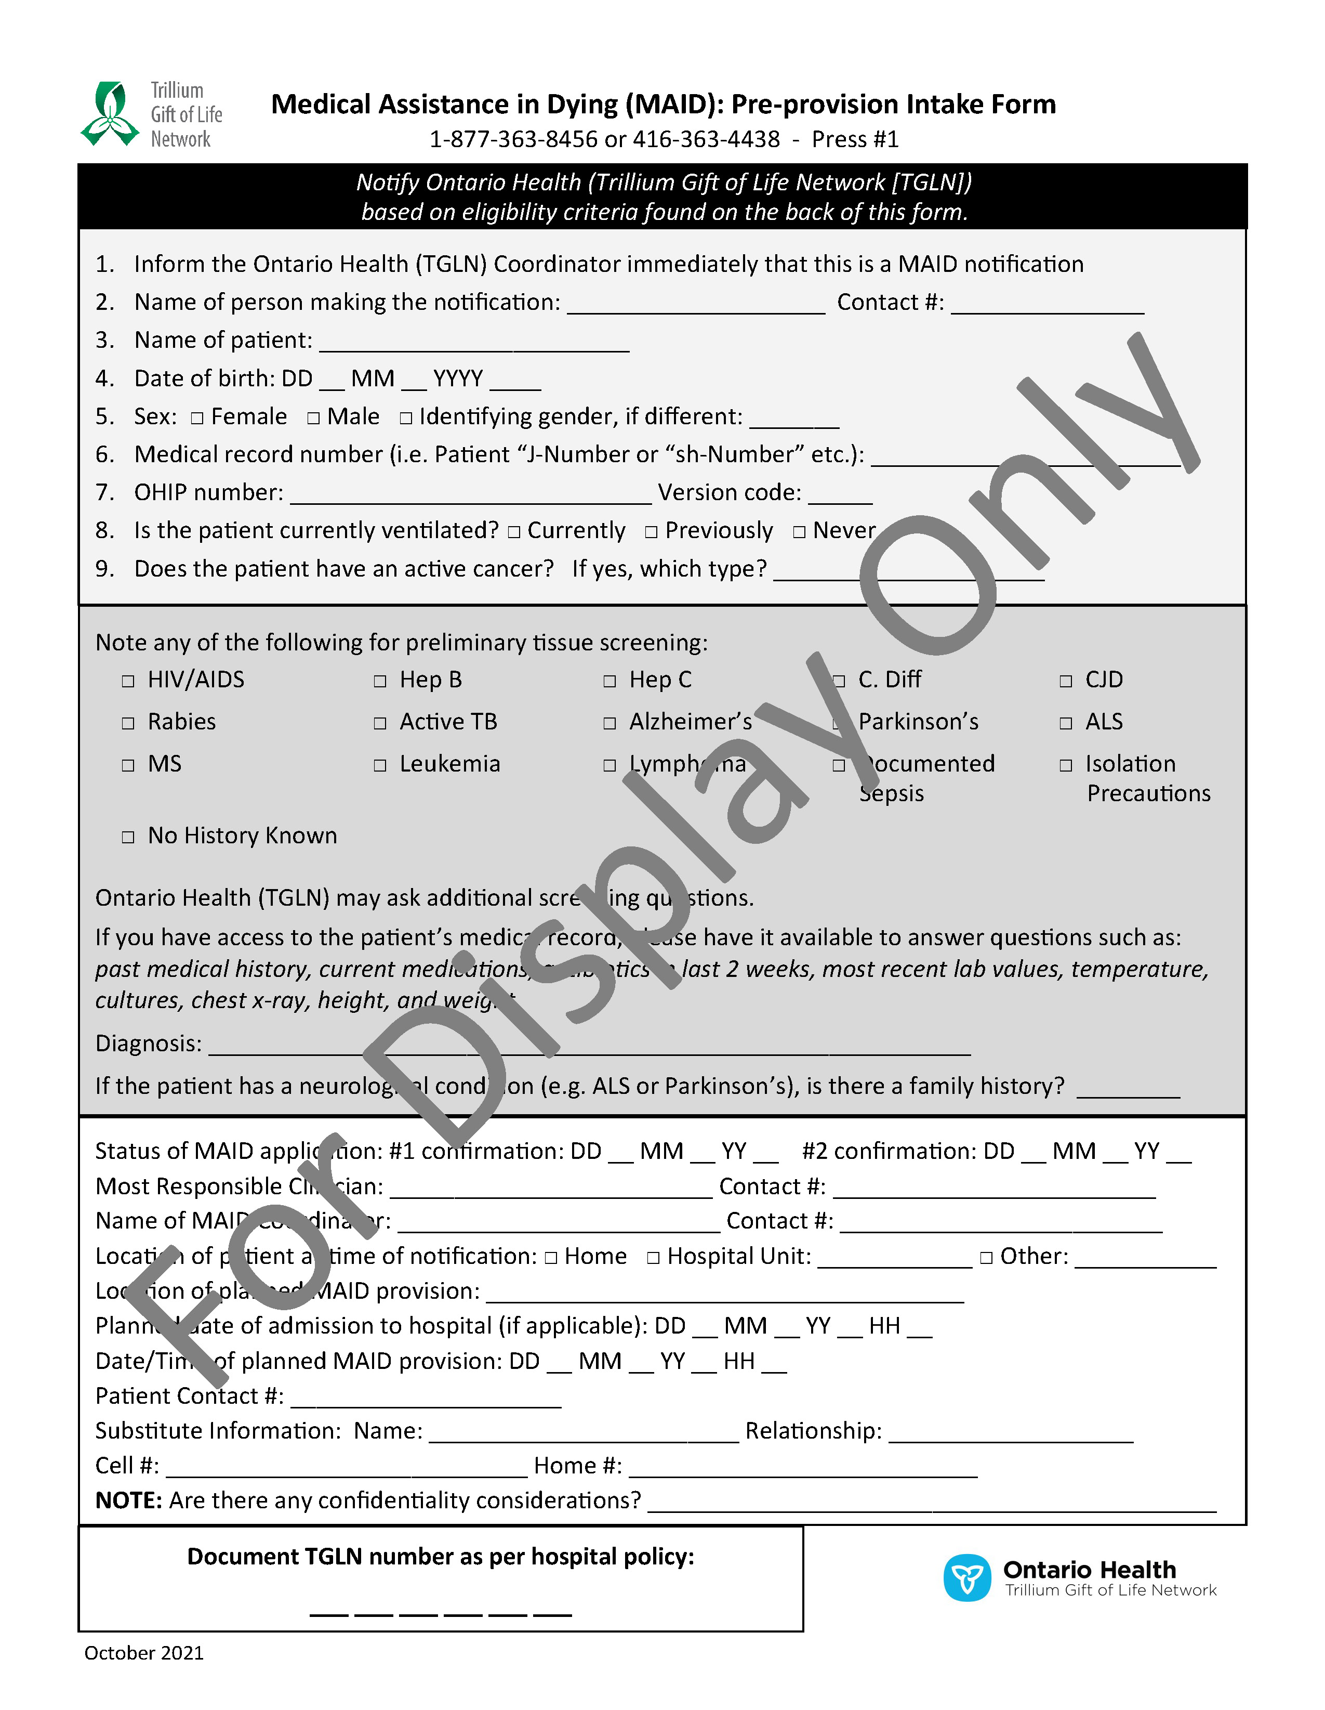**Appendix B: MAID Pre-Provision Intake Form**

**Appendix C: Ontario Health (TGLN) Guidelines for Ocular Recovery**

1. Recovery area-controlled airflow system. No direct access to the outside of the building from the room at any time during or before the recovery. All vents clean. No vented airflow direct towards the sterile field.
2. Space at room temperature – not refrigerated.
3. Room with limited access (i.e., locked door). Human traffic is restricted during recovery to only those involved in the procedure (Authorized observation or doing the recovery). Provides complete privacy from any persons not directly involved in the recovery.
4. Any windows in the room are draped so no one can see the procedure from outside the room.
5. Sink with a drain and running water or appropriate non-water based surgical hand antisepsis system.
6. Adequate lighting to perform detailed physical exam.
7. Adequate counter space to allow for sterile instrumentation (minimum space approx. 2 ft x 2 ft).
8. No other activities occurring simultaneously in the same room (i.e., autopsy).
9. Walls, floors, and work surfaces easily cleanable (i.e., not carpeted) and in a state of good repair.
10. No insects, rodents, or other pests.
11. No standing fluids or contaminated waste in the room.
12. Reasonable efforts that donor is on height adjustable surface (for staff Health and Safety – not part of EBAA standard).

**Reference:**

Eye Bank Association of America, Procedures Manual

2016 Standard C3.000 Facilities, C.100

Note: Additional supplies required for the recovery area include containers for the disposal of sharps, biohazard waste, and garbage.

Version 3_October_2019

**Records**

No records.

**References**

Canadian Council for Donation and Transplantation. (2003). *Severe brain injury to neurological determination of death: A Canadian forum: Report and recommendations. April 9-11, 2003.* Vancouver, B.C.

*Coroners Act*, R.S.A. 1990, c. 37.

Eberle, B., Dick, W., Schneider, T., Wisser, G., Doetsch, S., & Tzanova, I. (1996). Checking the carotid pulse check: Diagnostic accuracy of first responders in patients with and without a pulse. *Resuscitation*, *33*(2), 107-[116. http://dx.doi.org/10.1016/s0300-9572(96)01016-7](http://dx.doi.org/10.1016/s0300-9572(96)01016-7)

*Gift of Life Act,* R.S.O. 1990, c. H. 20.

Haas, M., Allendörfer, J., Walcher, F., Neumann-Haefelin, T., Blaivas, M., Seeger, F., . . . Breitkreutz., R. (2010). Focused examination of cerebral blood flow in peri-resuscitation: A new advanced life support compliant concept—an extension of the focused echocardiography evaluation in life support examination. *Critical Ultrasound Journal*, *2*(1), 1-[12. http://dx.doi.org/10.1007/s13089-010-0027-2](http://dx.doi.org/10.1007/s13089-010-0027-2)

*Health Care Consent Act*, R.S.O. 1996, c. 2.

Lapostolle, F., Le Toumelin, P., Agostinucci, J. M., Catineau, J., & Adnet, F. (2004). Basic cardiac life support providers checking the carotid pulse: Performance, degree of conviction, and influencing factors. *Academic Emergency Medicine*, *11*(8), 878-880. https://doi.org/10.1197/j.aem.2004.02.528

Ministry of Health and Long-Term Care. (2016). Medical Assistance in Dying. Retrieved March 1, 2018 fr[om http://health.gov.on.ca/en/pro/programs/maid/](http://health.gov.on.ca/en/pro/programs/maid/)

Ochoa, F. J., Ramalle-Gomara, E., Carpintero, J. M., Garcıa, A., & Saralegui, I. (1998). Competence of health professionals to check the carotid pulse. *Resuscitation*, *37*(3), 173-175. https://doi.org/10.1016/S0300-9572(98)00055-0

Salen, P., Melniker, L., Chooljian, C., Rose, J. S., Alteveer, J., Reed, J., & Heller, M. (2005). Does the presence or absence of sonographically identified cardiac activity predict resuscitation outcomes of cardiac arrest patients?. *The American journal of emergency medicine*, *23*(4), 459-462. https://doi.org/10.1016/j.ajem.2004.11.007

Shemie, S. D., Baker, A. J., Knoll, G., Wall, W., Rocker, G., & Howes, D. (2006). National recommendations for donation after cardiocirculatory death in Canada. *Canadian Medical Association Journal*, *175*, S1-S24. https://doi.org/10.1503/cmaj.060895

Shemie, S.D., Wilson, L.C., Hornby, L., et al. (2023). A brain-based definition of death and criteria for its determination after arrest of circulation or neurologic function in Canada: A 2023 clinical practice guideline. Can J Anesth/J Can Anesth. Advance online publication. https://doi.org/10.1007/s12630-023-02431-4

*Substitute Decisions Act*, S.O. 1992, c. 30.

Trillium Gift of Life Network. (2010). *Donation resource manual: A tool to assist hospitals with the process of organ and tissue donation.* Ontario: Author.