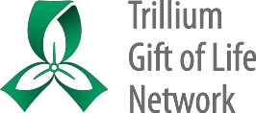

**VCA Bilateral Upper Limb Donation**

**Reference Package for Hospital Programs**

**Version date: October 13, 2021**

Contents

**Deceased Donor Criteria – Ontario VCA - Upper Limb Transplantation** 2

**Possible Bilateral Upper Limb Donor Hospitals** 3

**VCA Bilateral Upper Limb Process Flow** 4

**OTDC Checklist - VCA Bilateral Upper Limb** 5

**Approach Principles and Scripting – VCA Bilateral Upper Limb** 11

**VCA Bilateral Upper Limb Huddle Overview Document** 15

**Upper Limb Donation - Information for Families** 19

**Prostheses Photographs** 22

**Amendments to Consent Documentation - VCA Cases** 23

**Consent to Donate Organs and/or Tissues Mock-up - VCA Bilateral Upper Limb** 26

**iTransplant Authorization Page Mock-up - VCA Bilateral Upper Limb** 28

**Limb Physical Assessment Form** 29

**VCA Bilateral Upper Limb Measurement and Photography Reference** 30

**Modified Allen’s Test with Doppler VCA Bilateral Upper Limb Assessment Worksheet** 31

**FAQs for Critical Care – VCA Bilateral Upper Limb Donation and Transplantation** 32

**FAQs for Perioperative Staff – VCA Bilateral Upper Limb Donation and Transplantation** 36

**Coroner Permission Form Mock-up – VCA Bilateral Upper Limb** 40

**VCA Bilateral Upper Limb OR Pick List** 41

**Funeral Home Communication Process - VCA Bilateral Upper Limb** 42

**VCA Bilateral Upper Limb One Pager for Funeral Services** 45

**VCA Case Debrief Form** 47

**Associated CPIs and CSFs** 49

# **Deceased Donor Criteria – Ontario VCA - Upper Limb Transplantation**

**Ontario VCA - Upper Limb Transplantation**

**Deceased Donor Criteria**

VCA Working Group

Refer to document posted on ORC for most recent criteria [here](https://orc.giftoflife.on.ca/FORMS/Donor%20Exclusion%20Criteria/Ontario%20VCA%20-%20Upper%20Limb%20Transplantation%20Deceased%20Donor%20Criteria.pdf).

# **Possible Bilateral Upper Limb Donor Hospitals**

**VCA Bilateral Upper Limb Donor Case – Possible Hospitals**

The following hospitals are able to participate in NDD donation cases and may be the donor site for this case:

Bluewater Health - Sarnia

Brant Community Healthcare System - Brantford General Hospital

Brockville General Hospital - General Site

Cambridge Memorial Hospital

Chatham-Kent Health Alliance

Children’s Hospital Of Eastern Ontario

Collingwood General and Marine Hospital

Cornwall Community Hospital

Georgian Bay General Hospital

Grand River Hospital - Kitchener

Grey Bruce Health Services - Owen Sound

Guelph General Hospital

Halton Healthcare Services - Oakville

Halton Healthcare Services - Milton

Hamilton Health Science - Hamilton General

Hamilton Health Science - Juravinski

Hamilton Health Science - MUMC

Health Sciences North

Hopital Montfort

Hospital for Sick Kids

Humber River Regional Hospital

Huron Perth Health Alliance - Stratford General

Joseph Brant Hospital

Kingston General Hospital

Lakeridge - Ajax and Pickering

Lakeridge - Bowmanville

Lakeridge - Oshawa

London Health Sciences - Childrens Hospital

London Health Sciences - Victoria

London Health Sciences - University

Mackenzie Health - Cortellucci Vaughan Hosp

Mackenzie Health - Richmond Hill Hospital

Michael Garron Hospital

Muskoka Algonquin Healthcare - Huntsville

Muskoka Algonquin Healthcare - South Muskoka

Niagara Health System - Greater Niagara

Niagara Health System - St Catharines

Niagara Health System - Welland

Norfolk General Hospital

North Bay Regional Health Centre

North York General Hospital

Northumberland Hills Hospital

Oak Valley Health - Markham Stouffville Hospital

Orillia Soldiers’ Memorial Hospital

Pembroke Regional Hospital

Peterborough Regional Health Centre

Queensway Carleton Hospital

Quinte Health Care - Belleville

Ross Memorial Hospital

Royal Victoria Regional Health Centre

Sault Area Hospital

Scarborough Health Network - General

Scarborough Health Network - Birchmount

Scarborough Health Network - Centenary

Sinai Health System - Mount Sinai

Southlake Regional Health Centre

St. Joseph's Healthcare Hamilton

St. Mary’s General Hospital

St. Thomas – Elgin General Hospital

Sunnybrook Health Sciences Centre

The Ottawa Hospital - General

The Ottawa Hospital - Civic

Thunder Bay Regional Health Sciences Centre

Timmins and District Hospital

Trillium Health Partners - Mississauga

Trillium Health Partners - Credit Valley

Unity Health Toronto - St. Michael’s Hospital

Unity Health Toronto - St. Joseph's Health Centre (Toronto)

UHN - Toronto General

UHN - Toronto Western

University of Ottawa Heart Institute

William Osler - Etobicoke

William Osler - Brampton

Windsor Regional - Metropolitan

Windsor Regional - Ouellette

Woodstock General Hospital

# **VCA Bilateral Upper Limb Process Flow**

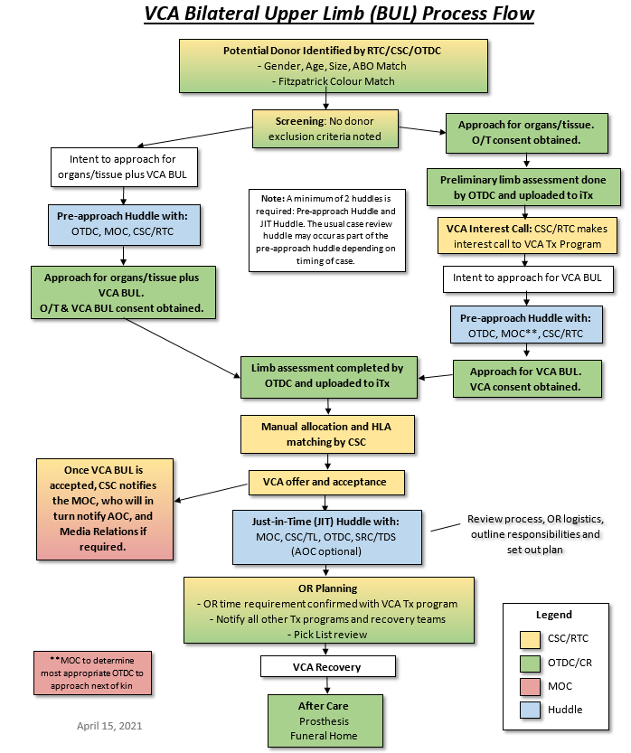

# **OTDC Checklist - VCA Bilateral Upper Limb**

**OTDC Checklist - VCA Bilateral Upper Limb**

The resource package (including VCA BUL Reference Document) for staff is located here.

**Note: This document is intended to be supplementary to usual NDD processes.**

|  |  |  |
| --- | --- | --- |
| **OTDC 1: Pre-Consent Process** | | |
| * Potential donor identified (by OTDC or PRC) as having potential to become VCA bilateral upper limb donor. * NOK may already have been approached for organ/tissue, in which case VCA bilateral upper limb would be a secondary approach. | | |
|  | **Action** | **Notes & *Reference Documents*** |
|  | Assess for absolute exclusion criteria. | See [*Ontario VCA – Upper Limb Transplantation* *Deceased Donor Criteria*](https://orc.giftoflife.on.ca/FORMS/Donor%20Exclusion%20Criteria/Ontario%20VCA%20-%20Upper%20Limb%20Transplantation%20Deceased%20Donor%20Criteria.pdf)  Donor must be male and 1, 2 or 3 on Fitzpatrick scale.  Registered Consent Exemptions (Donor Preference)  DP *exclusion for bone precludes* VCA bilateral upper limb donation. However, DP exclusion of *skin,* does notexclude VCA. |
|  | Decision regarding approach: If family has not already been approached, based on available knowledge of family situation or known patient information, decide whether to approach for organ, tissue and VCA up front, or to approach for organ and tissue alone, possibly followed by a separate approach for VCA (2 tier approach). | If a single approach for organ, tissue and VCA is preferred, a pre-approach huddle must occur first (see pre-approach huddle list in ***VCA BUL Huddle Overview Document***, page 16 of the VCA BUL Reference Document).  For 2 tier approaches, proceed with regular organ and tissue (no VCA) donation discussion and consent with family.  See ***Approach Principles and Scripting – VCA Bilateral Upper Limb***, page 12 of the VCA BUL Reference Document, for tips and suggested language. |
|  | Complete donor assessment required for interest call for VCA as per CPI 307:   1. Donor chart including Medical Social History, ABO, and physical assessment* 2. Measurement of donor limb from the body elbow tip to the bony prominence of the wrist (for potential limb donors) 3. Skin tone as measured by Fitzpatrick scale.   *Limb physical assessment required for interest call.  Upload Consent, Medical Social History, Limb Physical Assessment forms to iTransplant. | At this time, complete the [***Limb Physical Assessment Form*** ***(CSF-9-18)***](https://orc.giftoflife.on.ca/FORMS/Donor%20Assessment,%20Screening,%20Suitability%20and%20Testing/CSF-9-18.pdf) up to, and including, capillary refill assessment.  *The limb assessment portion of the physical assessment can be completed before the COVID swab result comes back if COVID Screening is considered ‘low risk’ for COVID-19.  Photographs and other tests referenced on the form should be done post-consent. |
|  | Advise HCP staff that consented NDD donors in province currently have a limb assessment done, with the rationale that there is a recipient listed for bilateral upper arm donation. | Scripting to explain limb assessment activities to staff:  *“At this time we are completing an initial assessment on all NDD donors to determine if there is a potential match for our listed VCA recipient. If interest and a preliminary match is confirmed, we will approach the family for consent.”* |
|  | Contact CSC to confirm inclusion criteria and absolute exclusion criteria, and ensure all information for interest call is obtained. | CSC will confirm they have needed medical information and testing results for the interest call, or request any outstanding information. |
|  | When *interest* is confirmed, caution staff re: privacy for this case. |  |
|  | Pre-approach huddle. | Discuss donor criteria, family dynamics, and approach planning. Confirm access to VCA bilateral upper limb approach scripting. (See the “VCA BUL Huddle Overview Document”, page 15 of the VCA BUL Reference Document).  Note: the Case Huddle may also be completed at this time, depending on case timing. |
|  | Approach Family for VCA. | If the subsequent (2nd tier) approach for VCA is made by phone, the consent form needs to be updated.  Consider if the family will be returning to hospital, if so the original consent form can be altered and uploaded.  If the family will not returning, ensure a witness confirms VCA consent and that the consent form is updated or that a new form is used as required.  See ***Amendments to Consent Documentation – Vascularized Composite Allotransplantation (VCA) Cases,*** page 24 of the VCA BUL Reference Document.  Other references:   * ***Consent to Donate Organs and/or Tissues Mock-up – VCA Bilateral Upper Limb,*** page 27 of the VCA BUL Reference Document. * ***iTransplant Authorization Page Mock-up – VCA Bilateral Upper Limb,*** page 29 of the VCA BUL Reference Document. |
| **Family Considerations (both pre/post-consent)** | | |
|  | **Action** | **Notes & Reference Documents** |
|  | Provide the VCA bilateral upper limb donation donor family handout (“Upper Limb Donation – Information for Families”).  Note: if consent if by phone, inquire as to whether they would like the family handout sent by email. | Fill in applicable OTDC contact info on family handout (last page) before providing to family.  ***Upper Limb Donation – Information for Families,*** page 20 of the VCA BUL Reference Document and available as a single document here.  VCA bilateral upper limb donation and transplant is not a guarantee: communicate that organ donation will be prioritized in the event of donor instability. Ask families if they would like limbs returned to funeral home, in the event that limbs cannot be transplanted, late in the process. |
|  | Request information re any functional limitations of limbs, and hand dominance. | Add details to the ***Limb Physical Assessment Form (CSF-9-18)*** |
|  | Discuss expectations for news media post-donation about the transplant and recipient. Point out the TGLN Communications contact information in the family handout in case of situation in future where transplant and recipient media coverage occur. | An initial media release by the transplant program is expected approx. 2 weeks after the transplant. Timing of any future media releases regarding the success of the transplant may be unknown (days to months, if ever), and family may see the recipient in such communications, including their loved ones’ limbs. Further information is available in the family handout. |
|  | Ensure ongoing confirmation of TGLN contact information for families throughout donation work-up. | Donor family may have more questions or need more support – ensure they always have a point of contact. |
|  | Determine funeral home and plans for funeral service.  Would the family like prosthetic limbs for viewings? | Prostheses have been constructed in advance and will be sent to the funeral home, if the family choses prostheses. Note that family may want to revisit this decision if the funeral home or plans haven’t been determined yet.  Photos of the prostheses are available if the family wishes to see them (See page 23 of VCA BUL Reference Document, but note that the prostheses are lighter in colour than they appear in these photographs). |
|  | Discuss the plan and return of rings and bracelets on hands/arms, as well as necklaces and other jewelry. | Preferable to be removed prior to OR. Necklaces removed in the OR should be fastened to ankle. Make alternate arrangements to secure items if family wishes items to go with donor to OR. |

|  |  |
| --- | --- |
| **OTDC Roles** (suggested, but TBD between OTDCs) | |
| **OTDC 1**: ICU for donor management and family liaison | **OTDC 2:** OR planning, including huddles and liaising with the funeral service provider, and the prostheses delivery process. |

|  |  |  |
| --- | --- | --- |
| **OTDC 1: Donor Assessment, Management, & Family Liaison** | | |
|  | **Action** | **Notes & Reference Documents** |
|  | Coordinate with OTDC 2 to attend/organize/lead VCA bilateral upper limb-specific huddles as required.  Determine which OTDC will document huddles and communications as appropriate in iTransplant. | * Case Huddle * High-Level Hospital Huddle * OR Planning Huddle * OR Pre-Op Huddle   Note: [***VCA BUL OR Pick List***](https://orc.giftoflife.on.ca/SOP/PDF_CPI/CPI-9-307.pdf) (Appendix 2) shows quantities ‘per limb’. |
|  | Provide bedside staff with FAQs for Critical Care document. | See ***FAQs for Critical Care – VCA Bilateral Upper Limb Donation and Transplantation,*** page 33 of the VCA BUL Reference Document and available as a single document here.  FAQs for Critical Care includes details of modified Allen’s test, and requested x-rays, as well as instructions on vascular access. |
|  | Provide the MD with the modified Allan’s test worksheet for completion. Note for MD that additional Doppler testing may be requested later in the process.  Physician to complete Modified Allen’s Test with Doppler and order X-rays. | [***Modified Allen’s Test with Doppler VCA Bilateral Upper Limb Assessment Worksheet***](https://orc.giftoflife.on.ca/FORMS/Donor%20Assessment,%20Screening,%20Suitability%20and%20Testing/CSF-9-246.pdf) [CSF-9-246] |
|  | Photograph limbs. | See ***VCA Bilateral Upper Limb Measurement and Photography Reference*** page 31 of the VCA BUL Reference Document |
|  | Complete limb-specific testing not previously completed:   * Modified Allen’s Test with Doppler * X-rays * Photos of limbs   Upload new Limb Physical Assessment Form to iTransplant. | Complete new copy of ***Limb Physical Assessment Form (CSF-9-18)***, repeating (thus confirming) the initial assessments as well as completing the form for the 3 new elements. Sign and date the new form and upload to iTransplant. |
| **After Offer is Accepted for VCA** | | |
|  | **Action** | **Notes & Reference Documents** |
|  | JIT Huddle | ***JIT Huddle:*** Appendix 1 of [CPI-9-307](https://orc.giftoflife.on.ca/SOP/PDF_CPI/CPI-9-307.pdf)  Plan for case coverage/ 2nd OTDC on-site if not previously arranged |
|  | Consider connecting the DSP and MRP. | A limb donor is likely going to be a multi-organ donor. Connecting the DPS and MRP early during COVID may be useful, as the allocation process for the other organs, for example the heart, may lengthen the process. |
|  | Confirm need for STAT cross-match with CSC. | Confirm number of ACDs to be sent to London HLA |
|  | After VCA *acceptance* assess need for peripheral/arterial lines to be moved, and central vascular access established.  Discuss/request from MRP | This is noted on the ***FAQs for Critical Care*** document.  Ensure that existing upper limb lines are removed after new access has been established. |
|  | Have patient ID band moved to ankle. |  |
|  | Obtain coroner permission (if applicable). | Coroner may need to come on-site to view body, as upper limbs will not be available post-donation. When speaking with Coroner, refer to email sent to the Coroner’s office on June 15, 2021. MOC is able to access communication if requested by Coroner.  See ***Coroner Permission Form Mock-up,*** page 41 of the VCA BUL Reference Document |
|  | Continue with usual donor work-up and management through the solid organ allocation process. |  |

|  |  |  |
| --- | --- | --- |
| **OTDC 2: Hospital/OR Planning** | | |
|  | **Action** | **Notes & Reference Documents** |
|  | Coordinate with OTDC 1 attend/organize/lead VCA bilateral upper limbs specific huddles as required and document huddles and communications as appropriate in iTransplant. | * High-Level Hospital Huddle * OR Planning Huddle * OR Pre-Op Huddle   Note: ***VCA BUL OR Pick List*** shows quantities ‘per arm’.  OTDCs to determine who will upload which huddle information to iTransplant |
|  | Provide bedside staff with FAQs for Critical Care document. | See ***FAQs for Perioperative Staff – VCA Bilateral Upper Limb Donation and Transplantation,*** page 37 of the VCA BUL Ref Doc and available as a single document here. |
|  | Liaise with and support OTDC 1 as needed. |  |
|  | Contact the funeral home as soon as identified. Document the points of contact and communication as appropriate in iTransplant. | The ***Funeral Home Communication Process – VCA Bilateral Upper Limb*** document, page 43 of the VCA BUL Ref Doc outlines specific OTDC actions required including: initial call, email/fax of documents, ensuring prostheses are placed in body bag, and confirming receipt of prostheses with funeral home. Send **VCA Bilateral Upper Limb One Pager for Funeral Services** to funeral service provider – see page 45 of VCA BUL Ref Doc. |
|  | Assume responsibility for the prostheses/package from transplant team.  Remove the prostheses package from the box and add a patient addressograph label to the third outer layer. | The outer box can be discarded. |
|  | At end of recovery with care of body, place prostheses in body bag. | If prostheses will be used, OTDC #2 will stay on site to ensure prosthesis package is inserted into the body bag. |

|  |  |  |
| --- | --- | --- |
| **Organ Recovery** | | |
|  | **Action** | **Notes & Reference Documents** |
|  | At least one OTDC should remain on site throughout OR until completion | Further transplant teams arriving after the London team will not be in initial huddle, and OTDC can present documents, answer questions, etc. The on-site OTDC can assist with any concerns that arise and will be responsible for the prostheses, as noted above. |
|  | As per usual, viewing of the body post organ recovery is highly discouraged. Do not offer to family. If requested, process and location will need to be discussed with hospital staff. | If the family wishes to view the donor after recovery, a second OTDC should remain on site in order to facilitate this while the other OTDC does the post-op debrief (see below). |

|  |  |  |
| --- | --- | --- |
| **Hospital Follow-up** | | |
|  | **Action** | **Notes & Reference Documents** |
|  | At least one OTDC should remain on site throughout OR until completion | An informal debrief should be done with staff in OR and ICU after OR |
|  | Organize a formal debrief 1-3 weeks following the recovery | Consult hospital to determine who they wish involved.  Ensure Director of Hospitals or Delegate is available to facilitate/attend debrief (note some hospitals appoint a facilitator at hospital)  ***VCA Case Debrief Form***, page 48 of the VCA BUL Ref Doc. |

# **Approach Principles and Scripting – VCA Bilateral Upper Limb**

**Approach Principles and Scripting**

**VCA Bilateral Upper Limb (2021)**

**Underlying Principles – Optimizing the Approach**

* Discussion of VCA consent will only be introduced after solid organ consent is provided by family
* OTDCs will not raise VCA if any of the ABSOLUTE exclusion are present and will screen for inclusion criteria prior to discussion
* If possible, an interest call will be placed prior to approach
* Preference to discuss in-person, so OTDCs/CRs may or may not have the information to place an interest call at time of in-person family discussion
* Ability to have discussion in-person, family situation, including resilience/support to be considered
* OTDC/CR will review family situation and inclusion criteria via pre-approach huddle prior to approaching for VCA

**Preamble for re-approach**

* “I just wanted to thank you again for consenting to donation. I know there are some families out there who will be getting a phone call that they always wanted to…”
* “As we have started our testing, we have learned that your loved one has the opportunity to help another person. This is very special and quite unique and I’d like to tell you about this”.
* “I would like to share with you some new information that we didn’t know about when we first spoke” (following an interest call in a staggered approach)
* “There is another way s/he can help above what we’ve discussed”

**Introduction of VCA**

* “Through advancing medical technology and science s/he has the opportunity to help…”
* “Your loved one would be an eligible donor for a double arm donation for transplant to another person (use simple language)

**Tips for the Donation Discussion**

**Identify the uniqueness of the opportunity**

* “S/he would be the first person in Canada able to help someone with a double limb transplant”
* “This type of procedure has only been done in Canada once before, with a single-arm transplant. We needed to approach the right family to make that happen, and it took a special family for us to speak to, to offer that opportunity. This time around, to be the first for double-arm transplant, we feel that you might be that special family”

**Assure family VCA-BUL donation is not meant to impact organ and tissue donation process negatively**

* “This does not impact the gifts that you have already consented to” (Lets the family know that this is in addition to what has already been consented)
* “The procedure would add a couple hours to the OR to arrange for the recovery, and some things might need to be considered like a larger operating room, but it shouldn’t impact the timelines we are working with. Allocation and testing for the organs we are trying to place will still continue as normal while we arrange the details of the arm donation.”

**Share the meaning of VCA-BUL donation through practical meaningful use (rather than vision of arm)**

* “This would go to a person who has had a devastating injury and lost their hand and arms at the elbow.”
* “The recipient could hold the hand of someone they love, or possibly drive again someday”
* “We have a specific recipient who s/he might help” (This helped the family in that it was something solid, there is actually a real person who needs a limb, hand, etc.)
* “People can do things again that you need two hands to do”
* “Through arm donation, someone may be able once again to:
  + hold a child
  + dial a phone
  + drive a car
  + open a door”

**Research**

* “This is not research, it is a real technique for real people”

**Leverage research and teaching consent with cutting edge medicine**

* “I noticed your loved one agreed to donation for research and teaching as well. Although this procedure itself isn’t research, it is new and innovative enough that it would honour their wishes to be at the forefront of ground-breaking medical procedures”

**Provide some assurance of success**

* “There are people who have been working on this for a long time who have every reason to believe it will be successful”
* “This is the first (double arm) [or second (arm/limb)] of its kind in Canada, but there have been successes around the world you may have heard of in the news, like face transplants and other limb transplants”
* “We wouldn’t be speaking to you if there wasn’t a good chance there was a match”

**Media (must be shared with family)**

* “There would be potential for media coverage. We (TGLN) would not be able to give you information on the recipient, but you might find out through the media” (Note: TGLN is committed to giving a donor family a ‘heads up’ if we know about media coverage about the recipient.)
* “I do need to share with you that since this is the first time a double upper limb transplant is being done in Canada, there may be a lot of media interest”
* “Because this procedure is a first, there may be some significant media interest. The transplanting hospital might be covered in the media spotlight. I just wanted to make you aware of this so that you didn’t hear about it for the first time when if you saw it on the news”

**Recipient**

The family may have seen media coverage of a specific person seeking a transplant here in Ontario (or they may google this after Approach). If asked whether this person would be the recipient of their loved one’s limbs…

* “I can appreciate your curiosity, I’m not permitted to share the name of the recipient, but that media story that you referred to does provide a good example of how arm donation could make a different to the recipient.”

**If unsure of answers to family questions, show commitment to learning with family along the way**

* “I may not have all the answers for you, but I know where to go to get some of these questions answered”
* “Because this procedure is newer, I may not have all the answers as well, but I promise that I will seek out the information that you’re looking for, or find the answers from the right people who can answer that”
* “You know what, it *would* be helpful to know what the prostheses would look like – why don’t I connect with our team to get a photo of the prostheses.”

**Questions about prostheses and/or open-casket funeral**

* “There are many ways we can work with the funeral home to ensure that the arm donation isn’t as obvious, if that is your wish. With the prostheses, we may be able to
  + dress your loved one in a long-sleeve shirt, or
  + cover up the arms with flowers or photos, or
  + some caskets offer a partial view …”
* “with an open casket, many families and guests may be more focused on recalling and seeing the face of the person they love, then the fact that their arms are prostheses”
* **(***MUST be done with the RIGHT family***)** “your loved one may have even preferred NOT to have the prostheses – they may have wanted to celebrate the fact that they were the first double arm donor in Canada as a badge of honour, and wanted everyone to know”

**Avoid the following**

* Conducting conversation in ‘ominous’ tone, or demonstrated hesitance. Examples of language not to use:
  + “I know I mentioned I would call back if something came up”
  + “As you know, we promised to call you back if things arose during our investigations”
* Focusing too much on process
  + With the dynamic nature of VCA, we may not have all the information with us. While Education and the VCA working group will endeavor to provide as much information as possible to coordinators prior to launch, a reliance on process and details may cause perceived lack of confidence due to unfamiliarity with topic.
  + Remember conversations are more successful when meaning is put before process.
* Focus on the recipient vs donor,
  + This sentence emphasis’s recipient’s needs, not donor: “Because of the nature of the recipient, your loved one is almost an exact match for this person.”
* Guarantee donation/match
  + “Based on what my team has told me, your loved one may be a match for a potential recipient who needs a double arm transplant.”

Feb 10, 2021

# **VCA Bilateral Upper Limb Huddle Overview Document**

**VCA Bilateral Upper Limb Donation**

**Huddle Overview Document**

*A minimum of two TGLN huddles will be completed on the VCA case. The usual Case Huddle may occur as part of the Pre-approach Huddle, or on its own (3 huddles).*

A brief overview of Both TGLN huddles and Hospitals Huddles are in the table below.

|  |  |  |
| --- | --- | --- |
| **Huddle Type** | **Trigger for Huddle** | **Notes** |
| **TGLN Huddles** | | |
| Pre-approach Huddle | Intent to approach for VCA | Lead by MOC: Guidelines below |
| Case Huddle | Med-Soc/consent completed with donor information needed for allocation uploaded | Lead by CSC: Usual huddle checklist |
| JIT VCA Huddle | VCA offer accepted | Lead by CSC: Appendix 1 of [CPI-9-307](https://orc.giftoflife.on.ca/SOP/PDF_CPI/CPI-9-307.pdf) and also included below |
| **Hospital Huddles** | | |
| High Level Hospital Huddle | Consent obtained and interest confirmed | Lead by Hospital Director or delegate: Guideline below |
| OR Planning Huddle with perioperative hospital staff/OTDC | Acceptance of upper limbs | Lead by OTDC: Guideline below |
| OR Pre-Op Huddle | Arrival of BUL transplant team | Lead by OTDC: Guideline below |

**TGLN HUDDLES**

**Pre-approach Huddle – Intent to approach for VCA**

MOC to review the following:

1. Status of case
   1. Confirm program is open for offers and CSC/RTC has reviewed current medical information for absolute exclusions/missing history/red flags, **or**
   2. Interest has been confirmed
2. Assess for suspicious death/coroner’s case where prudent to contact coroner prior to approach
3. Experience of the staff; are they the right person to approach?
   1. Assess experience level if casual staff (consider prior experience as OTDC)
      1. Consider assigning a more senior coordinator
   2. Ensure access to *VCA BUL Reference Document* with approach scripting, FAQs, etc. as well as individual documents for distribution to family, hospital staff, etc. The resource package for staff is located here.
4. Family situation – identification of appropriate substitute, in-person or phone approach, details of the registered consent (if applicable, any exceptions (confirm absence of exception to bone))
5. Confidentiality – Discuss ‘buzz’ at hospital regarding case and assess timing related to contacting Operational Lead or delegate regarding privacy considerations related to patient chart.

**Case Huddle (Following consent and Med-Soc history completion and review of case by CSC)**

MOC/CSC/OTDC case huddle (lead by CSC) – use the usual huddle checklist

**JIT VCA Huddle following Acceptance of VCA**

TGLN VCA Just in Time Huddle Checklist (CPI 9-307)

The CSC is responsible for arranging the ‘Just in Time’ VCA huddle which should include the CSC, the OTDC, and the MOC.

TGLN #: __________________ Date: _______________________ Time: ­_________________­___

CSC: _____________________ MOC: _______________________ OTDC: ____________________

**Completed** **Requires**

**Follow-Up**

* Discuss approach ⬜ ⬜
* Family situation/special considerations ⬜ ⬜
* Request VIP status on hospital donor chart, if appropriate ⬜ ⬜
* Coroner involvement? ⬜ ⬜
* Is transfer required (Family arrangements, etc.)? ⬜ ⬜
* Donor management (moving arterial line, central line, choice of BP medication, etc.)? ⬜ ⬜
* Plan for 2nd OTDC? ⬜ ⬜
* Plan for OR education/support ⬜ ⬜
* Planned OR date/time? ⬜ ⬜
* SRC considerations? ⬜ ⬜
* Other OR considerations? (e.g. book largest room) ⬜ ⬜
* OTDC to review Pick List with OR for any missing items ⬜ ⬜
* CSC to notify other accepting/recovery programs of VCA acceptance ⬜ ⬜
* Prosthesis required? Notify transplant program. ⬜ ⬜
* Other considerations? ⬜ ⬜

**Hospital Huddles**

**High Level Hospital Huddle**

**Trigger:** Should occur as soon as possible after consent and interest have been confirmed, with consideration of business hours.

**Purpose:** To alert key hospital stakeholders of the impending VCA bilateral upper limb donation, and address high-level considerations.

TGLN Director affiliated with hospital, or delegate, organizes by contacting Operational Lead, or his/her delegate, and suggesting potential attendees from hospital. This may be by email or phone.

**Attendees:**

* TGLN: Director, MOC, involved OTDCs, HD (if HD hospital)
* Hospital: Donation Operational Lead or delegate, ICU manager, OR manager or delegate, Privacy, MRP optional, HDP (optional),

**Items to Review:**

* Eligibility of NDD donor for VCA bilateral upper limbs +/- organ/tissue donor in the hospital
* Introduction of key TGLN leads on this case, and their contact information
* Discuss high-level overview about VCA bilateral upper limb donation and resources available (One pager previously provided at listing, FAQs for Critical Care/Perioperative Staff)
* Discuss potential privacy considerations and actions for flagging chart (e.g. VIP status or similar)
* Potential timeline to OR
* Communication and updates; consider an email chain of the key staff involved
* Confirm next steps and responsibilities

**OR Planning Huddle with Perioperative Staff/OTDC**

**Trigger time:** Following acceptance of upper limbs – typically during business hours

**Purpose:** To involve the key OR leadership to plan and prepare for the donor OR.

**Attendees:**

* TGLN: OTDCs, SRC (if identified)
* Hospital: OR manager, OR educator, OR charge nurse, other OR senior management as identified by hospital, Operational Lead (optional), anesthesia

**Items to Communicate:**

* Overview of VCA bilateral upper limb donation case and donor, reminder about privacy
* OR timing (schedule, and intra-op timing)
* Review Pick List
* OR logistics and set-up (staffing, OR room size, OR set-up)
* Any coroner or family special considerations
* Need for post-donation debriefing with all OR staff involved – an immediate post-op informal debrief, and a planned formal debrief (1-2 weeks after)
* Explain handling of prostheses
* Contact info for OTDCs as necessary
* Time for questions and discussion

**OR Pre-Op Huddle**

**Trigger time:** To occur very shortly before the donor scheduled OR, after arrival of the VCA recovery team.

**Purpose:** To review donor forms, to have the VCA bilateral upper limb recovery team meet with intra-op team.

**Attendees:**

* TGLN: OTDCs, SRC
* Hospital: OR intra-op staff, OR charge nurse, possibly OR manager or educator, anesthesia staff
* VCA Transplant team

**Items to Review:**

* VCA Transplant team to communicate needs and planning for OR with intra-op staff
* Review intra-op recovery timing, arrival of other teams, etc.
* Review of Pick List, equipment, and set-up
* Review usual donor forms and organs being recovered
* Address any family or coroner special considerations
* Review post-OR processes: any tissue recovery, prostheses to be placed in body bag
* Confirm moment of silence to be held prior to beginning of OR
* Plan for informal post-recovery debrief
* Time for questions and discussion

# **Upper Limb Donation - Information for Families**

This is an available as an individual document here.

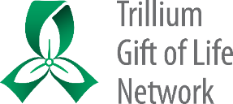

**Upper Limb Donation: Information for Families**

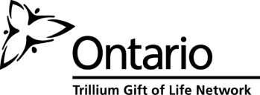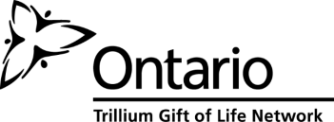

**What is upper limb donation and transplantation?**

Transplant medicine has evolved and we are now able to offer upper limb transplant to restore ability and independence in ways that artificial limbs or hands cannot. This type of transplant involves attaching an arm and hand from a deceased donor to a recipient in need. Muscle, bone, nerves and skin of the arm and hand are connected to the recipient to provide a functioning limb.

**How long has it been since the first upper limb transplant? How many have been done? Has it been done in Canada?**

The very first upper limb transplant was performed in [France](http://www.reuters.com/places/france) in 1998, and since then, internationally there have been 45 patients who received upper arm or hand transplants (22 single arms or hands and 23 cases where the recipient received two arms or hands simultaneously). The first upper limb transplant in Canada occurred in 2016 in Ontario.

**Who can be helped by upper limb donation?**

Donation helps children or adults who have no upper limbs due to congenital birth conditions, injuries, accidents, or infection. Donated limbs provide the potential for movement and sensation that would otherwise be impossible with an artificial limb. Many recipients have been motivated to receive a transplant in order to hold loved ones in their arms once again. Donation is a generous and selfless act that benefits others. It not only benefits the people who receive a donation, but also those who love them.

Families who have donated organs and tissues after death have said that when grieving the death of someone they love, donation has provided some measure of comfort in knowing that their gift has given hope, restored health and lessened the suffering of others.

**How is upper limb transplantation done?**

If it is determined that your loved one may have the opportunity to help someone through the gift of upper limb donation, the TGLN (Trillium Gift of Life Network) coordinator will review any needed information with you. Once consent is confirmed, testing is completed to confirm a match with the potential recipient. Blood type, age, gender, size and skin tone are considered in determining a match, as well as tissue matching to increase the success of the transplantation and reduce the risk of rejection. Testing to ensure the best possibility of a successful transplant will include x-rays and assessment of circulation to the limb.

To protect the blood vessels in preparation for donation, any intravenous lines will be moved from the upper limbs to other locations.

Once testing is completed, the hospital and transplant teams work together to determine a time for the recovery surgery to occur. Specially-trained surgeons remove the forearm and hand to prepare them for transplantation. Other organs that are consented for donation are recovered during the time in the operating room. Final determination of suitability and matching is made during recovery surgery, when the surgeons have the best opportunity to determine if the donated limb will be able to be transplanted.

**Other information for families**

**Timing**

The organ recovery process in the operating room takes approximately 4-6 hours. If limbs are being recovered for a transplant, an additional 2 hours will be required in the operating room. Family members will be updated throughout the process by the TGLN coordinator and healthcare team.

**Impact on funeral arrangements**

Release of the body to the funeral home can occur shortly after the recovery surgery (if the coroner has not requested an autopsy) and then the timing of the funeral ceremony can be arranged. Families will be advised by the TGLN coordinator if a delay is expected or occurs. Donation may influence the clothing used for burial but does not prevent cremation or an open casket ceremony. Some families who have donated limbs choose to accept the offer of artificial hands or prostheses. This choice is an individual family decision and it may depend upon the type of funeral service that is being planned.

**Confidentiality**

TGLN will maintain the donor and donor family’s anonymity. In Ontario, the confidentiality of donors and recipients is protected by law. TGLN does not provide any information regarding the identity of the donor or their family, and will not be able to confirm the identity of the recipient because of the laws regarding confidentiality of donation and transplantation. However, as stories of limb transplant often draw media attention, there is a real possibility of a donor family learning the identity of a recipient via the media or social media. After the first single hand transplant, there were two media announcements. First, in the few weeks after the donation and transplantation regarding the successful transplantation, then after approximately a year. Past coverage of limb recipients have shown the activities the person is able to once again do with their new arms and hands, and you may see similar images with the limbs that you and your loved ones have donated. If you require the support of TGLN media relations, please call Karyn Hyjek at 416-216-5931during regular business hours.

**Questions**

You may have other questions after having read this brochure, or during the donation process. A TGLN coordinator will be involved in every step of the way to provide you with up-to-date information and will be available to answer any questions you may have.

Thank you for taking the time to consider the gift of upper limb donation for transplantation.

TGLN Organ and Tissue Donation Coordinator #1

Name: ____________________________________

Mobile: _____________________________________

TGLN Organ and Tissue Donation Coordinator #2

Name: ____________________________________

Mobile: _____________________________________

# **Prostheses Photographs**

Do not share these images except as outlined within approved VCA process documents.

Note that the skin tone is lighter than it appears in these photographs (due to the white background).

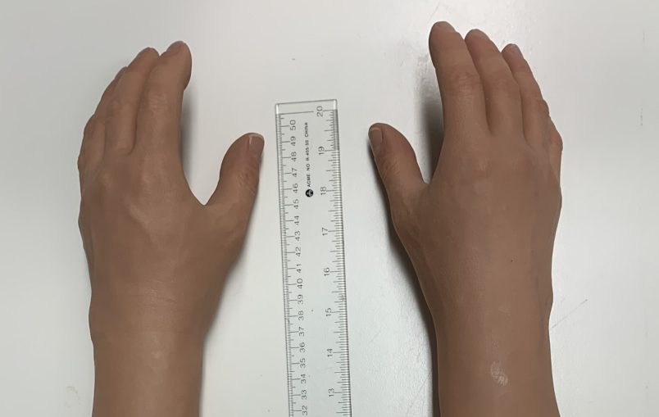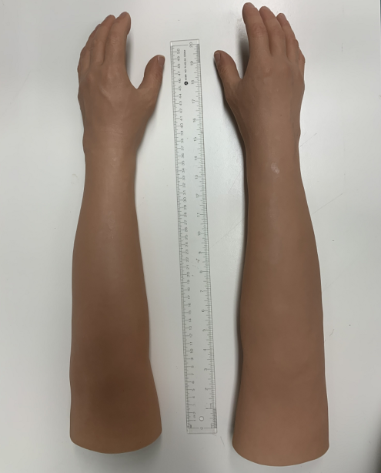

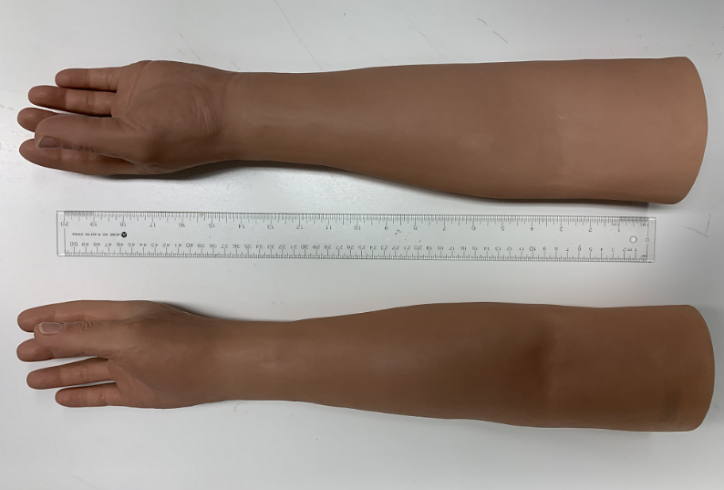

# **Amendments to Consent Documentation - VCA Cases**

**Amendments to Consent Documentation**

**Vascularized Composite Allotransplantation (VCA) Cases**

**Principles:**

* All oral (telephone) consents must have a witness
* Witnesses must sign a consent form (electronic or paper)
* All consent forms must be uploaded to iTransplant
* A paper copy of all relevant consent forms must be in the chart at the hospital prior to the OR recovery (fax to ICU if electronic copy, staple copies together as needed)

|  |  |  |
| --- | --- | --- |
|  | **Single Approach (Organ, Tissue and VCA all at once)** | |
| A | In Person | * Consent as per usual practice, one form, no witness required |
| B | Telephone (as per *COVID practice update instructions*) | 1. OTDC consents by phone, informs patient substitute that a colleague will call to confirm and witness consent. 2. OTDC completes consent form, including section C, dates and signs consent (fillable consent form on the ORC or paper form). 3. OTDC saves/emails/scans consent to witness. 4. Witness contacts patient substitute to confirm consent. 5. Witness completes section D of form and uploads form to iTransplant. |
|  | | |
|  | **Two Approaches (Organ and Tissue initially, then VCA separately)** | |
| C | Both consents in person | 1. First consent as per usual in person practice, one form, no witness required. 2. For VCA consent, hard copy of first consent from hospital chart is amended for VCA by hand by OTDC, dated and initialed by patient substitute and OTDC. No witness required. 3. OTDC uploads amended form to iTransplant. |
| D | Both consents by telephone | 1. First consent by telephone as per *COVID practice update instructions* (see B above), including witnessing. 2. For VCA consent, OTDC again obtains consent by phone and informs patient substitute that a colleague will shortly call again to confirm and witness VCA consent. 3. OTDC creates a new consent form for *all originally consented organs/tissue plus VCA* (fillable consent form on the ORC or paper form), including completing section C. 4. OTDC saves/emails/scans consent to witness. 5. Witness contacts patient substitute again and confirms consent for everything (organ/tissue previously consented and VCA). 6. Witness completes section D of form and uploads form the iTransplant. |
| E | Organ/Tissue consent in person, VCA by telephone | 1. First consent as per usual in person practice, one form, no witness required. 2. For VCA consent, OTDC obtains consent by phone and informs patient substitute that a colleague will shortly call again to confirm and witness VCA consent.   **If the OTDC and witness are both at the hospital**:   1. The hard copy of first consent from hospital chart is amended for VCA by hand by OTDC, dated and initialed by the OTDC. 2. Witness contacts patient substitute and confirms consent for everything (organ/tissue previously consented and VCA). 3. Witness completes section D of form and uploads form the iTransplant.   **If either the OTDC or the witness is not on-site at the hospital**:   1. OTDC creates a new consent form for *all originally consented organs/tissue plus VCA* (fillable consent form on the ORC or paper form), including completing section C. 2. OTDC saves/emails/scans consent to witness. 3. Witness contacts patient substitute and confirms consent for everything (organ/tissue previously consented and VCA). 4. Witness completes section D of form and uploads form the iTransplant |

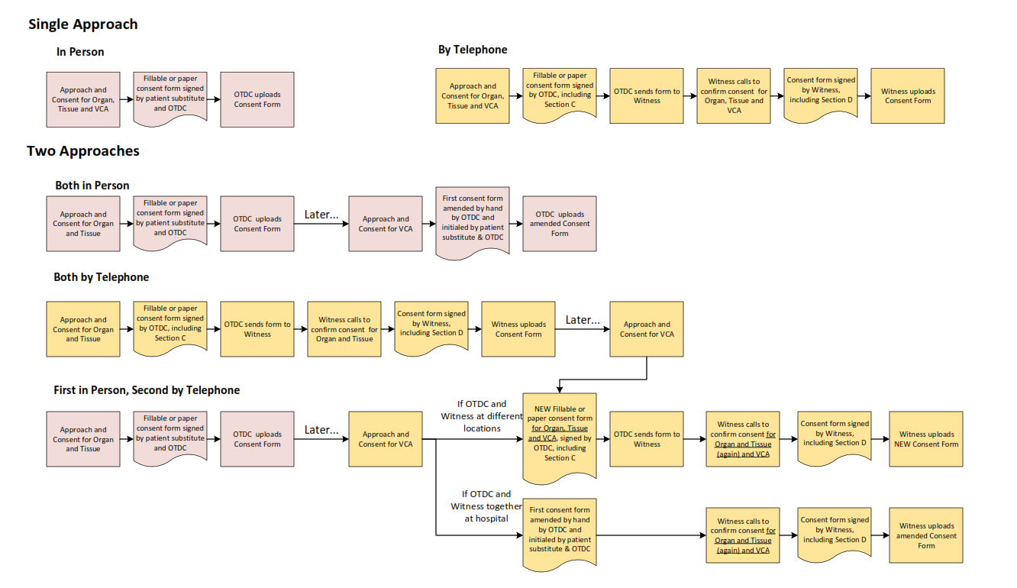

# **Consent to Donate Organs and/or Tissues Mock-up - VCA Bilateral Upper Limb**

Link to form on ORC [here](https://orc.giftoflife.on.ca/FORMS/Donor%20Assessment,%20Screening,%20Suitability%20and%20Testing/CSF-9-11.pdf)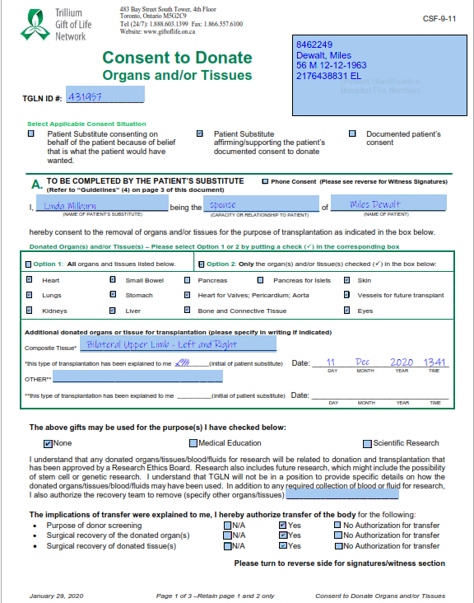

SAMPLE

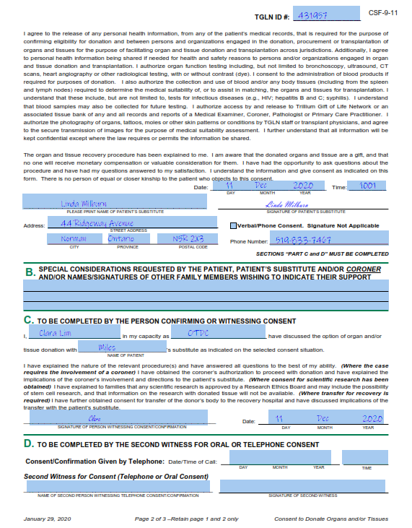

SAMPLE

# **iTransplant Authorization Page Mock-up - VCA Bilateral Upper Limb**

In addition to selecting any other organs consented, select ‘Yes’ for both VCA and Other, and add “VCA-Bilateral Upper Limb” in the Other text field.

Note that VCA – bilateral upper limb transplantation is not research. ‘Yes’ for research is *only* selected when the family has consented to research for general organ and tissue donation.

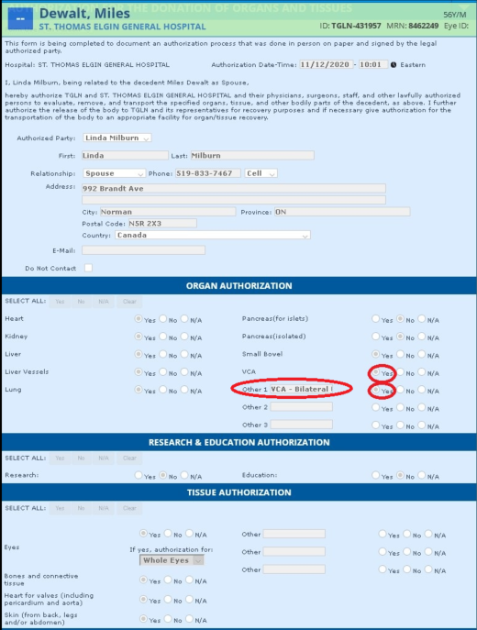

# **Limb Physical Assessment Form**

Link to form on ORC [here](https://orc.giftoflife.on.ca/FORMS/Donor%20Assessment,%20Screening,%20Suitability%20and%20Testing/CSF-9-18.pdf)

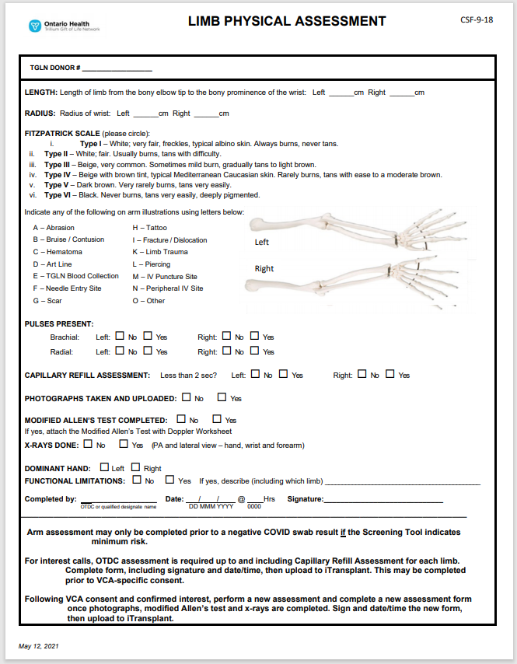

SAMPLE

# **VCA Bilateral Upper Limb Measurement and Photography Reference**

**VCA Bilateral Upper Limb Measurement and Photography Reference**

The following **measurements** must be taken for each limb (right and left) and recorded on the Limb Physical Assessment form (CSF-9-18) and is required for the Interest Call to the transplant program.

1. 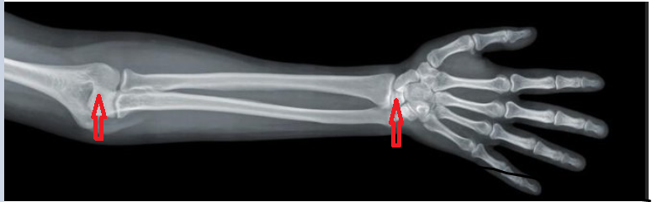Length: Landmark the measurement from the bony elbow tip to the bony prominence of the wrist, as indicated below.
2. 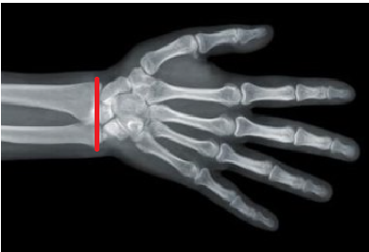Radius: Measure around the wrist at the level of the tip of the radial styloid, as indicated below.

Note that the above measurements do not need to be micro-precise but are intended to help the transplant team determine whether the limbs will be reasonably proportionate for the recipient’s size.

The following **photographs** should be taken and provided to the transplant program after confirmation of Interest and NOK Consent.

Please place a green towel* or other non-pattern fabric under the arms and hands for the photos.

* Left hand and forearm, palm up, viewed from near the elbow
* Left hand and forearm, palm down, viewed from near the elbow
* Right hand and forearm, palm up, viewed from near the elbow
* Right hand and forearm, palm down, viewed from near the elbow

* Green towels are preferred to allow better judgement of skin colour match. If no solid coloured background is available, white may be used.

# **Modified Allen’s Test with Doppler VCA Bilateral Upper Limb Assessment Worksheet**

Link to form on ORC [here](https://orc.giftoflife.on.ca/FORMS/Donor%20Assessment,%20Screening,%20Suitability%20and%20Testing/CSF-9-246.pdf)

SAMPLE

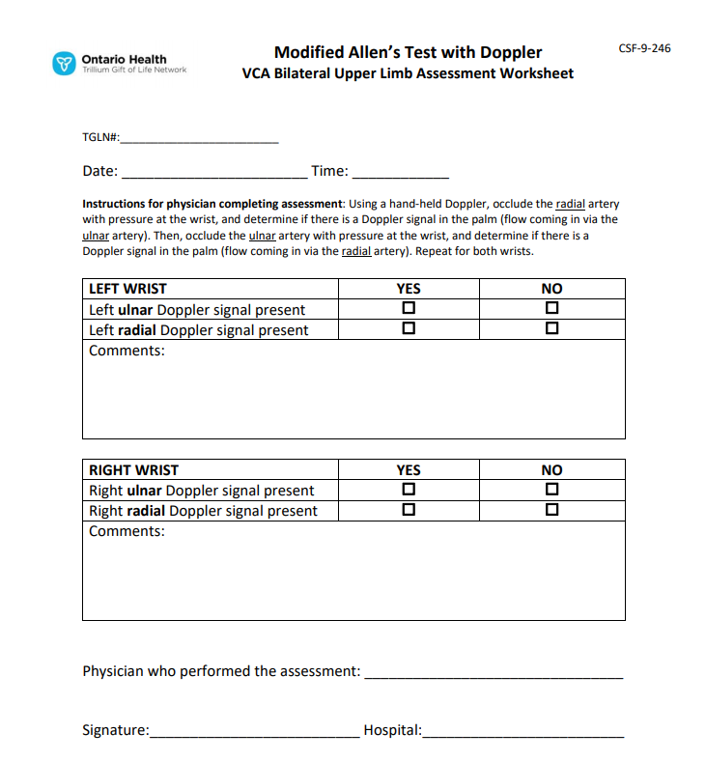

# **FAQs for Critical Care – VCA Bilateral Upper Limb Donation and Transplantation**

This is an available as an individual document here.

**FAQs for Critical Care:**

**Vascular Composite Allotransplantation**

**Bilateral Upper Limb Donation and Transplantation**

**What is Vascular Composite Allotransplantation (VCA)?**

Vascular Composite Allotransplantation (VCA) is the transplantation of components such as nerve, tendon, skin and/or bone as a functional unit to reconstruct tissues from one individual to another e.g. hand and forearm, elements of face and underlying structure, or the trachea. Once the revascularization of the donated tissues in the recipient occurs it can restore sensory and motor functional status, anatomy, appearance, and psychosocial well-being including self-esteem and reintegration into family and social life. This type of donation provides results not possible to achieve through an artificial limb prosthetic device or plastic surgery. The term vascular composite tissue is used interchangeably with VCA.

**When was the first upper limb transplant? How many have been done?**

The first upper limb transplant was performed in France in 1998, and the first in the United States was completed in 1999. Since 1998, there have been more than 70 upper limb transplantations performed internationally. Canada performed its first upper limb transplant in Toronto in 2016.

**Who is eligible to be a VCA donor?**

Only donors who meet the clinical criteria for neurological determination of death (NDD) are eligible as VCA transplantation involves revascularization and re-establishment of blood flow to the tissue.

Potential donors will be assessed on a case-by-case basis. For example, individuals with a history of vascular disease or reduced movement of the limb would not be considered eligible for upper limb donation.

**Is the notification process or death determination process any different for VCA donors?**

The notification/referral process and death determination process remain unchanged.

**When is the family approached for VCA?**

Donation for VCA is discussed with families after initial screening indicates there is potential to help someone waiting for a transplant.

**What information is shared with the families about VCA?**

The following information is provided to the family if a donor is considered a potential match for a recipient:

* + - What may be donated (specifics about the limbs) and who could be helped, in general terms;
    - How matching is done (blood type, age, gender, size, skin tone and tissue type matching);
    - Additional testing that may be required (including x-rays and assessment of circulation to the limb);
    - Any expected impact on timing of the organ and tissue recovery process and funeral arrangements;
    - Impact on funeral arrangement decisions, such as clothing, casket selection, or choice of a viewing;
    - Option of prostheses for donated limbs;
    - Confidentiality and potential for media attention with recipient images

**What are the additional privacy considerations?**

Given the uniqueness of the bilateral upper limb donation and transplantation, additional efforts need to be made to ensure that only individuals immediately involved in patient care, testing, and OR planning have information about the donor and potential recovery. The Privacy Officer at the hospital may be made aware of the case to assist in managing confidentiality.

**Are there any special interventions or management for VCA?**

Following consent, in addition to the donor’s medical and social history, x-rays will be required to assess bone structure. Other tests to assess circulation such as a modified Allen’s test or pulse confirmation by Doppler may also be requested. There may be a need to reposition lines (I.V. or arterial line) to preserve vascular integrity. The identity band of the patient may also need to be moved to another limb. Responsibilities for the most responsible physician (MRP) and primary nurse are included on the last page with the specific testing and information needed if VCA is proceeding.

**What are the timing considerations?**

Typically, testing, matching and assessment do not add significantly to the length of the overall process. If suitable, the recovery of a donor upper limbs may add up to 2 hours to the organ recovery process.

**Does the Coroner need to be involved?**

As with any donation, if the case has previously been designated a coroner’s case, permission must be obtained from the coroner to proceed. TGLN will ensure that the involved coroner is aware of the family consent for VCA when permission to proceed with donation is obtained.

**What happens during the recovery?**

Any specialized recovery instruments or equipment required will be reviewed with the operating room staff prior to the recovery to ensure that they are available. Composite tissue is typically recovered prior to organs to keep ischemic time as short as possible. Recovery of any consented organs will take place immediately following limb recovery, in the same OR.

## 

**What happens after recovery?**

Aftercare proceeds as per hospital policy and the body is taken to the morgue. The family may wish to see their loved one following the recovery; the TGLN Coordinator will work with the family and the hospital team to determine how this request can be honored. Since there is a visible change in the donor’s appearance, it will be necessary to clarify options with the donor family for viewing the donor’s body post recovery. Sensitive draping will need to reflect the family’s wishes regarding visualizing the change.

If there is no coroner involvement, arrangements can be made for release to the funeral home. TGLN notifies the hospital as to when this should occur. Depending on the type of funeral the family has planned, some choose to accept prostheses for the donated limbs. Should the family choose prostheses, TGLN will work with the OR team and hospital to ensure the prostheses are included with the transfer of the body to the funeral home.

**What follow-up is done with the family following donation?**

TGLN will contact the family at their request to let them know that the recovery is complete. The follow-up process is similar to that which occurs with all organ donations.

**During composite tissue donation the wishes and needs of the family are paramount and are always the focus of both the health care team and TGLN.**

**Responsibilities for Critical Care Team**

* Provide usual care to the patient’s family to support their end-of-life journey and decision to donate
* Donor management and tests as per approved donor order set

**Most Responsible Physician (MRP)**

1. Upon OTDC request following consent for VCA

* Order x-ray views of both arms (PA and lateral view – hand, wrist and forearm), request measurements for limb length:
  + tip of olecranon to styloid process of radius
    - limb transplant team may request consult with MRP or radiologist
* Perform a modified Allen’s test using Doppler to confirm arterial (ulnar and radial) patency using TGLN worksheet to record results
  + using a hand-held Doppler
    - occlude the radial artery with pressure at the wrist to confirm presence of a Doppler signal in the palm (flow coming in via ulnar artery)
    - occlude the ulnar artery at the wrist, confirm a Doppler signal in the palm (indicating flow coming in via radial artery)
  + Note that additional or repeat Doppler testing may be requested by the transplant program. TBD by the program.

1. Upon OTDC request following transplant program acceptance for recipient

* Change invasive line location to lower limbs to preserve the integrity of vasculature for VCA 
  + arterial line position change to femoral line
  + primary vascular access (central line or femoral line) exclusive of upper limbs

**Primary Nurse**

1. Upon OTDC request following transplant program acceptance for recipient

* Change secondary I.V. line location to lower limbs to preserve the integrity of vasculature for VCA
* Move identification band to ankle

# **FAQs for Perioperative Staff – VCA Bilateral Upper Limb Donation and Transplantation**

This is an available as an individual document here.

**FAQs for Perioperative Staff**

**Vascular Composite Allotransplantation**

**Bilateral Upper Limb Donation and Transplantation**

**What is Vascular Composite Allotransplantation (VCA)?**

Vascular Composite Allotransplantation (VCA) is the transplantation of components such as nerve, tendon, skin and/or bone as a functional unit to reconstruct tissues from one individual to another e.g. hand and forearm, elements of face and underlying structure, or the trachea. Once the revascularization of the donated tissues in the recipient occurs it can restore sensory and motor functional status, anatomy, appearance, and psychosocial well-being including self-esteem and reintegration into family and social life. This type of donation provides results not possible to achieve through an artificial limb prosthetic device or plastic surgery. The term vascular composite tissue is used interchangeably with VCA.

**When was the first upper limb transplant? How many have been done?**

The first upper limb transplant was performed in France in 1998, and the first in the United States was completed in 1999. Since 1998, there have been more than 70 upper limb transplantations performed internationally. Canada performed its first upper limb transplant in Toronto in 2016.

**Who is eligible to be a VCA donor?**

Only donors who meet the clinical criteria for neurological determination of death (NDD) are eligible as VCA transplantation involves revascularization and re-establishment of blood flow to the tissue.

Potential donors will be assessed on a case-by-case basis. For example, individuals with a history of vascular disease or reduced movement of the limb would not be considered eligible for upper limb donation.

**Is the notification process or death determination process any different for VCA donors?**

The notification/referral process and death determination process remain unchanged.

**When is the family approached for VCA?**

Donation for VCA is discussed with families after initial screening indicates there is potential to help someone waiting for a transplant.

**What information is shared with the families about VCA?**

The following information is provided to the family if a donor is considered a potential match for a recipient;

* + - What may be donated (specifics about the limbs) and who could be helped, in general terms;
    - How matching is done (blood type, age, gender, size, skin tone and tissue-type matching);
    - Additional testing that may be required (including x-rays and assessment of circulation to the limb);
    - Any expected impact on timing of the organ and tissue recovery process and funeral arrangements;
    - Impact on funeral arrangement decisions, such as clothing, casket selection, or choice of a viewing;
    - Option of prostheses for donated limbs;
    - Confidentiality and potential for media attention with recipient images

**What are the additional privacy considerations?**

Given the uniqueness of the bilateral upper limb donation and transplantation, additional efforts need be made to ensure that only individuals immediately involved in patient care, testing, and OR planning have information about the donor and potential recovery. The Privacy Officer at the hospital may be made aware of the case to assist in managing confidentiality.

**Are there any special interventions or management for VCA?**

Following consent, in addition to the donor’s medical and social history, x-rays will be completed to assess bone structure. Other tests to assess circulation such as a modified Allen’s test by Doppler may also be requested. There will be a need to reposition lines (I.V. or arterial line) to the lower limbs to preserve vascular integrity. The identity band of the patient will also be repositioned to the ankle.

**Does the Coroner need to be involved?**

As with any donation, if the case has previously been designated a coroner’s case, permission must be obtained from the coroner to proceed. TGLN will ensure that the involved coroner is aware of the family consent for VCA when permission to proceed with donation is obtained.

**What staff will be present in the operating room?**

As with any NDD donor, scrub and circulating nurses are present. And an anesthetist is required until cross clamp and organ recovery begins. A TGLN surgical recovery coordinator (SRC) will be present. The limb recovery team will include 2 staff for each limb. They will assist with the OR set up and any other recovery-related procedures. As well, members of the recovery team for organs may also be present. If the donor becomes unstable, limb recovery may cease in order to ensure recovery of life saving organs. A large OR is required to accommodate the recovery staff from various transplant centers. Due to the uniqueness of this case, OR staff should only admit members required for the recovery in the OR. See the last page for specific OR planning required for the case.

**What are the timing considerations?**

VCA testing, and matching to the recipient is not expected to add significantly to the length of the overall process. Upper limb recovery will add up to 2 hours to the usual 3-6 hours needed for organ recovery. Family members will be updated throughout the donation process.

**What does the VCA recovery process for upper limbs involve?**

Composite tissue is typically recovered prior to organs in order to keep ischemic time as short as possible. Limbs will be recovered first and simultaneously, with one surgeon and assistant for each arm. Each limb will be extended, prepped and draped on an hour glass (“surgical”) arm-board or two regular arm-boards immediately adjacent to one-another. The limbs will be disarticulated at the elbow. After recovery, the sites will be dressed and tucked close to the body. At this time, consented organs will be recovered by the organ transplant teams.

**What type of equipment may be needed for VCA recovery?**

Any specialized equipment will be reviewed with the operating room staff prior to the recovery to ensure it is available. Equipment includes standard bone and reconstructive equipment as well as 2 sterile 18-inch pneumatic tourniquets. TGLN will ensure a pick list is available. Note that the pick list specifies that two (sets or quantities) of everything listed are required -- one for each limb. For example, two sterile back tables (one for each arm) should be set up for the VCA recovery teams. TGLN surgical recovery coordinators will assist in OR set-up.

Similar to organ donation, the recovery teams will bring extra supplies that may be needed. TGLN will review with the perioperative team the list of instrumentation to ensure that the operating room has all the necessary supplies.

**What happens after recovery?**

Aftercare proceeds as per hospital policy and the body is taken to the morgue. The family may wish to see their loved one following the recovery; the TGLN coordinator will work with the family and the hospital team to determine how this request can be honored. Since there is a visible change in the donor’s appearance, it will be necessary to clarify options with the donor family for viewing the donor’s body post recovery. Sensitive draping will be required to reflect the family’s wishes regarding visualizing the change.

If there is no coroner involvement, arrangements can be made for release to the funeral home. TGLN notifies the hospital as to when this should occur. Depending on the type of funeral the family has planned, some choose to accept prostheses for the donated limbs. Should the family choose prostheses, TGLN will work with the OR Team and hospital to ensure the prostheses are included with the transfer of the body to the funeral home.

**What follow-up is done with the family following donation?**

TGLN will contact the family at their request to let them know that the recovery is complete. The follow-up process is similar to that which occurs with all organ donations.

**During composite tissue donation the wishes and needs of the family are paramount and are always the focus of both the health care team and TGLN.**

**Perioperative Team Responsibilities**

* Plan for an OR booking in a large OR for 2 additional hours
* Participate in a OR panning huddle once donation is accepted by the transplant program to confirm availability of instruments required for VCA recovery
* Review Pick List to identify outstanding instruments needed to be provided by transplant team

**Anesthesia:**

* Direct all medical management modalities required to maintain the patient intraoperatively, e.g. hemodynamic management, neuromuscular blockade for rigidity

**Nursing Team:**

* Facilitate specific OR set-up to accommodate multiple teams and 2 additional sterile back tables

# **Coroner Permission Form Mock-up – VCA Bilateral Upper Limb**

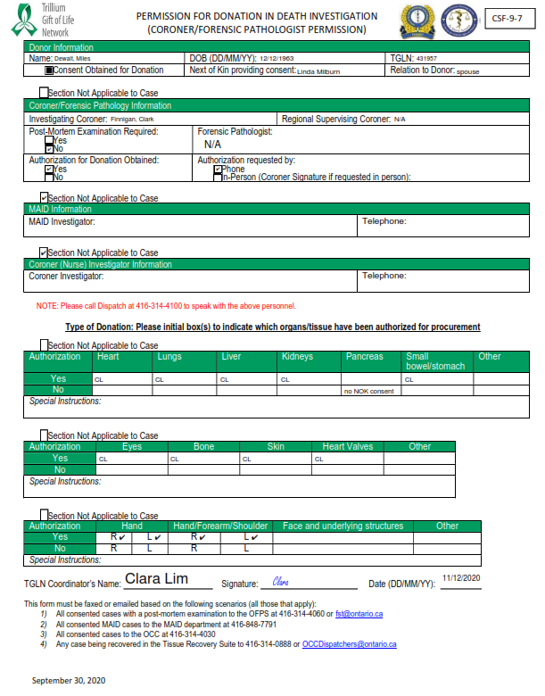

SAMPLE

# **VCA Bilateral Upper Limb OR Pick List**

London Health Sciences Centre VCA OR Pick List

Instrument list for bilateral hand procurement for transplantation.

If any of the below items are not available at the donor OR, Transplant Donation Specialist (TDS) will be notified and will bring the item(s).

* OR Ice machine – if not available locally, TDS will be notified to bring ice

**Please Note**: Requirements below are **per limb**, so two sets of all items and quantities shown below are required.

* Arm board or substitute to enable prep and drape of each arm positioned at 90-degrees abduction*
* Amputation tray
* Skin marker
* Bipolar electrocautery and tips
* Extremity drapes
* Towel clips
* Sterile Tourniquet (pneumatic cuff)
* Bone wax
* General surgical pack
* Bone set
* Sterile ruler
* Skin stapler (2)
* 2.0 vicryl suture kits (1)
* Webril rolls (1)
* Sterile Esmark or Tensor wrap
* Medium “ligaclip” Appliers and clips
* Large “ligaclip” Appliers and clips
* 8 – 0 suture
* Kling gauze wrap rolls (2)
* Normal Saline Solution bags (1)
* Sterile basin for back table flush
* Back table

* "Surgical arm boards" would be ideal. If unavailable, place two "regular arm boards" immediately adjacent together, on each side of the operating table (two for each arm).

# **Funeral Home Communication Process - VCA Bilateral Upper Limb**

**Funeral Home Communication Process**

**VCA Bilateral Upper Limb**

After the funeral service provider has been confirmed by family, ensure the family is aware you will be speaking to the funeral service provider about arrangements and the possibility of using prostheses for potential viewing. Initiate the call to provider as soon as possible during business hours.

Steps:

1. Call funeral home
2. Email/fax information
3. If prostheses are declined by family at any time, update the funeral home
4. Ensure that prostheses are placed inside the body bag after all recoveries are completed
5. Advise funeral home donation recovery is complete
6. Confirmation of receipt of prostheses by funeral service provider (preferred but optional)

**Initial Phone Call**

Before you call: Ensure that you are familiar with all information in the funeral service provider handout (see “VCA one pager for Funeral Services”) and have reviewed the photograph of the prostheses, in case the funeral home director has specific questions. Please also review the document, “Prostheses Delivery Process” prior to calling.

When you call: Ask to speak with a funeral director, as opposed to an office administration staff person, if possible.

* Introduce self, working with the ____ family and their loved one _____.
* “We have been informed by the ___ family that they have chosen you to provide funeral arrangements – have they reached out to you about arrangements yet?”
* Establish if the family relayed that their loved one was going to be an organ and tissue donor – it is likely family has already relayed this information.
* “In addition to donating organs and tissues, ______ will be part of an unprecedented procedure in Canada: the donation of bilateral arms, for transplant.”
* “We also call this type of donation VCA, or Vascularized Composite Allotransplantation. They will be donating both of their arms, from below the elbow.”
* Communicate whether the family has declined prostheses, asked for the prostheses, or is still deciding
* If the family has asked for the prostheses, or is still deciding:
  + “We are reaching out now, as we want to make sure you are prepared from your end for either an open casket viewing, or private family viewing arrangement, so we have prepared two arm prostheses that we will send you.”
  + “Regarding the prostheses, they will be the ‘press fit’ type, meaning that they are concave at the end so that they can be ‘fit’ onto the elbow stump.”
* Update on potential OR time, if known.
* “The prostheses will be sent to you along with the body, inside of the body bag but well wrapped”.
* “As you would normally, we would appreciate your confidentiality and discretion in this unique situation, for the privacy of the family.”
* Ask if there are any questions as this time.
* “I will send you some additional information, including a photograph of the prostheses, via email or fax.”
* Relay OTDC contact information.

**Emailed/Faxed Information**

As soon as possible after speaking with the funeral service provider send an email (see template below) or fax with the following attachments:

* “Upper Limb Donation Information for Families” [ensure that OTDC contact information has been added]
* Funeral service provider handout, “Information for Funeral Service Providers – VCA Bilateral Upper Limb Donation” [ensure that OTDC contact information has been added]

**Procure prostheses, label and ensure that prostheses are placed inside the body bag after all recoveries are completed**

The London transplant team will bring the prostheses, securely packaged, to the donor hospital, and hand the package over to the OTDC. The OTDC will remove the triple-wrapped prostheses from their box and add a patient addressograph to the outer-most plastic layer.

At the end of all recoveries, the OTDC is responsible to ensure that the prostheses package is inserted into the body bag for delivery to the funeral service provider along with the donor.

**Confirmation of receipt of prostheses by OTDC**

If possible, please contact the funeral service provider to confirm receipt of the prostheses and to respond to any additional questions.

**Approved Email/Fax Text**

Dear _______,

Thank you for taking my call earlier. As discussed, I am writing to provide you with additional information regarding the unique arrangements that may be required for the _____ family.

Please find attached “Upper Limb Donation - Information for Families”, which was also provided to the family and which provides some background regarding vascular composite allograph donation. I am also attaching a document which includes other information related to the donation procedure and the prostheses, which we believe you may require. We appreciate your professionalism, and commitment to the maintaining confidentiality and discretion with regard to the sensitive nature of this unique situation. Please dispose of these documents as per your protocol for confidential information.

Please do not hesitate to reach out to me at [number, email, and contact hours]. If you require assistance after hours, please call the Provincial Resource Centre at 1-877-363-8456, press 1, and ask to speak to a coordinator regarding the deceased, citing their TGLN # (XXX XXX).

Thank you for your participation in assisting the _____ family with this process.

Sincerely,

# **VCA Bilateral Upper Limb One Pager for Funeral Services**

This is an available as an individual document here.

**Information for Funeral Service Providers**

**VCA Bilateral Upper Limb Donation**

As the chosen funeral service provider, we would like to provide some information regarding someone who may be donating their upper limbs for transplantation. The organ and tissue donation coordinator (OTDC) who spoke with you will be your liaison for this case (please see contact information below). However, should you require assistance afterhours, please call the Provincial Resource Centre at 1-877-363-8456, press 1, and ask to speak to a coordinator regarding the deceased, citing their TGLN #. We hope that this additional information will help with planning the arrangements chosen by the family.

**Anatomical surgical recovery site:** Upper limb donation will occur at the point of the elbow for both arms; there may be additional surgical incisions to the chest and abdomen consistent with solid organ recovery for donation. Recovery of other tissues, such as eyes, skin, and other bone may have occurred in some circumstances.

**Vasculature:** The arms will be ligated during surgery via a combination of suture ligation (major vessels like brachial artery), cautery and vascular clips.

**Dressing:** Arm wound sites will be sutured and stump dressings applied, including gauze and kling.

**Prosthesis details:**

* Two non-flexible, non-articulated lower arm prostheses. Please see attached photographs but note that they are lighter in tone than they appear in the pictures.
* Upper connecting portion of prostheses will be press fit to the elbow joint.
* Please do not apply heat to the prostheses.
* Please do not apply cosmetics to the prostheses, as we are uncertain of how it will react with the material.

If in the event that the prostheses are not used in any arrangements, or cannot be part of the body’s cremation, you may dispose of them as you see fit.

We appreciate your professionalism, and commitment to the maintaining confidentiality and discretion with regard to the sensitive nature of this unique situation. We thank you sincerely for your cooperation.

|  |  |
| --- | --- |
| TGLN OTDC #1  Name:  Cell: | TGLN OTDC #2  Name:  Cell: |

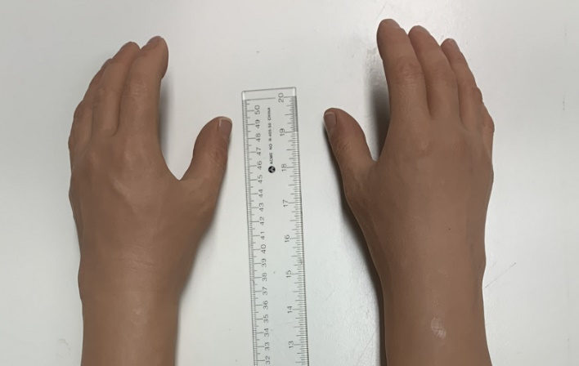

# **VCA Case Debrief Form**

This is an available as an individual document here.

**VCA Case Debrief Form**

**Debrief/Case Demographics**

|  |  |  |
| --- | --- | --- |
| Hospital Name: | Date: | Time: |
| Facilitator:  (Name, Title, Organization) | | |
| TGLN#: | MRN#: | |
| 🗹 NDD | Organ/VCA Outcome: | |

**Participant List:**

|  |  |
| --- | --- |
| **Name/Designation** | **Unit** |
|  |  |
|  |  |
|  |  |
|  |  |
|  |  |
|  |  |

**Action Items:**

|  |  |
| --- | --- |
| **Action Required** | **Person Responsible** |
|  |  |
|  |  |
|  |  |
|  |  |
|  |  |
|  |  |

**Debrief Findings:**

|  |
| --- |
| **List a brief summary of the events, including the timeline:** |
|  |
| **Celebrate the successes:** |
|  |
| **Identify challenges and opportunities for improvement:** |
|  |
| **Status of any media related to the case:** |
|  |
| **Document lessons learned:** |
|  |

# **Associated CPIs and CSFs**

|  |  |
| --- | --- |
| Discussing Donation Opportunities and Obtaining Consent | [CPI-9-204](https://orc.giftoflife.on.ca/SOP/PDF_CPI/CPI-9-204.pdf) |
| Donor Assessment | [CPI-9-208](https://orc.giftoflife.on.ca/SOP/PDF_CPI/CPI-9-208.pdf) |
| Physical Examination - Organ and/or Combined Organ and Tissue Donors | [CPI-9-209](https://orc.giftoflife.on.ca/SOP/PDF_CPI/CPI-9-209.pdf) |
| Organ and Composite Tissue Specific Data Collection | [CPI-9-215](https://orc.giftoflife.on.ca/SOP/PDF_CPI/CPI-9-215.pdf) |
| Offering and Allocation of Composite Tissue Upper Limb Process Instruction | [CPI-9-307](https://orc.giftoflife.on.ca/SOP/PDF_CPI/CPI-9-307.pdf) |
| Listing and Status Changes of Composite Tissue Candidates on the Ontario Provincial Wait List | [CPI-9-308](https://orc.giftoflife.on.ca/SOP/PDF_CPI/CPI-9-308.pdf) |
| Organ and Composite Tissue Labelling and Re-Labelling Process Instruction | [CPI-9-417](https://orc.giftoflife.on.ca/SOP/PDF_CPI/CPI-9-417.pdf) |
| Perfusion & Packaging: Composite Tissue Allograft Process Instruction | [CPI-9-428](https://orc.giftoflife.on.ca/SOP/PDF_CPI/CPI-9-428.pdf) |
|  |  |
| Coroner Permission Form | [CSF-9-7](https://orc.giftoflife.on.ca/FORMS/Donor%20Assessment,%20Screening,%20Suitability%20and%20Testing/CSF-9-7.pdf) |
| Consent Form to Donate: Organs and/or Tissues | [CSF-9-11](https://orc.giftoflife.on.ca/FORMS/Donor%20Assessment,%20Screening,%20Suitability%20and%20Testing/CSF-9-11.pdf) |
| Consent Form to Donate: Organs and/or Tissues (FRENCH) | [CSF-9-12](https://orc.giftoflife.on.ca/FORMS/Donor%20Assessment,%20Screening,%20Suitability%20and%20Testing/CSF-9-12.pdf) |
| Limb Physical Assessment | [CSF-9-18](https://orc.giftoflife.on.ca/FORMS/Donor%20Assessment,%20Screening,%20Suitability%20and%20Testing/CSF-9-18.pdf) |
| Vascularized Composite Tissue Retrieval Operative Note | [CSF-9-76](https://orc.giftoflife.on.ca/FORMS/Donor%20OR%20Planning,%20Perfusion,%20Packing%20&%20Labelling/CSF-9-76.pdf) |
| Summary of Placement of Organs and Tissues | [CSF-9-87](https://orc.giftoflife.on.ca/FORMS/Donor%20Case%20Follow-up/CSF-9-87.pdf) |
| VCA Patient Registration and Status Change Form | [CSF-9-114](https://orc.giftoflife.on.ca/FORMS/Donor%20Organ%20and%20Tissue%20Allocation%20and%20Waitlist%20Management/CSF-9-114.pdf) |
| VCA Wait List Registration | [CSF-9-115](https://orc.giftoflife.on.ca/FORMS/Donor%20Organ%20and%20Tissue%20Allocation%20and%20Waitlist%20Management/CSF-9-115.pdf) |
| Modified Allen’s Test with Doppler Worksheet | [CSF-9-246](https://orc.giftoflife.on.ca/FORMS/Donor%20Assessment,%20Screening,%20Suitability%20and%20Testing/CSF-9-246.pdf) |