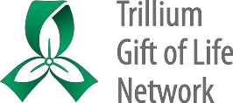**VCA Parathyroid Donation**

**Reference Package for Hospital Programs**

**Version date: February 15, 2022**

Contents

**Deceased Donor Criteria – Ontario VCA – Parathyroid** 2

**Possible Parathyroid Donor Hospitals** 2

**VCA Parathyroid Process Flow** 3

**OTDC Checklist - VCA Parathyroid** 4

**Approach Principles and Scripting – VCA Parathyroid** 8

**VCA Parathyroid Huddle Overview Document** 11

**VCA Parathyroid - Information for Families** 15

**Amendments to Consent Documentation – VCA Cases** 18

**Consent to Donate Organs and/or Tissues Mock-up - VCA Parathyroid** 21

**iTransplant Authorization Page Mock-up – VCA Parathyroid** 23

**FAQs for Hospital Staff – VCA Parathyroid Donation and Transplantation** 24

**Coroner Permission Form Mock-up – VCA Parathyroid** 28

**Donor OR Required Instruments - Parathyroid Transplant - Pick List** 29

**VCA Parathyroid - One Pager for Funeral Services** 30

**Parathyroid Incision Photographs** 31

**VCA Case Debrief Form** 32

**Associated CPIs and CSFs** 34

# **Deceased Donor Criteria – Ontario VCA – Parathyroid**

Refer to ORC [*Parathyroid Transplant* *Deceased Donor Criteria*](https://orc.giftoflife.on.ca/FORMS/Donor%20Exclusion%20Criteria/Deceased%20Parathyroid%20Donor%20Exclusion%20Criteria.pdf)

# **Possible Parathyroid Donor Hospitals**

**VCA Parathyroid Donor Case – Possible Hospitals**

The following hospitals are **within a 2 hour (120 minute) driving distance** of downtown Toronto* (at night) and are considered within the catchment area for VCA Parathyroid donation during low traffic times.

|  |  |  |  |
| --- | --- | --- | --- |
| Hospital Name | Est. Driving Time (min) | Hospital Name | Est. Driving Time (min) |
| Brant Community Healthcare System | 85 | Northumberland Hills Hospital | 90 |
| Brantford General Hospital | 85 | Orillia Soldiers’ Memorial Hospital | 110 |
| Cambridge Memorial Hospital | 85 | Peterborough Regional Health Centre | 100 |
| Collingwood General and Marine Hospital# | 120 | Quinte Health Care – Belleville# | 120 |
| Grand River Hospital | 90 | Ross Memorial Hospital | 100 |
| Georgian Bay General Hospital# | 100 | Royal Victoria Regional Health Centre | 90 |
| Guelph General Hospital | 85 | Scarborough Health Network (all sites) | 29 - 31 |
| Halton Healthcare – Oakville | 42 | St. Joseph’s Health Care – Hamilton | 56 |
| Hamilton Health Sciences | 56 | St. Joseph’s Health Centre – Toronto | 16 |
| Humber River Hospital | 40 | St. Mary’s General Hospital Kitchener | 85 |
| Joseph Brant Hospital | 45 | St. Michael’s Hospital | 7 |
| Lakeridge Health (all sites) | 41 - 70 | St. Thomas Elgin Hospital# | 120 |
| London Health Sciences Centre# | 120 | Stratford General Hospital# | 120 |
| Mackenzie Health | 38 | Southlake Regional Hospital | 47 |
| Markham Stouffville Hospital | 35 | Sunnybrook Health Sciences Centre | 21 |
| McMaster Children’s Hospital | 56 | The Hospital for Sick Children | 1 |
| Mount Sinai Hospital | 1 | Michael Garron Hospital | 20 |
| Muskoka Algonquin Healthcare# | 120 | Trillium Health Partners (all sites) | 27 - 35 |
| Niagara Health System | 85 | University Health Network – General | 0 |
| North York General Hospital | 24 | William Osler Health System (all sites) | 40 - 55 |
|  |  | Woodstock General Hospital# | 110 |

* Measured from Toronto General Hospital

# Denotes a hospital which, due to traffic patterns or other issues, is unlikely to be reached within 2 hours without lights and sirens.

# **VCA Parathyroid Process Flow**

# **OTDC Checklist - VCA Parathyroid**

**Note:** Donors will only be approached for parathyroid at hospitals within 2 hours driving time of Toronto.

**OTDC Checklist – VCA Parathyroid**

The resource package (including VCA Parathyroid Reference Document) for staff is located here.

**Note: This document is intended to be supplementary to usual NDD processes.**

|  |  |  |
| --- | --- | --- |
| **Pre-Consent Process** | | |
|  | **Action** | **Notes & *Reference Documents*** |
|  | Assess for absolute exclusion criteria | See [*Parathyroid Transplant* *Deceased Donor Criteria*](https://orc.giftoflife.on.ca/FORMS/Donor%20Exclusion%20Criteria/Deceased%20Parathyroid%20Donor%20Exclusion%20Criteria.pdf) |
|  | Decision regarding approach: If family has not already been approached, based on available knowledge of family situation or known patient information, decide whether to approach for organ, tissue and VCA up front, or to approach for organ and tissue alone, possibly followed by a separate approach for VCA (2 tier approach). | If a single approach for organ, tissue and VCA is preferred, a pre-approach huddle must occur first (see pre-approach huddle list in ***VCA Parathyroid Huddle Overview Document***, page 12 of the VCA Parathyroid Reference Document.  For 2 tier approaches, proceed with regular organ and tissue (no VCA) donation discussion and consent with family. |
|  | If there are no absolute exclusion criteria, approach family for VCA parathyroid with usual approach for organ and tissue. | See ***Approach Principles and Scripting – VCA Parathyroid***, page 9 of the VCA Parathyroid Reference Document, for tips and suggested language.  Acceptable to approach every family at a hospital in the 2 hour radius of UHN when the donor meets criteria until VCA Parathyroid recipient is transplanted.  Other references:  ***Amendments to Consent Documentation – Vascularized Composite Allotransplantation (VCA) Cases,*** page 18 of the VCA Parathyroid Reference Document.  ***Consent to Donate Organs and/or Tissues Mock-up – VCA Parathyroid,*** page 21 of the VCA Parathyroid Reference Document.  ***iTransplant Authorization Page Mock-up – VCA Parathyroid,*** page 23 of the VCA Parathyroid Reference Document. |

|  |  |  |
| --- | --- | --- |
| **Family Considerations (both pre/post-consent)** | | |
|  | **Action** | **Notes & Reference Documents** |
|  | Provide the VCA Parathyroid donor family handout.  Note: if consent is by phone, inquire as to whether they would like the family handout sent by email. | Fill in applicable OTDC contact info on family handout (last page) before providing to family.  ***VCA Parathyroid – Information for Families,*** page 15 of the VCA Parathyroid Reference Document and available as a single document here. |
|  | Ensure ongoing confirmation of TGLN contact information for families throughout donation work-up. | Donor family may have more questions or need more support – ensure they always have a point of contact. |
|  | Discuss expectations for news media post-donation about the transplant and recipient. Point out the TGLN Communications contact information in the family handout in case of situation in future where transplant and recipient media coverage occur. | Timing of any media releases regarding the success of the transplant may be unknown (days to months, if ever). Further information is available in the family handout. |

|  |  |  |
| --- | --- | --- |
| **Donor Assessment, Management, & Family Liaison** | | |
|  | **Action** | **Notes & Reference Documents** |
|  | Complete donor assessment required for interest call for VCA as per CPI 315:  Donor chart including Medical Social History, ABO, and physical assessment (COVID test result permitting).  Upload Consent, Medical Social History, and Physical Assessment Forms to iTransplant. | At this time, complete the [*Assessment Form: Organ/Combined Organ & Tissue Donor (CFS-9-15)*](https://orc.giftoflife.on.ca/FORMS/Donor%20Assessment,%20Screening,%20Suitability%20and%20Testing/CSF-9-15.pdf)  Information that should be included in the interest call includes the donor chart, Medical and Social History Questionnaire, ABO, CBC and chemistry. The physical assessment should include a comprehensive observation of neck scars/incisions. If present, highlight to CSC. |
|  | Contact CSC to confirm inclusion criteria and absolute exclusion criteria, and ensure all information for interest call is obtained. | CSC will confirm they have needed medical information and testing results for the interest call, or request any outstanding information |
|  | Provide bedside staff with ***FAQs for Hospital Staff*** | ***FAQs for Hospital Staff -*** ***VCA Parathyroid Donation and Transplantation,*** page 24 of the VCA Parathyroid Reference Document and available as a single document here. |
| **After Offer is Accepted for VCA** | | |
|  | **Action** | **Notes & Reference Documents** |
|  | Notify MOC that parathyroid is accepted | ***JIT Huddle: Appendix 1/Case Huddle*** [(CSF-9-208)](https://orc.giftoflife.on.ca/SOP/PDF_CPI/CPI-9-208.pdf)   * Plan for case coverage * Draft email to Operations Lead/delegate or from TGLN Hospital Director or delegate to be sent regarding active NDD parathyroid donor (will include privacy/media considerations). |
|  | Two ACD (pink or lavender top) tubes will be collected. | One tube will be sent stat to the donor hospital lab to be spun and separated following standard sample separation process. Once separated the lab will aliquot the plasma into a fresh tube (any standard tube).  The second tube will be sent as whole blood.  See [*Offering and Allocation of Parathyroid Allotransplant (CPI-9-315)*](https://orc.giftoflife.on.ca/SOP/PDF_CPI/CPI-9-315.pdf)  The OTDC will send both samples on ice to Toronto Medical Lab (TML) in a green bag. The OTDC will include a copy of [*CSF-9-20 Stat/Non-Stat Infectious Disease Testing of Organ Donors*](https://orc.giftoflife.on.ca/FORMS/Donor%20Assessment,%20Screening,%20Suitability%20and%20Testing/CSF-9-20.pdf)(Appendix 2) and write ‘PTH’ on the ‘Other’ section of the requisition. |
|  | Obtain coroner permission (if applicable). | ***Coroner Permission Form Mock-Up VCA Parathyroid,*** page 28 of the VCA Parathyroid Reference Document |
|  | Continue usual donor work-up and management through the solid organ allocation process. |  |
|  | Contact the funeral home as soon as identified. Provide one-pager for funeral homes to funeral services provider.  Document the points of contact and communication as appropriate in iTransplant. | ***VCA Parathyroid - One Pager for Funeral Services,*** page 30 of the VCA Parathyroid Reference Document |

|  |  |  |
| --- | --- | --- |
| **Hospital/OR Planning** | | |
|  | **Action** | **Notes & Reference Documents** |
|  | OTDC to attend/organize/lead VCA Parathyroid specific huddles as required and document huddles and communications as appropriate in iTransplant. | Parathyroid is recovered first, additional one hour is expected   * OR Planning Huddle (OR Pick List review and special instruments required) * OR Pre-Op Huddle   ***VCA Parathyroid Huddle Overview Document***  [*Donor OR Required Instruments - Parathyroid Transplant - Pick List (CSF-9-240)*](https://orc.giftoflife.on.ca/FORMS/Donor%20OR%20Planning,%20Perfusion,%20Packing%20&%20Labelling/CSF-9-240.pdf) |
|  | In OR planning huddle, provide perioperative staff with ***FAQs for Hospital Staff*** | ***FAQs for Hospital Staff -*** ***VCA Parathyroid Donation and Transplantation,*** page 24 of the VCA Parathyroid Reference Document |

|  |  |  |
| --- | --- | --- |
| **Organ Recovery** | | |
|  | **Action** | **Notes & Reference Documents** |
|  | The OTDC should remain on site throughout OR until the parathyroid has been recovered. | Retrieval of parathyroid approx. 1 hour with 2 Endocrine surgeons. |
|  | As per usual, viewing of the body post organ recovery is highly discouraged. Do not offer to family. If requested, process and location will need to be discussed with hospital staff. | If the family wishes to view the donor after recovery, a second OTDC should remain on site in order to facilitate this while the other OTDC does the post-op debrief (see below). |

|  |  |  |
| --- | --- | --- |
| **Hospital Follow-up** | | |
|  | **Action** | **Notes & Reference Documents** |
|  | Perform informal post-OR debrief with OR and ICU staff |  |
|  | Organize a formal debrief 1-3 weeks following the recovery if requested | Following informal debrief, if formal debrief is requested, consult hospital to determine who they wish involved  Ensure Director of Hospitals or Delegate is available to facilitate/attend debrief (note some hospitals appoint a facilitator at hospital)  ***VCA Case Debrief Form***, page 32 of the VCA Parathyroid Reference Document |

# **Approach Principles and Scripting – VCA Parathyroid**

**Approach Principles and Scripting**

**Note:** Donors will only be approached for parathyroid at hospitals within 2 hours driving time of Toronto.

**VCA Parathyroid (2021)**

**Underlying Principles – Optimizing the Approach**

* Discussion of VCA consent will only be introduced after solid organ consent is provided by family
* OTDCs will not raise VCA if any of the ABSOLUTE exclusion are present

**Introduction of VCA**

* “Through advancing medical technology and science s/he has the opportunity to help…”
* “Your loved one would be an eligible donor for a parathyroid donation for transplant to another person” (use simple language)
* “In addition to the organs we have already discussed, your loved one has the opportunity to help another person. This is very special and quite unique and I’d like to tell you about this”.
* “There is another way s/he can help above what we’ve discussed"

**Tips for the Donation Discussion**

**Identify the uniqueness of the opportunity**

* “S/he would be the first person in Canada able to help someone with a parathyroid”

**Assure family VCA-Parathyroid is not meant to impact organ and tissue donation process negatively**

* “The procedure would add up to 1 hour to the OR time, and some things might need to be considered like a larger operating room, but it shouldn’t impact the timelines we are working with. Allocation and testing for the organs we are trying to place will still continue as usual while we arrange the details of the parathyroid donation.”
* “The process should have little impact on the timelines. Screening is minimal, and the team is committed to being timely. We don’t anticipate the surgery to add much more than an hour to our typical donation surgery.”

**Share the meaning of VCA-parathyroid donation through practical meaningful use**

* “Through this type of donation and transplant, doctors can replace the parathyroid of someone who may have lost the function of their own, for example due to cancers of the thyroid. Without the parathyroid, a person is unable to maintain an appropriate calcium balance in their body, which may lead to life-altering conditions like seizures, which might require frequent medications, transfusions, and hospitalization to manage. In receiving a parathyroid transplant, the recipient would stand to have a significantly improved quality of life.”
* “We have a specific recipient who s/he might help” (This may help the family in that it was something solid, there is actually a real person who needs the parathyroid, etc.)
* “This person would be able to return to work and be more able to care for their children”

**Research**

* “This is not research, it is a real technique for real people”

**Leverage research and teaching consent with cutting edge medicine**

* “I noticed your loved one agreed to donation for research and teaching as well. Although this procedure itself isn’t research, it is new and innovative enough that it would honour their wishes to be at the forefront of ground-breaking medical procedures”

**Provide some assurance of success**

* “The surgery is fairly straightforward, and very similar to thyroid surgeries that are commonly done at the hospital.”

**Media (must be shared with family)**

* “There would be potential for media coverage. We (TGLN) would not be able to give you information on the recipient, but you might find out through the media” (Note: TGLN is committed to giving a donor family a ‘heads up’ if we know about media coverage about the recipient.)
* “I do need to share with you that since this is the first time a parathyroid transplant is being done in Canada, there may be some media interest”
* “Because this procedure is a first, there may be some media interest. The transplanting hospital might be covered in the media spotlight. I just wanted to make you aware of this so that you didn’t hear about it for the first time when if you saw it on the news”

**If unsure of answers to family questions, show commitment to learning with family along the way**

* “I may not have all the answers for you, but I know where to go to get some of these questions answered”
* “Because this procedure is newer, I may not have all the answers as well, but I promise that I will seek out the information that you’re looking for, or find the answers from the right people who can answer that”

**Questions about visible incisions and open-casket funeral**

* “The donation would involve an additional small incision at the neck, which can be covered with a bandage.”
* “We can work with the funeral home to ensure that incision isn’t visible. The funeral home will have make-up they can apply, and if desired they could
  + dress your loved one in a higher collared shirt or blouse
  + cover up the incision with a scarf
* “With an open casket, many families and guests may be more focused on reflecting fondly on the person they love, that they usually don’t notice the rest of the body”

# **VCA Parathyroid Huddle Overview Document**

**VCA Parathyroid Donation**

**Huddle Overview Document**

*A minimum of two TGLN huddles will be completed on the VCA Parathyroid (PThd) case. The usual Case Huddle may occur as part of the Pre-approach Huddle, or on its own (3 huddles).*

A brief overview of Both TGLN huddles and Hospitals Huddles are in the table below.

|  |  |  |
| --- | --- | --- |
| **Huddle Type** | **Trigger for Huddle** | **Notes** |
| **TGLN Huddles** | | |
| Pre-approach Huddle | Intent to approach for VCA PThd | Lead by MOC: Guidelines below |
| Case Huddle | Med-soc/consent completed with donor information needed for allocation uploaded | Lead by CSC: Usual huddle checklist |
| Parathyroid JIT VCA Huddle (CSF-9-242) | VCA PThd offer accepted | Lead by CSC: [Parathyroid JIT VCA Huddle (CSF-9-242)](https://orc.giftoflife.on.ca/FORMS/Donor%20Assessment,%20Screening,%20Suitability%20and%20Testing/CSF-9-242.pdf)  Checklist also included below |
| **Hospital Huddles** | | |
| High Level Hospital Huddle | Consent obtained and interest confirmed | Lead by Hospital Director or delegate: Guideline below |
| OR Planning Huddle with perioperative hospital staff/OTDC | Acceptance of parathyroid. | Lead by OTDC: Guideline below |
| OR Pre-Op Huddle | Arrival of PThd transplant team | Lead by OTDC: Guideline below |

**TGLN HUDDLES**

**Pre-approach Huddle – Intent to approach for VCA PThd**

MOC to review the following:

1. Status of case
   1. Confirm program is open for offers and CSC/RTC has reviewed current medical information for absolute exclusions/missing history/red flags,
2. Ensure access to *VCA Parathyroid Reference Document* with approach scripting, FAQs, etc. as well as individual documents for distribution to family, hospital staff, etc. The resource package for staff is located here.
3. Family situation – identification of appropriate substitute, in-person or phone approach, details of the registered consent
4. Confidentiality – Discuss ‘buzz’ at hospital regarding case and assess timing related to contacting Operational Lead or delegate regarding privacy considerations related to patient chart.

**Case Huddle (Following consent and med-soc history completion and review of case by CSC)**

MOC/CSC/OTDC case huddle (lead by CSC) – use the usual huddle checklist

**JIT VCA Huddle following Acceptance of VCA PThd**

TGLN Parathyroid Just-in-Time Huddle Checklist (CSF-9-242)

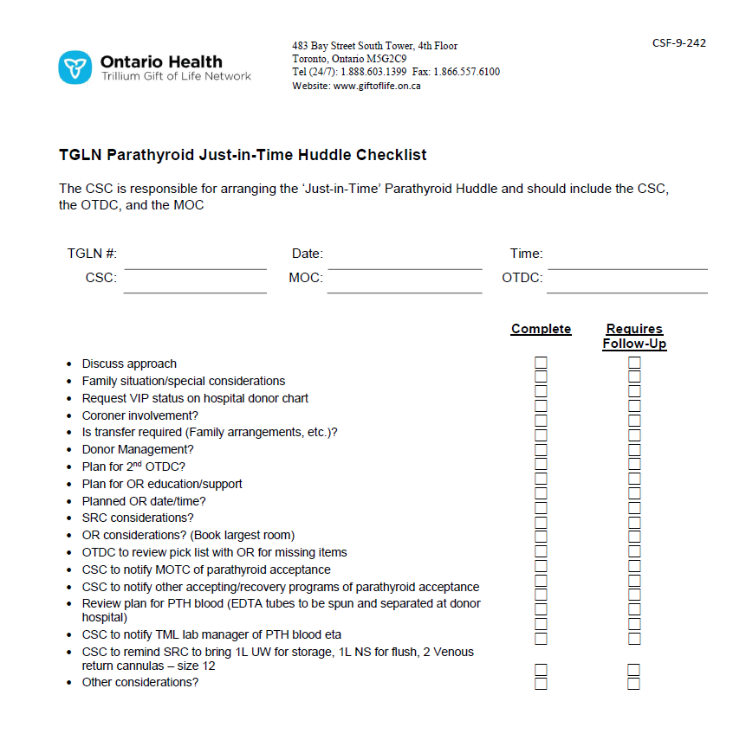

SAMPLE

**Hospital Huddles**

**OR Planning Huddle with Perioperative Staff/OTDC**

**Trigger time:** Following acceptance of parathyroid gland for transplant – typically during business hours

**Purpose:** To involve the key OR leadership to plan and prepare for the donor OR.

**Attendees:**

* TGLN: OTDCs
* Hospital: OR charge nurse or other individuals involved in booking (anesthesia, OR Educator and Manager welcome)

**Items to Communicate:**

* Overview of VCA Parathyroid Gland donation case and donor, reminder about privacy
* Review Pick List
* Any coroner or family special considerations
* Contact info for OTDCs as necessary
* Time for questions and discussion

**OR Pre-Op Huddle**

**Trigger time:** To occur very shortly before the donor scheduled OR, after arrival of the VCA PThd recovery team.

**Purpose:** To review donor forms, to have the VCA PThd recovery team meet with intra-op team.

**Attendees:**

* TGLN: OTDCs, SRC
* Hospital: OR intra-op staff, OR charge nurse, possibly OR manager or educator, anesthesia staff
* VCA PThd Transplant team

**Items to Review:**

* VCA PThd Transplant team to communicate needs and planning for OR with intra-op staff
* Review intra-op recovery timing, arrival of other teams, etc.
* Review of Pick List, equipment, and set-up
* Review usual donor forms and organs being recovered
* Address any family or coroner special considerations
* Review post-OR processes: any tissue recovery
* Confirm moment of silence to be held prior to beginning of OR
* Plan for informal post-recovery debrief
* Time for questions and discussion

**VCA Parathyroid - Information for Families**

Link to document for printing/emailing: link

**Parathyroid Donation: Information for Families**

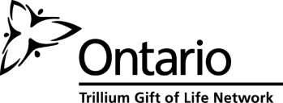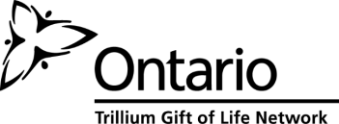

**What is parathyroid gland donation and transplantation?**

Transplant medicine has evolved and we are now able to offer parathyroid gland transplant for people suffering from permanent post-operative hypoparathyroidism. This is a rare but devastating complication for some who undergo removal of their thyroid gland for medical reasons.

**How often has this been done?**

Transplant of parathyroid tissue is a common procedure around the world and has been in practice since the early 1900s. It has usually been done using parathyroid tissue from the patient themselves, or from a related living donor, during or after thyroid surgery. What is new this time is using parathyroid tissue from a deceased donor, which is being done because no living donor matches have been found for one potential recipient. Given the success of transplantation of parathyroid in other situations, it is anticipated that this donation will improve the recipient’s quality of life.

**Who can be helped by parathyroid tissue donation?**

Parathyroid donation helps children or adults who have experienced thyroid cancer or other disease resulting in complete removal of the thyroid. A very small number of people develop permanent severe health complications which require life-long IV treatments, and which can result in, among other things, frequent hospitalizations, seizures and loss of the ability to work. Transplantation can help to restore normal function, allowing people to more fully live their lives, return to work and have a better quality of life. Donation is a generous and selfless act that benefits others. It not only benefits the people who receive a donation, but also those who love them.

Families who have donated organs and tissues after death have said that when grieving the death of someone they love, donation has provided some measure of comfort in knowing that their gift has given hope, restored health and lessened the suffering of others.

**How is parathyroid transplantation done?**

If it is determined that your loved one may have the opportunity to help someone through the gift of parathyroid glands, the TGLN (Trillium Gift of Life Network) coordinator will review any needed information with you. Once consent is confirmed, testing is completed to confirm a match with the potential recipient. Blood type and age are considered in determining a match. Testing to ensure the best possibility of a successful transplant will include blood calcium levels and thyroid hormone levels.

Once testing is completed, the hospital and transplant teams work together to determine a time for the recovery surgery to occur. Specially-trained surgeons remove the parathyroid glands to prepare them for transplantation. The incision will be closed and covered with a gauze dressing. Other organs that are consented for donation are also recovered during the time in the operating room. Final determination of suitability and matching will be completed after the donated tissue is recovered and evaluated.

**Other information for families**

**Timing**

The organ recovery process in the operating room takes approximately 4-6 hours. If parathyroid glands are being recovered for a transplant, one additional hour will be required in the operating room. Family members will be updated throughout the process by the TGLN coordinator and healthcare team.

**Impact on funeral arrangements**

Release of the body to the funeral home can occur shortly after the recovery surgery (if the coroner has not requested an autopsy) and then the timing of the funeral ceremony can be arranged. Families will be advised by the TGLN coordinator if a delay is expected or occurs. Parathyroid donation will require an additional incision of several inches, at the base of the neck. The funeral home may use make-up to cover the incision or you may choose clothing with a higher neckline for burial, but donation will not prevent an open casket ceremony. This choice is an individual family decision and it may depend upon the type of funeral service that is being planned.

**Confidentiality**

TGLN will maintain the donor and donor family’s anonymity. In Ontario, the confidentiality of donors and recipients is protected by law. TGLN does not provide any information regarding the identity of the donor or their family, and will not be able to confirm the identity of the recipient because of the laws regarding confidentiality of donation and transplantation. However, as stories of unique transplants sometimes draw media attention, there is a real possibility of a donor family learning the identity of a recipient via the media or social media. In is anticipated that the hospital will announce the transplant approximately 2 weeks after the surgery. If you require the support of TGLN media relations, please call Karyn Hyjek at 416-216-5931during regular business hours.

**Questions**

You may have other questions after having read this brochure, or during the donation process. A TGLN coordinator will be involved in every step of the way to provide you with up-to-date information and will be available to answer any questions you may have.

Thank you for taking the time to consider the gift of parathyroid donation for transplantation.

TGLN Organ and Tissue Donation Coordinator

Name: ____________________________________

Mobile: _____________________________________

# **Amendments to Consent Documentation – VCA Cases**

**Amendments to Consent Documentation**

**Vascularized Composite Allotransplantation Cases**

**Principles:**

* All oral (telephone) consents must have a witness
* Witnesses must sign a consent form (electronic or paper)
* All consent forms must be uploaded to iTransplant
* A paper copy of all relevant consent forms must be in the chart at the hospital prior to the OR recovery (fax to ICU if electronic copy, staple copies together as needed)

|  |  |  |
| --- | --- | --- |
|  | **Single Approach (Organ, Tissue and VCA all at once)** | |
| A | In Person | * Consent as per usual practice, one form, no witness required |
| B | Telephone (as per *COVID practice update instructions*) | 1. OTDC consents by phone, informs patient substitute that a colleague will call to confirm and witness consent. 2. OTDC completes consent form, including section C, dates and signs consent (fillable consent form on the ORC or paper form). 3. OTDC saves/emails/scans consent to witness. 4. Witness contacts patient substitute to confirm consent. 5. Witness completes section D of form and uploads form to iTransplant. |
|  | | |
|  | **Two Approaches (Organ and Tissue initially, then VCA separately)** | |
| C | Both consents in person | 1. First consent as per usual in person practice, one form, no witness required. 2. For VCA consent, hard copy of first consent from hospital chart is amended for VCA by hand by OTDC, dated and initialed by patient substitute and OTDC. No witness required. 3. OTDC uploads amended form to iTransplant. |
| D | Both consents by telephone | 1. First consent by telephone as per *COVID practice update instructions* (see B above), including witnessing. 2. For VCA consent, OTDC again obtains consent by phone and informs patient substitute that a colleague will shortly call again to confirm and witness VCA consent. 3. OTDC creates a new consent form for *all originally consented organs/tissue plus VCA* (fillable consent form on the ORC or paper form), including completing section C. 4. OTDC saves/emails/scans consent to witness. 5. Witness contacts patient substitute again and confirms consent for everything (organ/tissue previously consented and VCA). 6. Witness completes section D of form and uploads form the iTransplant. |
| E | Organ/Tissue consent in person, VCA by telephone | 1. First consent as per usual in person practice, one form, no witness required. 2. For VCA consent, OTDC obtains consent by phone and informs patient substitute that a colleague will shortly call again to confirm and witness VCA consent.   **If the OTDC and witness are both at the hospital**:   1. The hard copy of first consent from hospital chart is amended for VCA by hand by OTDC, dated and initialed by the OTDC. 2. Witness contacts patient substitute and confirms consent for everything (organ/tissue previously consented and VCA). 3. Witness completes section D of form and uploads form the iTransplant.   **If either the OTDC or the witness is not on-site at the hospital**:   1. OTDC creates a new consent form for *all originally consented organs/tissue plus VCA* (fillable consent form on the ORC or paper form), including completing section C. 2. OTDC saves/emails/scans consent to witness. 3. Witness contacts patient substitute and confirms consent for everything (organ/tissue previously consented and VCA). 4. Witness completes section D of form and uploads form the iTransplant |

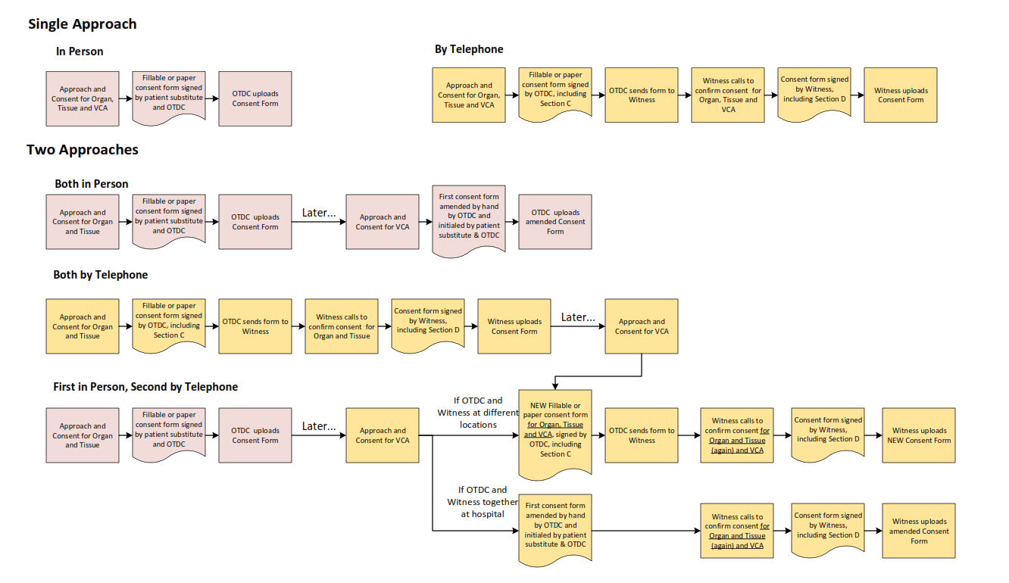

# **Consent to Donate Organs and/or Tissues Mock-up - VCA Parathyroid**

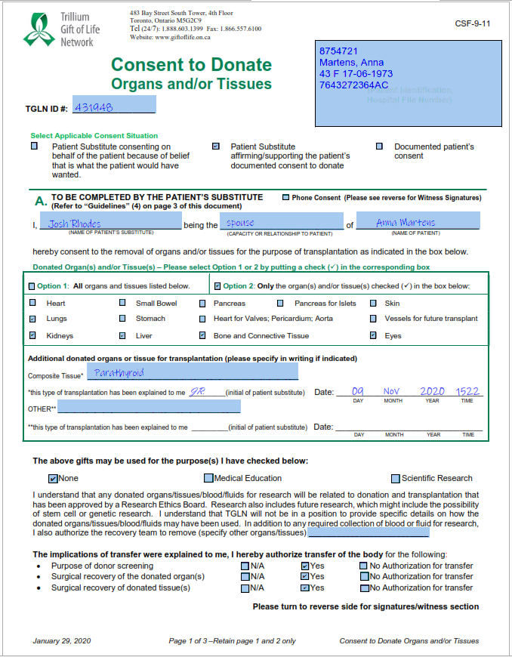

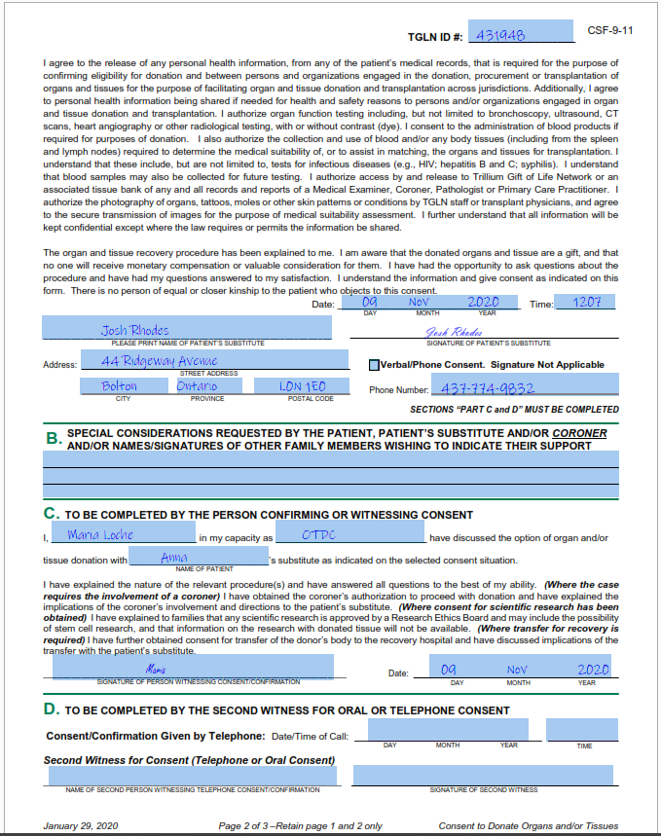

# **iTransplant Authorization Page Mock-up – VCA Parathyroid**

In addition to selecting any other organs consented, select ‘Yes’ for both VCA and Other, and add “VCA-Parathyroid” in the Other text field.

Note that VCA – parathyroid transplantation is not research. ‘Yes’ for research is *only* selected when the family has consented to research for general organ and tissue donation.

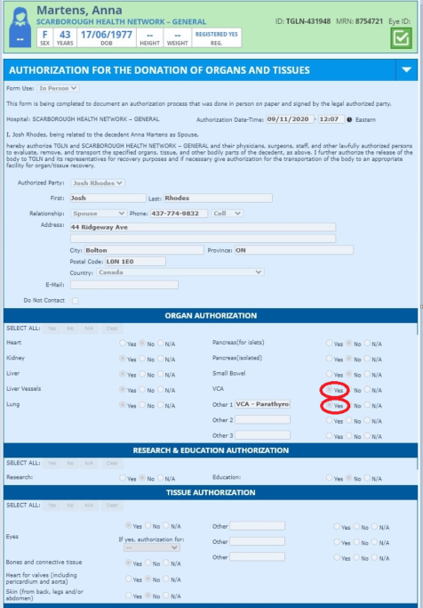

# **FAQs for Hospital Staff – VCA Parathyroid Donation and Transplantation**

Link to document for printing/emailing: link

**FAQs for Hospital Staff:**

**Vascular Composite Allotransplantation**

**Parathyroid Gland Donation and Transplantation**

**What is Vascular Composite Allotransplantation (VCA)?**

Vascular Composite Allotransplantation (VCA) is the transplantation of components such as nerve, tendon, skin and/or bone as a functional unit to reconstruct tissues from one individual to another, e.g. hand and forearm, elements of face and underlying structure, or the trachea. Parathyroid gland is included in this category. Once the revascularization of the donated tissues in the recipient occurs, it can restore function and sensory and motor status, appearance, and psychosocial well-being including self-esteem and reintegration into family and social life. The term vascular composite tissue is used interchangeably with VCA.

**Why is parathyroid gland transplantation done?**

Severe refractory hypoparathyroidism resulting from loss of parathyroid function is a highly debilitating condition requiring long-term treatment and resulting in frequent complications such as seizures, transfusions, ER visits and hospitalizations. Transplant of parathyroid tissue is a common procedure around the world and has been in practice since the early 1900s. Historically, the procedure has typically been carried out using parathyroid tissue from the patient themselves, or from a related living donor, during or after thyroid surgery. Transplantation of parathyroid tissue from a deceased donor occurs because no living donor matches have been found for the potential recipient.

**Who is eligible to be a VCA donor?**

Only donors who meet the clinical criteria for neurological determination of death (NDD) are eligible as VCA transplantation involves revascularization and re-establishment of blood flow to the tissue.

Potential donors will be assessed on a case-by-case basis. For example, individuals with a history of thyroid or kidney disease would not be considered eligible for parathyroid donation.

**Is the notification process or death determination process any different for VCA donors?**

The notification/referral process and death determination process remain unchanged.

**When is the family approached for VCA?**

Donation for VCA is discussed with families after initial screening indicates there is potential to help someone waiting for this type of transplant.

**What information is shared with the families about VCA?**

The following information is provided to the family if a donor is considered a potential match for a recipient:

* + - What may be donated, who could be helped, and how it would help them, in general terms;
    - How matching is done (e.g. blood type, age and tissue type matching);
    - Additional testing that may be required (specific blood tests);
    - Any expected impact on timing of the organ and tissue recovery process and funeral arrangements;
    - Impact on funeral arrangement decisions, such as clothing, casket selection, or choice of a viewing;
    - Confidentiality and potential for media attention with recipient images

**What are the additional privacy considerations?**

Given the uniqueness of parathyroid donation and transplantation, additional efforts need be made to ensure that only individuals immediately involved in patient care, testing, and OR planning have information about the donor and potential recovery. The Privacy Officer at the hospital may be made aware of the case to assist in managing confidentiality.

**Are there any special interventions or management for VCA?**

Following consent, in addition to the donor’s medical and social history, some additional bloodwork will be required. Details are included on the last page with the specific testing and information needed if VCA is proceeding.

**What are the timing considerations?**

Typically, testing, matching and assessment do not add significantly to the length of the overall process. If suitable, the recovery of parathyroid glands may add up to 1 hour to the OR time. Family members will be updated throughout the donation process.

**Does the Coroner need to be involved?**

As with any donation, if the case has previously been designated a coroner’s case, permission must be obtained from the coroner to proceed. TGLN will ensure that the involved coroner is aware of the family consent for VCA when permission to proceed with donation is obtained.

**What staff will be present in the operating room?**

As with any NDD donor, scrub and circulating nurses are present. An anesthetist is required until cross clamp and organ recovery begins. A TGLN surgical recovery coordinator (SRC) will be present. The parathyroid gland recovery team will include two surgeons. As well, members of the recovery team for other organs may be present. If the donor becomes unstable, parathyroid gland recovery may cease in order to ensure recovery of lifesaving organs. Due to the uniqueness of this case, OR staff should only admit members required for the recovery in the OR. See the last page for specific OR planning required for the case.

**What type of equipment may be needed for VCA recovery?**

Any specialized equipment will be reviewed with the operating room staff prior to the recovery to ensure it is available. If available, a harmonic saw will be requested, but acceptable alternatives are also noted in the pick list. A TGLN surgical recovery coordinator will assist in OR set-up.

Similarly to organ donation, the recovery teams will bring extra supplies that may be needed. TGLN will review with the perioperative team the list of instrumentation to ensure that the operating room has all the necessary supplies.

**What does the VCA recovery process for parathyroid involve?**

Parathyroid glands are typically recovered prior to other organs in order to keep ischemic time as short as possible. A low collar skin incision will be made, the thyroid gland retracted and parathyroid gland(s) identified. Parathyroid glands will then be removed and the incision closed and covered with steri-strips. Recovery of any further consented organs will take place immediately following parathyroid recovery, in the same OR.

**What happens after recovery?**

Aftercare proceeds as per hospital policy and the body is taken to the morgue. The family may wish to see their loved one following the recovery; the TGLN Coordinator will work with the family and the hospital team to determine how this request can be honoured as per usual hospital process, should this be requested. Since there is a visible change in the donor’s appearance, it will be necessary to clarify options with the donor family for viewing the donor’s body post recovery. Sensitive draping will need to reflect the family’s wishes regarding visualizing the change.

If there is no coroner involvement, arrangements can be made by the hospital for release to the funeral home. TGLN notifies the hospital as to when this should occur.

**What follow-up is done with the family following donation?**

TGLN will contact the family at their request to let them know that the recovery is complete. The follow-up process is similar to that which occurs with all organ donations.

**During composite tissue donation, the wishes and needs of the family are paramount and are always the focus of both the health care team and TGLN.**

**Responsibilities for Critical Care Team**

* Provide usual care to the patient’s family to support their end-of-life journey and decision to donate
* Donor management and tests as per approved donor order set
* Additional bloodwork related to parathyroid function upon request

**Perioperative Team Responsibilities**

* Plan for an OR booking for 1 additional hour
* Participate in an OR planning huddle once donation is accepted by the transplant program to confirm availability of instruments required for VCA recovery and review the sensitive nature of the case/special considerations for confidentiality
* Review Pick List to identify outstanding instruments needed to be provided by transplant team

**Anesthesia**

* Direct all medical management modalities required to maintain the patient intraoperatively, e.g. hemodynamic management, neuromuscular blockade for rigidity

# **Coroner Permission Form Mock-up – VCA Parathyroid**

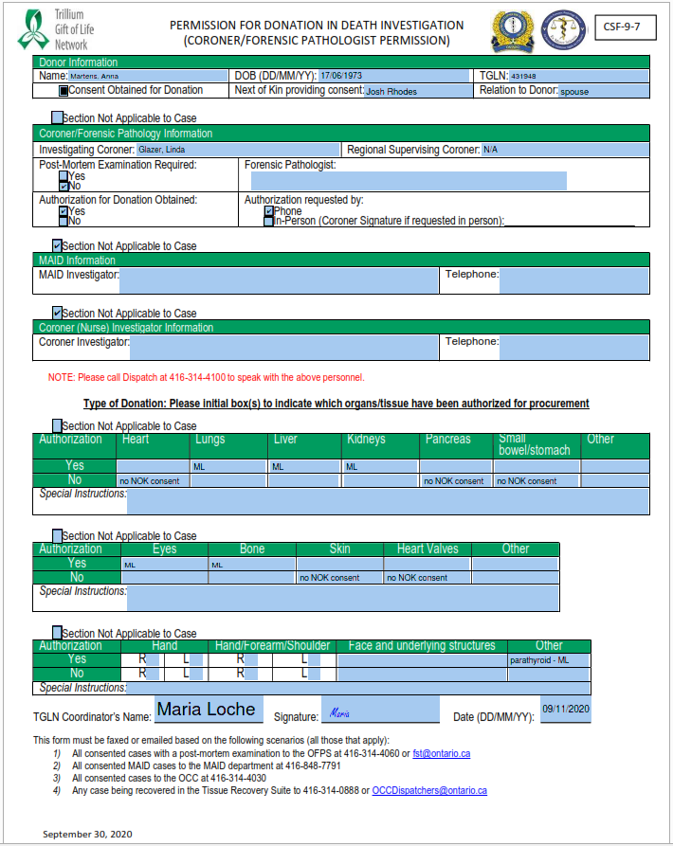

# **Donor OR Required Instruments - Parathyroid Transplant - Pick List**

Link to CPI: [here](https://orc.giftoflife.on.ca/FORMS/Donor%20OR%20Planning,%20Perfusion,%20Packing%20&%20Labelling/CSF-9-240.pdf)

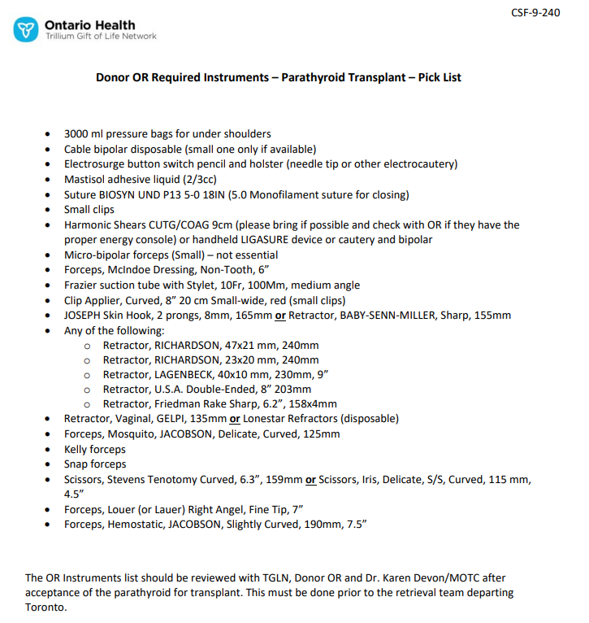

SAMPLE

# **VCA Parathyroid - One Pager for Funeral Services**

Link to document for printing/emailing: link

**Information for Funeral Service Providers**

**VCA Parathyroid Donation**

As the chosen funeral service provider, we would like to provide some information regarding someone who may be donating their parathyroid glands for transplantation.

Anatomical surgical recovery site: The incision will be somewhat low on the throat and from one to several inches across, depending on the patient (please see attached photographs for examples). The incisions will most likely be sealed with steri-strips or glue. The family may wish to discuss with you options for covering the incision should a viewing be desired.

In addition to parathyroid tissue recovery, there will be additional surgical incisions to the chest and abdomen consistent with solid organ recovery for donation. Recovery of other tissues, such as eyes, skin, and other bone may have occurred in some circumstances.

The organ and tissue donation coordinator (OTDC) who spoke with you will be your liaison for this case (please see contact information below). However, should you require assistance afterhours, please call the Provincial Resource Centre at 1-877-363-8456, press 1, and ask to speak to a coordinator regarding the deceased, citing their TGLN #. We hope that this additional information will help with planning the arrangements chosen by the family.

We appreciate your professionalism, and commitment to the maintaining confidentiality and discretion with regard to the sensitive nature of this unique situation. We thank you sincerely for your cooperation.

|  |  |
| --- | --- |
| TGLN OTDC  Name:  Cell: |  |

# **Parathyroid Incision Photographs**

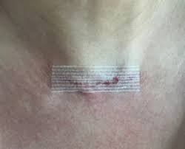

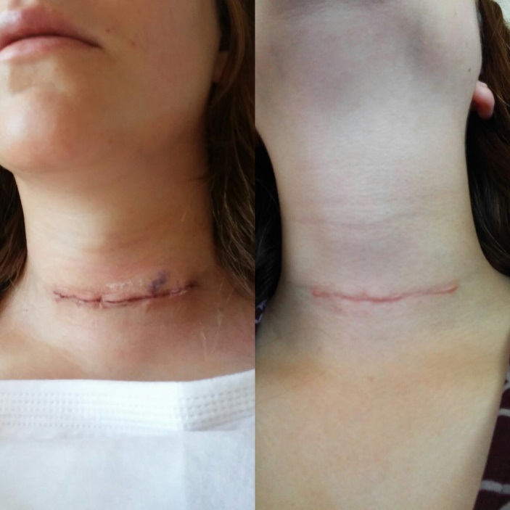

# **VCA Case Debrief Form**

Link to document for printing/emailing: link

**VCA Case Debrief Form**

**Debrief/Case Demographics**

|  |  |  |
| --- | --- | --- |
| Hospital Name: | Date: | Time: |
| Facilitator:  (Name, Title, Organization) | | |
| TGLN#: | MRN#: | |
| 🗹 NDD | Organ/VCA Outcome: | |

**Participant List:**

|  |  |
| --- | --- |
| **Name/Designation** | **Unit** |
|  |  |
|  |  |
|  |  |
|  |  |
|  |  |
|  |  |

**Action Items:**

|  |  |
| --- | --- |
| **Action Required** | **Person Responsible** |
|  |  |
|  |  |
|  |  |
|  |  |
|  |  |
|  |  |

**Debrief Findings:**

|  |
| --- |
| **List a brief summary of the events, including the timeline:** |
|  |
| **Celebrate the successes:** |
|  |
| **Identify challenges and opportunities for improvement:** |
|  |
| **Status of any media related to the case:** |
|  |
| **Document lessons learned:** |
|  |

# **Associated CPIs and CSFs**

|  |  |
| --- | --- |
| **Document Name** | **Link** |
| Discussing Donation Opportunities and Obtaining Consent | [CPI-9-204](https://orc.giftoflife.on.ca/SOP/PDF_CPI/CPI-9-204.pdf) |
| Donor Assessment | [CPI-9-208](https://orc.giftoflife.on.ca/SOP/PDF_CPI/CPI-9-208.pdf) |
| Physical Examination - Organ and/or Combined Organ and Tissue Donors | [CPI-9-209](https://orc.giftoflife.on.ca/SOP/PDF_CPI/CPI-9-209.pdf) |
| Organ and Composite Tissue Specific Data Collection | [CPI-9-215](https://orc.giftoflife.on.ca/SOP/PDF_CPI/CPI-9-215.pdf) |
| Listing and Status Changes of Parathyroid Candidates on the Ontario Provincial Wait List | [CPI-9-314](https://orc.giftoflife.on.ca/SOP/PDF_CPI/CPI-9-314.pdf) |
| Offering and Allocation of Parathyroid | [CPI-9-315](https://orc.giftoflife.on.ca/SOP/PDF_CPI/CPI-9-315.pdf) |
| Organ and Composite Tissue Labelling and Re-Labelling Process Instruction | [CPI-9-417](https://orc.giftoflife.on.ca/SOP/PDF_CPI/CPI-9-417.pdf) |
| Perfusion and Packaging - Parathyroid | [CPI-9-436](https://orc.giftoflife.on.ca/SOP/PDF_CPI/CPI-9-436.pdf) |
|  |  |
| Coroner Permission Form | [CSF-9-7](https://orc.giftoflife.on.ca/FORMS/Donor%20Assessment,%20Screening,%20Suitability%20and%20Testing/CSF-9-7.pdf) |
| Consent Form to Donate: Organs and/or Tissues | [CSF-9-11](https://orc.giftoflife.on.ca/FORMS/Donor%20Assessment,%20Screening,%20Suitability%20and%20Testing/CSF-9-11.pdf) |
| Consent Form to Donate: Organs and/or Tissues (FRENCH) | [CSF-9-12](https://orc.giftoflife.on.ca/FORMS/Donor%20Assessment,%20Screening,%20Suitability%20and%20Testing/CSF-9-12.pdf) |
| Assessment Form: Organ/Combined Organ and Tissue Donor | [CFS-9-15](https://orc.giftoflife.on.ca/FORMS/Donor%20Assessment,%20Screening,%20Suitability%20and%20Testing/CSF-9-15.pdf) |
| Summary of Placement of Organs and Tissues | [CSF-9-87](https://orc.giftoflife.on.ca/FORMS/Donor%20Case%20Follow-up/CSF-9-87.pdf) |
| Donor OR Instrument Requirements – Parathyroid Pick List | [CSF-9-240](https://orc.giftoflife.on.ca/FORMS/Donor%20OR%20Planning,%20Perfusion,%20Packing%20&%20Labelling/CSF-9-240.pdf) |
| Parathyroid Retrieval Op Note | [CSF-9-241](https://orc.giftoflife.on.ca/FORMS/Donor%20OR%20Planning,%20Perfusion,%20Packing%20&%20Labelling/CSF-9-241.pdf) |
| TGLN Parathyroid Just-in-Time Huddle Checklist | [CSF-9-242](https://orc.giftoflife.on.ca/FORMS/Donor%20Assessment,%20Screening,%20Suitability%20and%20Testing/CSF-9-242.pdf) |
| Parathyroid Patient Registration and Status Change Form | [CSF-9-243](https://orc.giftoflife.on.ca/FORMS/Donor%20Organ%20and%20Tissue%20Allocation%20and%20Waitlist%20Management/CSF-9-243.pdf) |
| Parathyroid Wait List Registration | [CSF-9-244](https://orc.giftoflife.on.ca/FORMS/Donor%20Organ%20and%20Tissue%20Allocation%20and%20Waitlist%20Management/CSF-9-244.pdf) |
| OR Data – Parathyroid | [CSF-9-245](https://orc.giftoflife.on.ca/FORMS/Donor%20OR%20Planning,%20Perfusion,%20Packing%20&%20Labelling/CSF-9-245.pdf) |