**PRC Mobile Emergency Backup Plan**

In case of emergency at the main site where call center agents normally operate from, calls coming to PRC Main phone number 416-363-4438 can be redirected away from Call Center queue and call forward to cell phone 416-807-2277.

416-807-2277 has cellular switch programming to ring 3 times and route to the 2nd cell number and after 3 rings routes to the 3rd cell number and so on.

The following list shows the sequence of cell phones programmed, but pretty much 416-807-2277 is the root number

Cellphone sequence

1. 416-807-2277     After 3 rings routes to next number
2. 416-209-3590     After 3 rings routes to next number
3. 416-557-2586     After 3 rings routes to next number
4. 416-346-4867     After 3 rings routes to next number
5. 416-407-8510     After 3 rings routes to next number
6. 416-557-3390     After 3 rings routes to next number
7. 416-407-9325     After 3 rings routes to next number
8. 416-557-0086     Routes to Cellular Voicemail box

The setup is already done on the Broad Connect platform end.

Enabling the forwarding has to be done via mypbx admin portal.

In the PRC Auto Attendant, we have pre-configured the Call Forwarding Always to 416-807-2277 but it’s turned off, once that’s needed, it should be turned on from the mypbx admin portal.

**PS:** this cannot be enabled from a voice portal by dialing a number as it’s not supported by the platform.

**Please follow the below steps for that:**

1. Go to <https://mypbx.broadconnect.ca> (can be even accessed from any mobile browser)
2. Enter username: **tgln_epp** and password: **Login#1234**

**PS:** above admin user is configured mainly for PRC team leads whether Tissue or Organ which gives access only to this specified feature, same steps can be done by signing in with any Global admin)

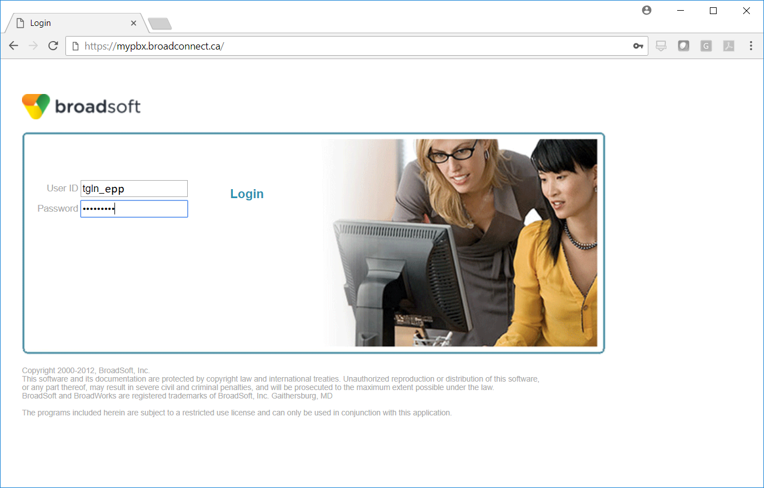

1. Click on **Group Services** (left side)

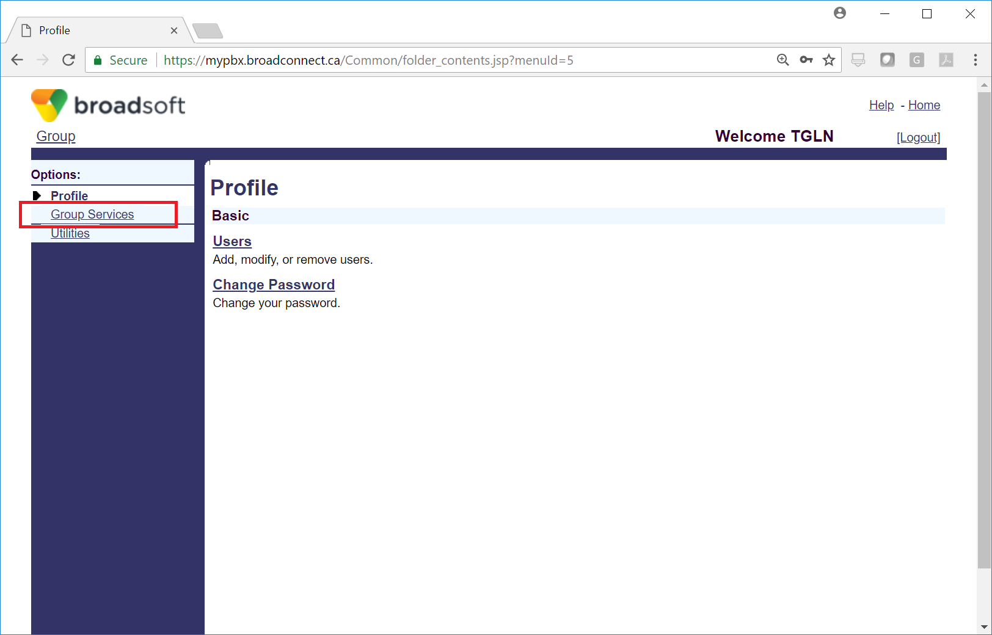

1. Click on Auto Attendant

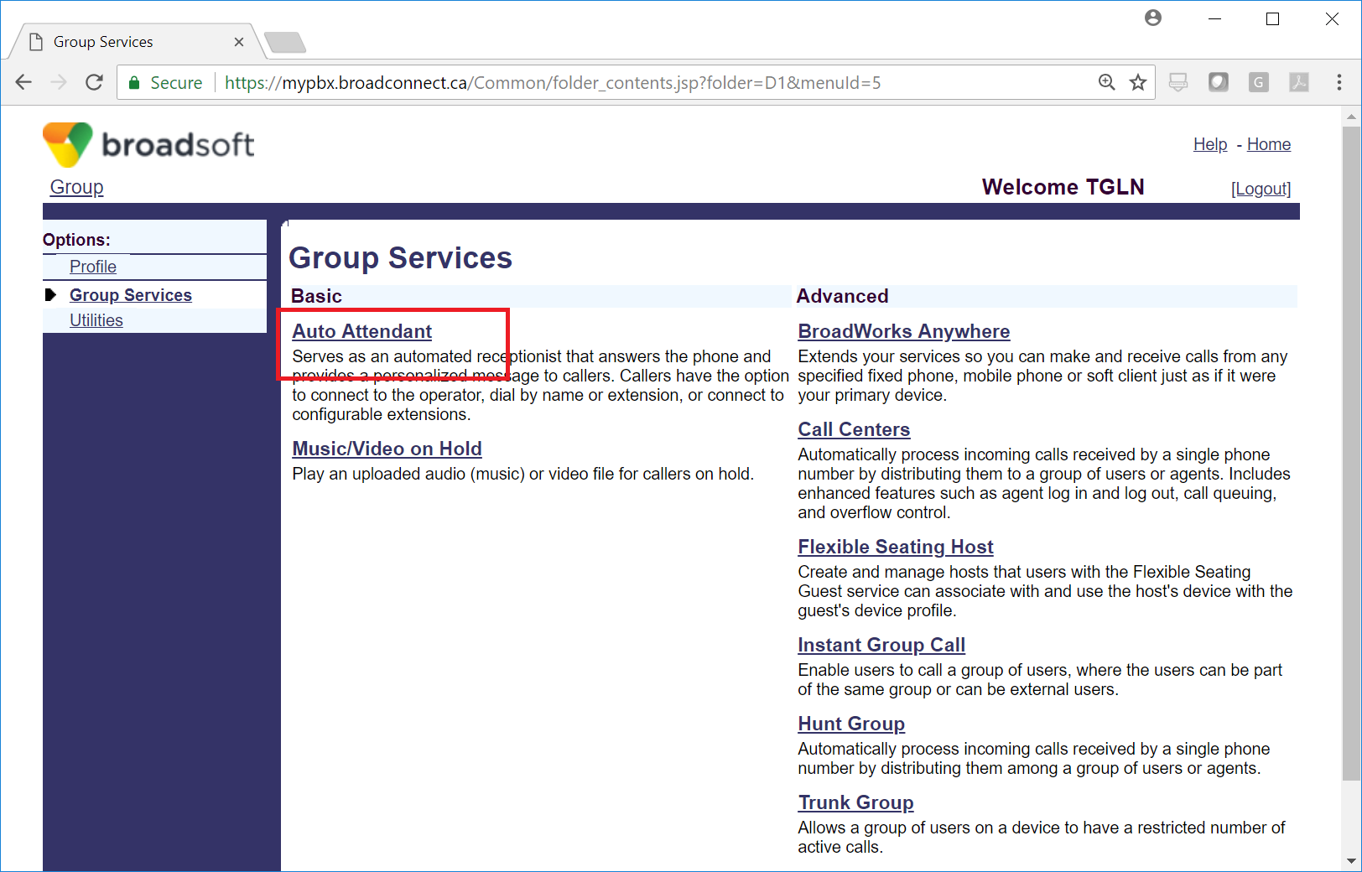

1. Click on **PRC AA** (or the word Edit)

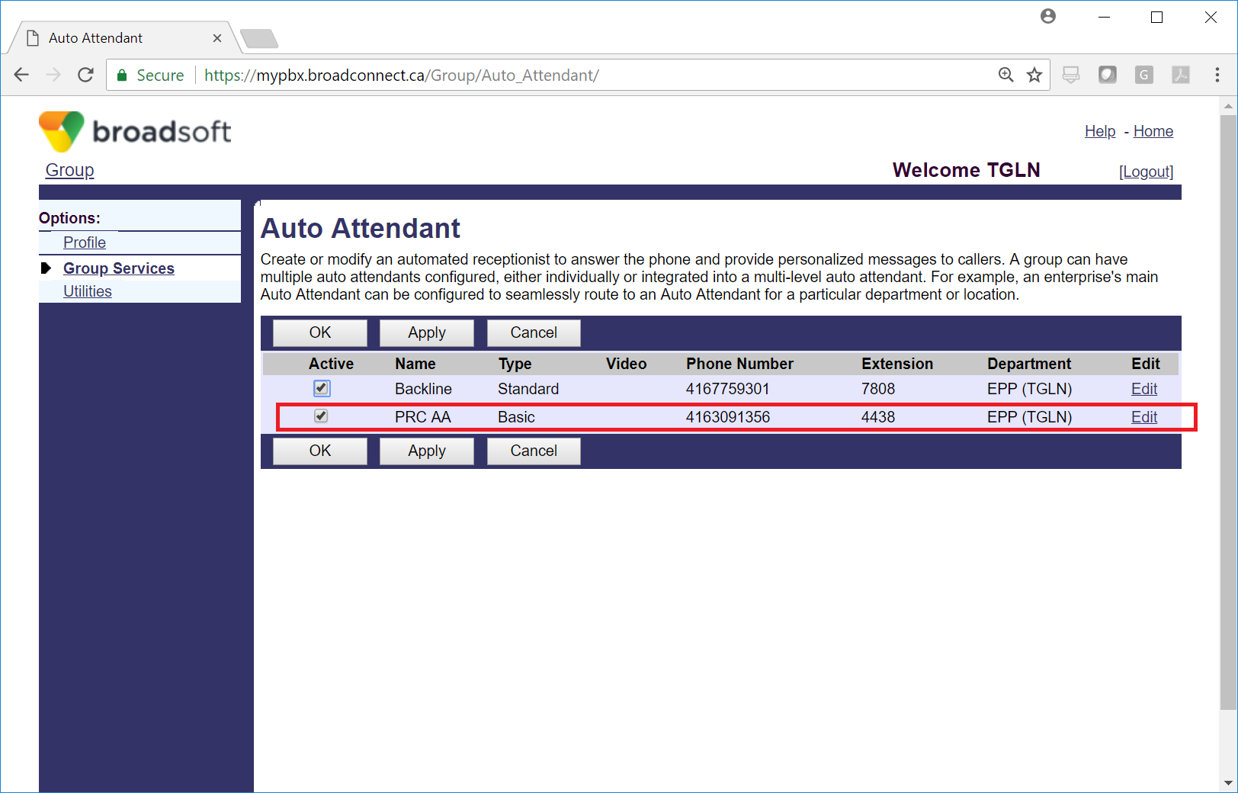

1. Click on **Incoming Calls** (left side)

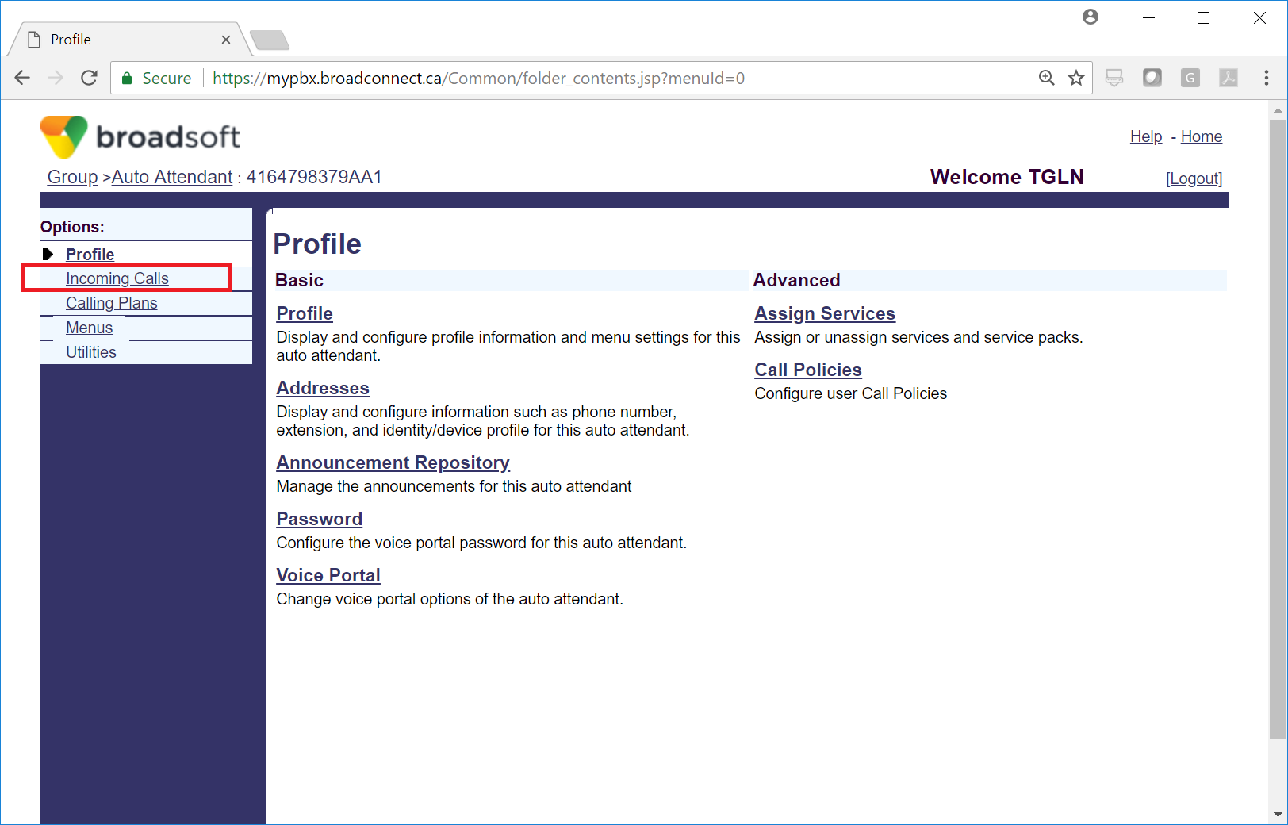

1. Click **Call Forwarding Always – off**

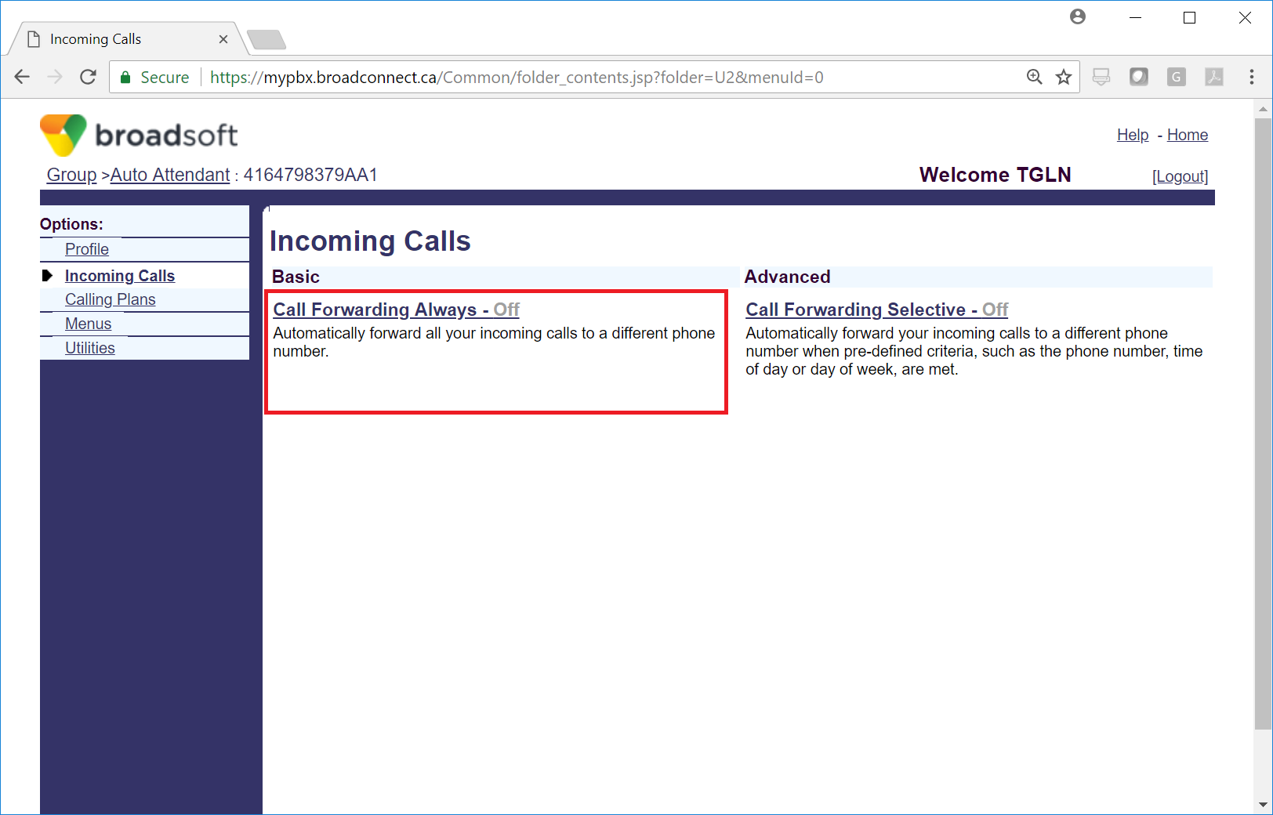

1. Choose **On** then click **Apply**

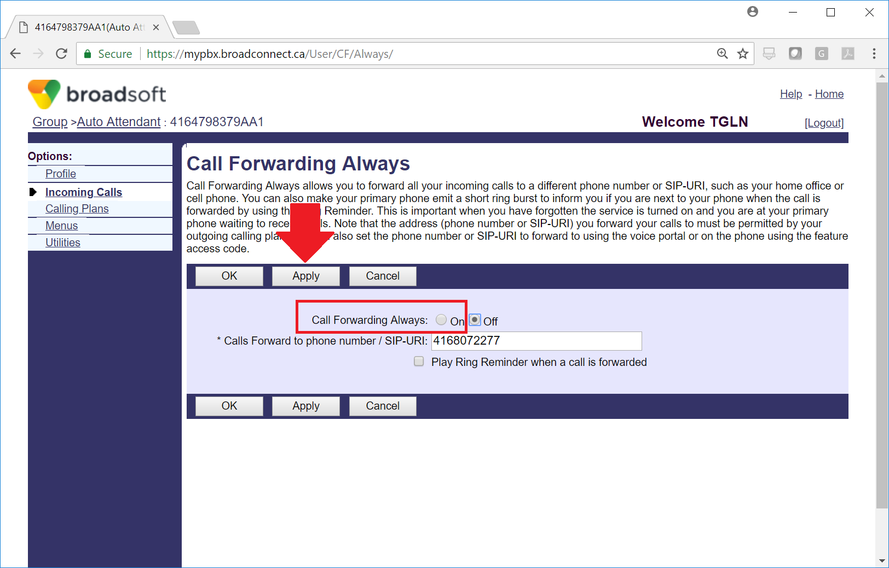

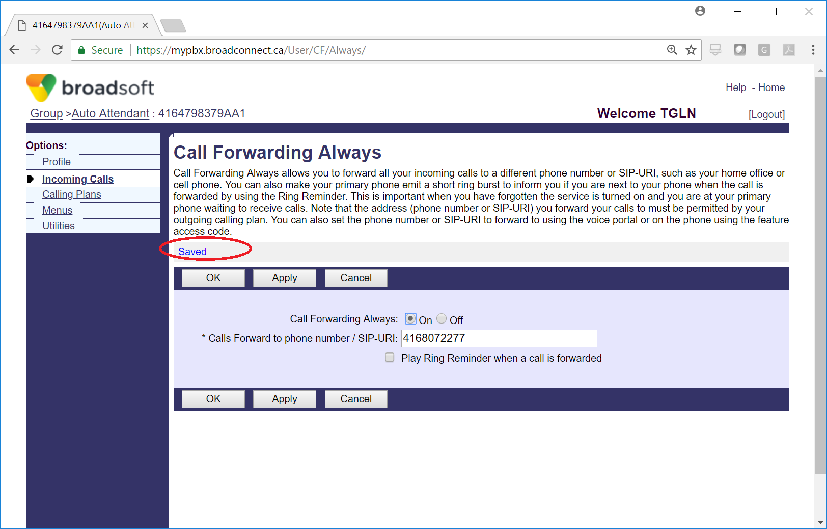

1. Logout
2. Repeat the same steps in order to turn the feature off.